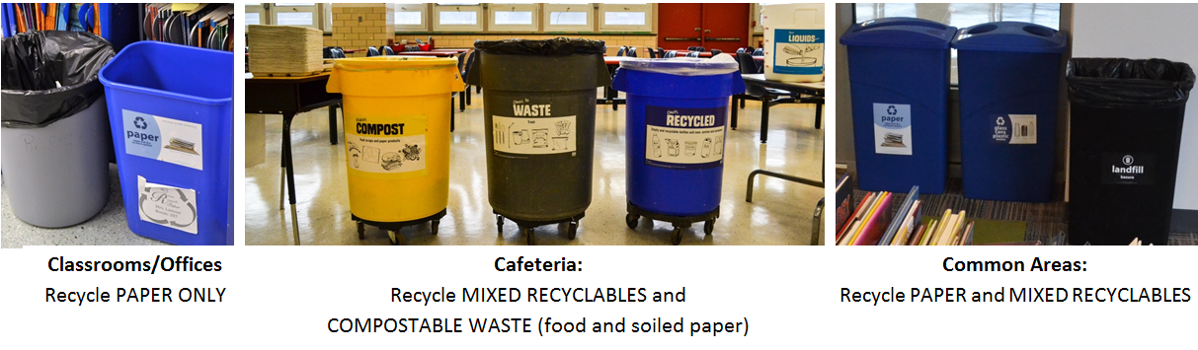
DCPS Recycles! All-Staff Memo

Dear staff,
I am pleased to remind you that our school is expected to fully participate in the DCPS Recycles! program. This program helps us meet our legal obligation to recycle, streamline building operations, reduce wasted money and natural resources, contribute to the citywide Sustainable DC goal of zero waste by 2032, and teach our students valuable skills that will set them up for success in a sustainable 21st century.
To be successful, recycling requires participation from everyone. To achieve this, our school is setting the following expectations:
- Everyone sorts! All staff and students will sort waste into bins according to their labels and the guidelines provided by DCPS Recycles!
- All staff will lead by example. Staff members are expected to sort correctly, remind students to be responsible by sorting correctly, and reinforce that this is the right thing to do.
- Teachers are responsible for ensuring that blue classroom bins are used for PAPER ONLY. Teachers also have the opportunity connect recycling with learning opportunities for students!
- Custodial staff is responsible for collection (getting materials into the correct containers outside). *Custodial staff is NOT responsible for sorting*—if one person puts trash in a recycling bin and contaminates the bin, it will be collected as trash and will get sent to the landfill!
- Anyone can be an advocate for recycling and a cleaner community!
Thank you for your participation in this school-wide effort!
Questions? Contact one of our school’s recycling delegates: [INSERT NAMES OF YOUR 3+ DELEGATES]
Please see the DCPS Recycles! website for more information.

YOUR NAME/SIGNATURE

