Government of the District of Columbia
Muriel Bowser, Mayor
Rashad M. Young, City Administrator

Department of General Services
Jonthan Kayne, Interim Director
Contractor’s Reference Guide to District Certified Business Enterprise Participation
FEBRUARY 2013

TABLE OF CONTENTS

NEW PROCEDURES FOR CERTIFIED BUSINESS ENTERPRISES PARTICIPATION
- General Contractors 1
- Contractors and Subcontractors 1
- Reporting to DGS 1
- DGS CBE Participation 2
- Contractor Assistance 2
- Contact Information 2

ATTACHMENTS DESCRIPTION

1 CERTIFIED BUSINESS ENTERPRISE (CBE) REPORTING FORM – Project Detail 3

2 DGS CBE PARTICIPATION REQUIREMENTS 4

SMALL, LOCAL AND DISADVANTAGED BUSINESS DEVELOPMENT ACT – Section 2346 4

CERTIFIED SMALL BUSINESS REQUIREMENTS 4

CERTIFIED BUSINESS REQUIREMENTS 5

CERTIFIED JOINT VENTURE REQUIREMENTS 6

CERTIFIED BUSINESS REQUIREMENTS FOR CONTRACTS UNDER
$1 MILLION 7

REQUIREMENTS FOR SUBCONTRACTING PLAN 7

ACRONYMS 9

The Department of General Services (DGS) has established new procedures to monitor and collect Certified Business Enterprise (CBE) information from its General Contractors, Contractors and Subcontractors. In the future, DGS will require the following:

General Contractors

- Each General Contractor must submit its proposed Certified Business Enterprise (CBE) Participation Plan and the bid sheets for its DGS project with or before it submits its GMP. The General Contractor’s CBE Participation Plan must be accepted by DGS before any work begins on the project. (See Attachment 2)

Contractors and Subcontractors

- Each Contractor or Subcontractor with a DGS contract must submit its Contracting Plan including CBE participation before it commences work on its project. The Contracting Plan must be approved by DGS and DSLBD. (See Attachment 2)

Reporting to DGS

- The General Contractor must submit a contracting report of all its Contractors and Subcontractors to DGS monthly with each invoice via Prolog Converge (CBE file to be uploaded separately). The monthly report should include:

  - Current Rate of CBE participation and payments made to CBEs (See Attachment 1).

- If the CBE requirements are not being met by any Contractor or Subcontractor, corrective action must be agreed upon before the offending Contractor or Subcontractor is paid.

- If the Contractor or Subcontractor fails to take corrective action in a timely manner, then the Contractor’s or Subcontractor’s invoice may be held by DGS until corrective action is taken.

- DGS will take total responsibility for collecting CBE participation information from the Contractors and Subcontractors on all DGS projects. DGS will provide each General Contractor, Contractor and Subcontractor official forms on which to submit their monthly CBE information.

DGS CBE Participation

- DGS will adhere to the DSLBD requirements for CBE participation on all of its contracts.

Contractor Assistance

- DGS will assist any General Contractor, Contractor, Subcontractor in their search for CBE firms.

Contact Information

For more information regarding the policies and procedures for DGS contact:

DEPARTMENT OF GENERAL SERVICES (DGS)
Ms. Olivia Warren Rosemary Suggs-Evans
Workforce Planning Specialist DGS CBE Compliance Officer
Office: (202)698-7780 Office: 202 698-4197
Cell: (202)570-3128 Cell: 202-494-1946
Olivia.Warren@dc.gov Rosemary.Suggs-Evans@dc.gov

Ms. Alice Patterson Mr. Courtland Cox
CBE and Workforce Compliance Officer CBE & Workforce Compliance Officer
Program Management Team Program Management Team
E-mail: alicefpatterson@aol.com E-mail: courtlandc@starpower.net
Phone: 202-271-7773 Phone: 202-550-8455

DEPARTMENT OF SMALL & LOCAL BUSINESS DEVELOPMENT (DSLBD)

Ms. Melissa Resil
Business Certification Manager
D.C. Department of Small & Local Business Development
Phone: 202-727-3900
Fax: 202-724-3786
E-mail: melissa.resil@dc.gov
Web address: http://dslbd.dc.gov

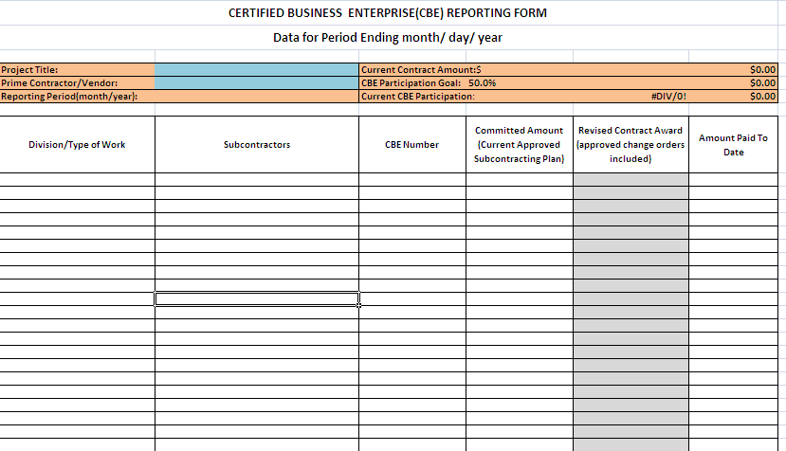

ATTACHMENT 1

DGS CBE PARTICIPATION REQUIREMENTS

DGS requires that 50% of all dollars spent on its projects be spent with businesses certified by the Department of Small & Local Business Development (DSLBD).

Example:

$5,000,000 – Contract value

$2,500,000 – DGS requires 50% of the dollars of the contract to be spent with CBE firms

SMALL, LOCAL AND DISADVANTAGED BUSINESS DEVELOPMENT ACT

Section 2346. Performance and subcontracting requirements for construction contracts; subcontracting plans.

CERTIFIED SMALL BUSINESS REQUIREMENTS

(a)(1) All construction contracts in excess of $250,000 shall include the following requirements:
(A) At least 35% of the dollar volume shall be subcontracted to small business enterprises; provided, that the costs of materials, goods and supplies shall not be counted towards the 35% subcontracting requirement unless such materials, goods and supplies are purchased from small business enterprises; or
(B) If there are insufficient qualified small business enterprises to completely fulfill the requirement of subparagraph (A) of this paragraph, then the subcontracting requirement may be satisfied by subcontracting 35% of the dollar volume to any certified business enterprises; provided, that all reasonable efforts shall be made to ensure that qualified small business enterprises are significant participants in the overall subcontracting work.

Example:

$5,000,000 – Contract Value

$1,750,000 – DSLBD law requires that 35% of the dollars to be contracted to a certified small business enterprise (SBE).

OR

$1,750,000 – DSLBD law permits that 35% of the dollars to be purchase FROM a small business enterprise (SBE) that is certified as a supplier of materials, goods and supplies.

OR

$1,750,000 – If there are insufficient qualified small business enterprises (SBE) to completely fulfill the requirement, then other categories of certified businesses may fulfill the small business requirement.

In this example, the DGS requirement is still $2,500,000.

CERTIFIED BUSINESS REQUIREMENTS

(b)(l)(A) Each construction contract for which a certified business enterprise is selected as a Prime Contractor and is granted points or a price reduction pursuant to Section 2343 or is selected through a set-aside program under this subpart shall include a requirement that the business enterprise perform at least 35% of the contracting effort, excluding the cost of materials, goods, and supplies, with its own organization and resources and, if it subcontracts, 35% of the subcontracted effort, excluding the cost of materials, goods, and supplies, shall be with certified business enterprises.

(B) If the total of the contracting effort, excluding the cost of materials, good, and supplies, proposed to be performed by certified business enterprises is less than the amount required by subparagraph (A) of this paragraph, then the business enterprise shall not be eligible to receive preference points or price reductions for a period of not less than 2 years.

Example:

$5,000,000 – Contract Value

$1,750,000 – DSLBD law requires that the CBE prime contractor perform 35% of the contracting effort.

AND

$1,750,000 – DSLBD law requires that if the CBE prime contractor subcontracts 35% must be spent with another CBE firm.

In this example, the DGS requirement is still $2,500,000.

CERTIFIED JOINT VENTURE REQUIREMENTS
(2)(A) Each construction contract for which a joint venture is selected as a Prime Contractor and is granted points or a price reduction pursuant to Section 2343 or is selected through a set-aside program under this subpart shall include a requirement that the certified business enterprise perform at least 50% of the contracting effort, excluding the cost of materials, goods, and supplies, with its own organization and resources and, if the joint venture subcontracts, 35% of the subcontracted effort, excluding the cost of materials, goods, and supplies, shall be with certified business enterprises.

(B) If the total of the contracting effort, excluding the cost of materials, good, and supplies, proposed to be performed by certified business enterprises is less than the amount required by subparagraph (A) of this paragraph, then the business enterprise shall not be eligible to receive preference points or price reductions for a period of not less than 2 years.

Example:

$5,000,000 – Contract value

DSLBD law requires that the certified business in the joint venture perform at least 50% of the effort of the joint venture excluding the cost of materials, goods and supplies.

AND

DSLBD law requires that 35% of all sub contract dollars of the joint venture be spent with certified businesses.

CERTIFIED BUSINESS REQUIREMENTS FOR CONTRACTS UNDER $1 MILLION

(c) Each construction contract of $1 million or less for which a certified business enterprise is selected as a Prime Contractor and is granted points or a price reduction pursuant to Section 2343 or is selected through a set-aside program under this subpart shall include a requirement that the business enterprise perform at least 50% of the on-site work with its own work force.

Example:

$900,000 – Contract value

$450,000 – DSLBD requires 50% to be performed by certified business enterprises (CBEs)

REQUIREMENTS FOR SUBCONTRACTING PLAN

(d) Bids or proposals responding to a solicitation, including an open market solicitation, shall be deemed nonresponsive and shall be rejected if the solicitation requires submission of a certified business enterprise subcontracting plan and the prime contractor fails to submit a subcontracting plan as part of its bid or proposal.

A certified business enterprise subcontracting plan shall specify the following:

- The name and address of the Subcontractor;

- Whether the Subcontractor is currently certified as a certified business enterprise;

- The scope of work to be performed by the Subcontractor; and

- The price to be paid by the contractor to the Subcontractor.

(e) No prime contractor shall be allowed to amend the subcontracting plan filed as part of its bid or proposal except with the consent of the Contracting Officer and the Director. Any reduction in the dollar volume of the subcontracted portion resulting from such amendment of the plan shall inure to the benefit of the District.

(f) No multi-year contracts or extended contracts in which the options or extensions exceed $1 million in value, which are not in compliance with this subtitle at the time of the contemplated exercise of the option or extension, shall be renewed or extended, and any such option or extension shall be void.
(g) The subcontracting requirements of this section may be waived pursuant to Section 2351.
(h) A prime contractor shall submit to the Contracting Officer in the District copies of the executed contracts with the Subcontractors identified in the subcontracting plan. Failure to submit copies of the executed contracts shall render the underlying contract with avoidable by the District.

Section 2348. Enforcement and penalties for willful breach of subcontracting plan.
The willful breach by a Contractor of a subcontracting plan for utilization of certified business enterprises in the performance of a contract, the failure to submit any required subcontracting plan monitoring or compliance report, or the deliberate submission of falsified data may be enforced by the Department through the imposition of penalties, including monetary fines of $15,000 or 5% of the total amount of the work that the Contractor was to subcontract to certified business enterprises, whichever is greater, for each such breach, failure, or falsified submission.

ACRONYMS

Below is a list of acronyms used in the document;

CBE Certified Business Enterprise

DBE Disadvantaged Business Enterprise

LBE Local Business Enterprise

SBE Small Business Enterprise

DC District of Columbia

DCPEP DC Partners for Revitalization of Education Projects

DSLBD Department of Small & Local Business Development

GMP Guaranteed Maximum Price

MEP Mechanical, Electrical, Plumbing

DGS Department of General Services

