INVOICE PROCESSING PROCEDURE
Effective July 15, 2015 all contractors/vendors invoices must be uploaded via Prolog Converge in the appropriate project folder. Once the invoice is uploaded into Prolog Converge both the vendor and the Project Manager will receive an automatic notification via e-mail that the invoice has been uploaded. Upon review of the invoice packet if it has missing or erroneous documentation/data the PM must change the invoice status to “Rejected” and the vendor will receive an electronic notification of the rejection and the reason for the rejection. The vendor must correct the error and/or provide the missing documentation/data and re-upload the corrected invoice packet via Prolog Converge.
Contract Invoice records are entered into Prolog only after the corresponding contract/purchase order has been entered, reviewed and approved. Pertinent invoice data is auto-populated from the underlying contract/purchase order.
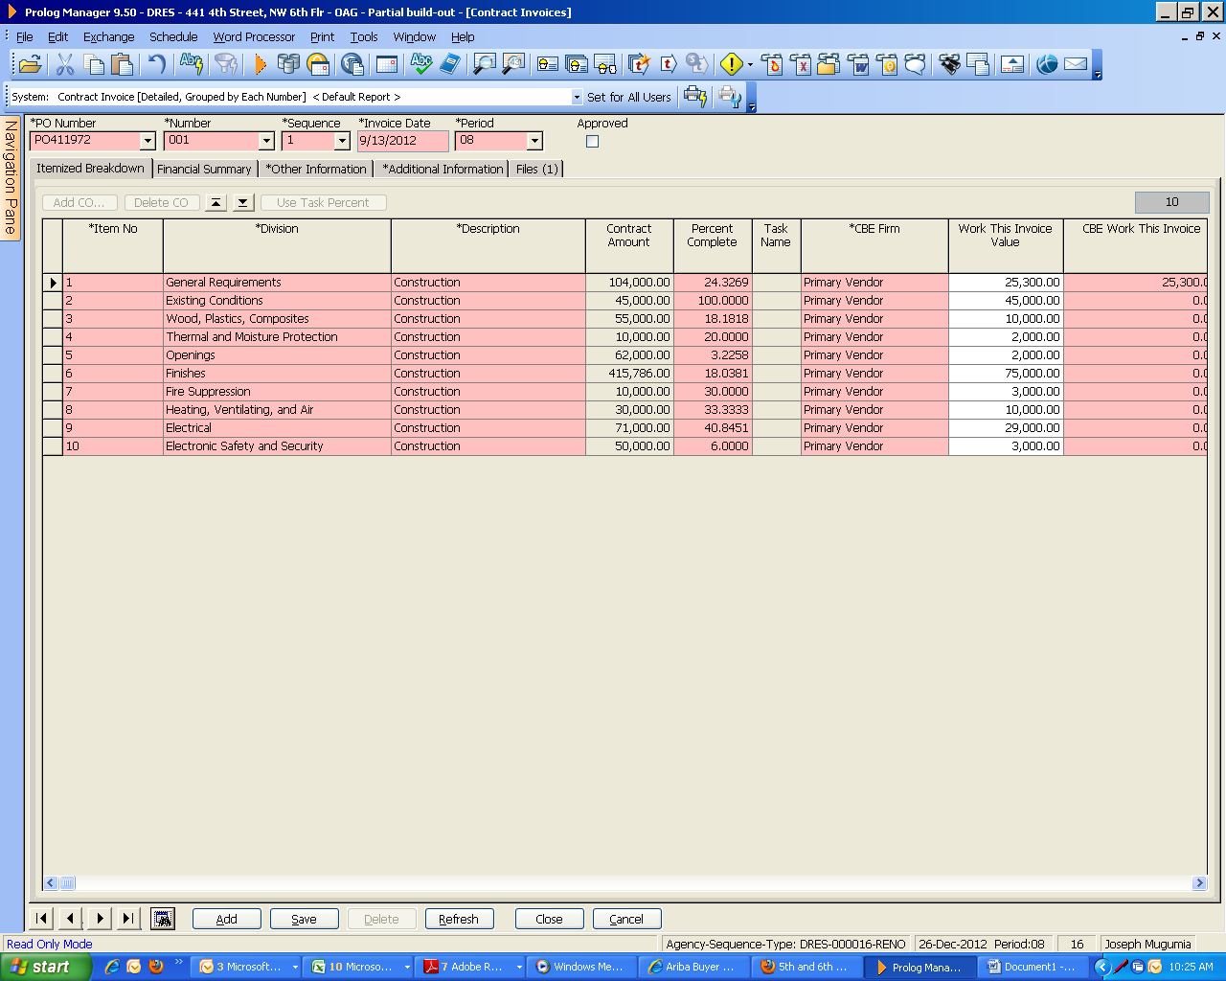

The pink data fields on the Contract Invoice form are required data:
PO# Invoice# Sequence #
Invoice date Cost period Approved date
Received date Vendor Invoice# PASS Receipt#
Billing period Start & End Dates

After the Contract Invoices are entered the PM is responsible for submitted a signed copy into their respective Cluster Leaders folder on the U drive for review and signature. If the invoice packet is complete, correct and all the required supporting documentation is attached play the electronic file on the U drive in the respective Cluster Leader’s folder. If the invoice packet is correct the Cluster Leader will review and sign the Pay Request form and place the electronic copy of the invoice packet with the signature on the U drive:\opmfile\ccsa\_Invoice Processing\_PMO Review (see screen shot below):

The PMO staff review the invoice packet and check against data entered in Prolog and ensure that all documentation foots to the supporting paperwork submitted by the vendor with their Pay Request form.
Please make sure that you enter all required data. If you do not complete the field highlighted pink you will not be able to save your data. These fields include: PO Number, Invoice#, Sequence #, Invoice date, Cost period, Approved date, Received date, Vendor Invoice#, Invoice Status, Billing Period Start & End Dates.
Invoices not in Prolog are not to be submitted to the PMO.
The PMO staff is responsible for ensuring that cost periods, attachments and vendor invoices are accurate and billing amounts are consistent with the Payment request form (a vendor invoice on the vendor’s letterhead is required by OCFO for processing). If the invoice packet is correct and complete PMO will ensure that each invoice is properly authorized (signatures from the PM, Cluster Leader and the Deputy Director), The PMO office will ensure that all supporting documentation is included as applicable. Any invoices with errors or missing information/documentation will be rejected by PMO. A rejection notification from Prolog will be sent via e-mail to the Project Manager, Cluster Leader, vendor and Deputy Director.

After approval by the Deputy Director the PMO staff with scan the entire invoice packet, do the requisite receiving and attach an electronic copy of the fully approved invoice packet in PASS so that DGS Finance can retrieve and process for payment.
PMO sends three (3) separate e-mails to DGS – Finance via dgsfinan.inv@dc.gov to notify them of all invoices ready for payment processing (see sample below).

Once invoices are sent to DGS - Finance for processing the PMO office will update the date field titled ‘Sent To OFRM’ in Prolog. After the “Sent to OFRM” has been updated an auto-notification will go out via e-mail to the PM and vendor for that project.

If you have any questions or need assistance please contact the Project Manager and/or Project Management Office via e-mail at prolog.support2@gmail.com .
All invoices must be entered into Prolog in a timely manner. Only the Capital Construction Officer, PMO Management & Program Analysis Officer or Deputy Director can authorize the submission of invoices outside of established Invoice processing procedure via Prolog due to exigent circumstances . Such direction/authorization should be given in writing. The request to submit invoices outside of Prolog will be sent to the PMO staff via e-mail.

