**DCPS HAULING SERVICES SCHEDULE** Fill in the blanks using the services schedule at:[**http://dgs.dc.gov/page/dgs-healthy-schools**](http://dgs.dc.gov/page/dgs-healthy-schools)**.** *Print and post in the Foreman’s office.*

Containers that are not under contract will NOT be serviced by hauling companies.

.

**REPORT PROBLEMS WITH SERVICES TO SUSAN RILEY at** [**susan.riley@dc.gov**](mailto:susan.riley@dc.gov) **or (202)-442-9746**

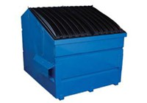

**______[#] of paper container(s)  
Picked up ____ [#] times per week   
on _________________________ [day(s) of week].**

**Organics Carts**Food scraps and soiled paper products  


**Mixed Recycling Carts**Empty plastic, metal, and glass containers  
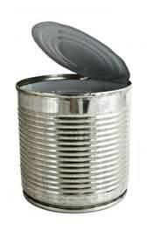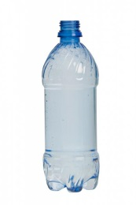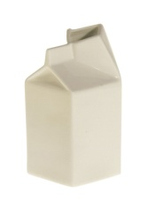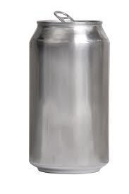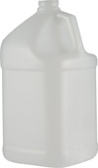

**Paper Recycling Dumpster or Compactor** Clean, dry paper products and broken-down cardboard  
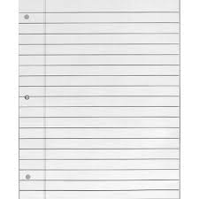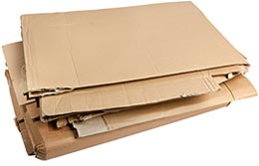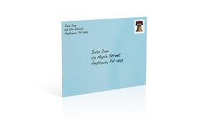

**______[#] of mixed recycling carts  
Picked up ____ [#] times per week   
on _________________________ [day(s) of week].**

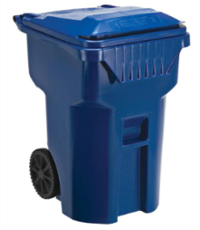

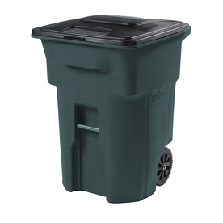

**______[#] of organics recycling carts  
Picked up ____ [#] times per week   
on _________________________ [day(s) of week].**

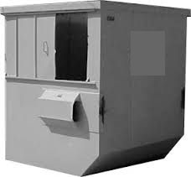

**______[#] of trash container(s)  
Picked up ____ [#] times per week   
on _________________________ [day(s) of week].**

**Trash Dumpster or Compactor**Non-recyclable waste   
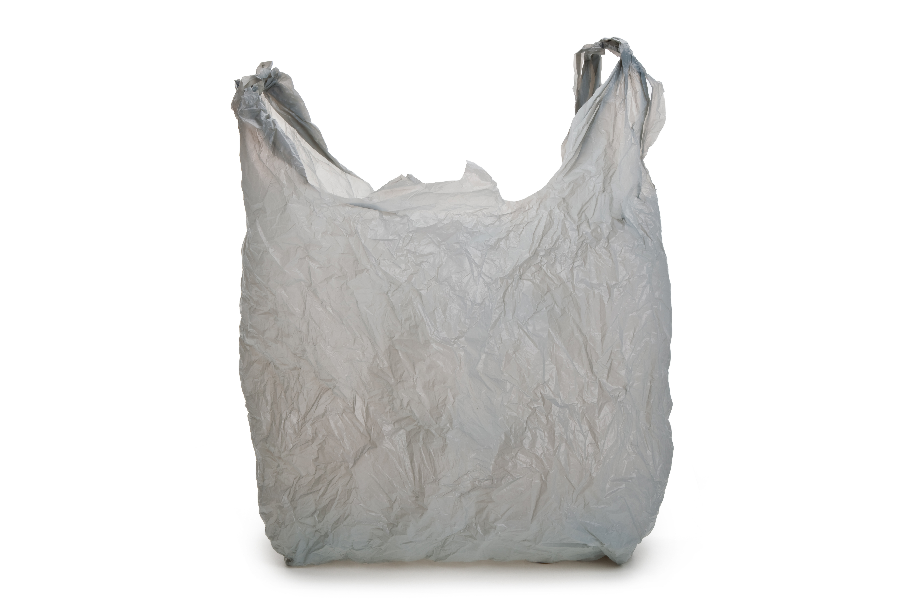

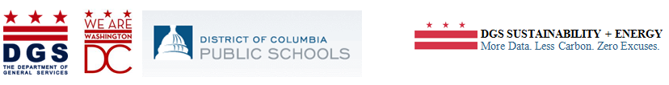

**Prevent Hauling Issues & Pests** ⚫ Use correct liners ⚫ Keep cart lids completely closed at all times ⚫ Lock dumpster or dumpster enclosure ⚫ Do not allow carts to park in front of dumpster area ⚫ Do not leave bulk trash outside unless you have requested bulk trash services

**Bulk Waste –** Request pick up using SmartDGS.  **Electronic Waste** - Fill out a 525 form. **Hazardous Waste –** Request pick up using SmartDGS. More info at <http://esa.dc.gov/>.