**DCPS HAULING SERVICES SCHEDULE** Fill in the blanks using the services schedule at:[**http://dgs.dc.gov/page/dgs-healthy-schools**](http://dgs.dc.gov/page/dgs-healthy-schools)**.** *Print and post in the Foreman’s office.*

Containers that are not under contract will NOT be serviced by hauling companies.

.

**REPORT PROBLEMS WITH SERVICES TO SUSAN RILEY at susan.riley@dc.gov or (202) 442-9746**

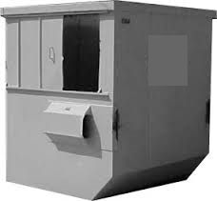

Service Days:  
  
**_____________**

# ofContainers:  
 **_____________**

**Trash Dumpster or Compactor**Non-recyclable waste   
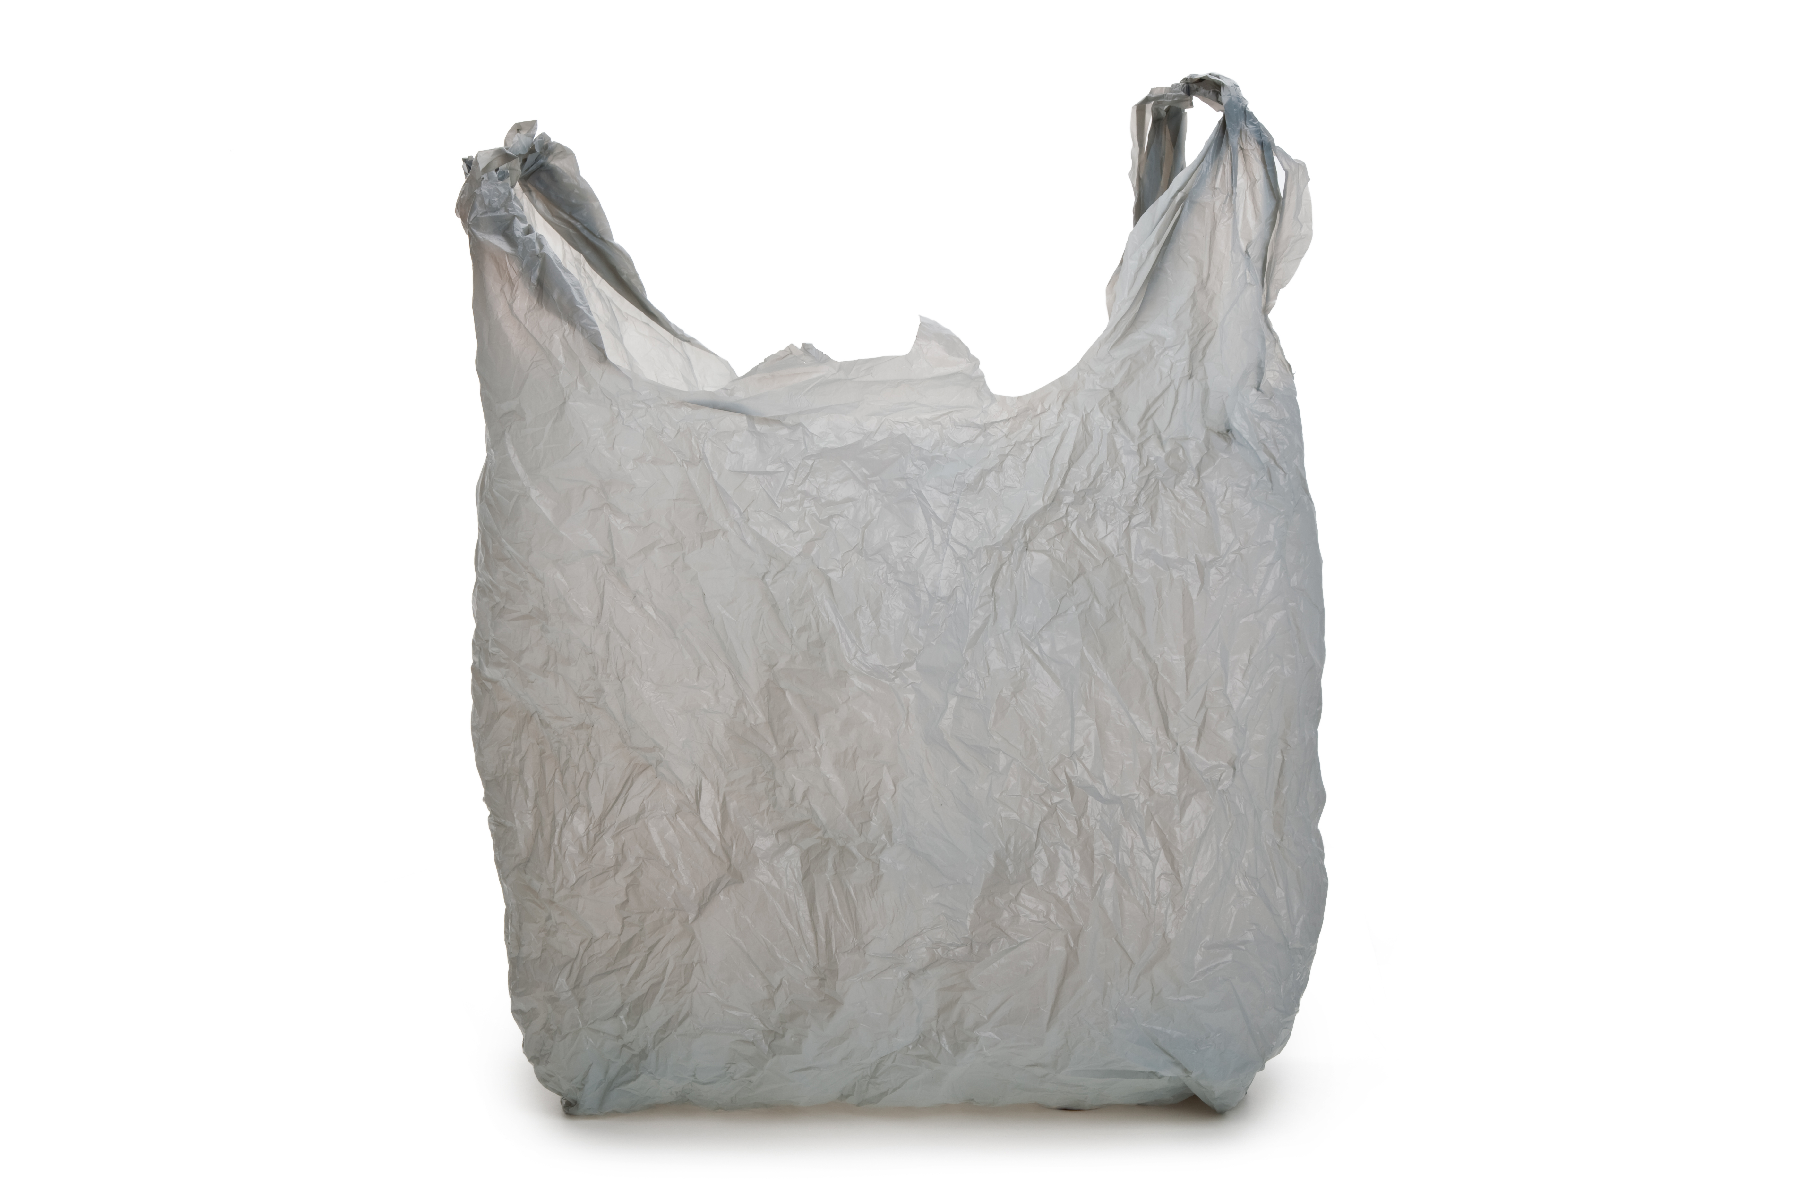

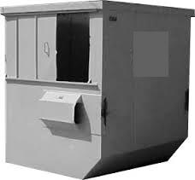

Service Days: **_____________**

# ofContainers:  
 **______________**

**Paper Recycling Dumpster or Compactor** Clean, dry paper products and broken-down cardboard  
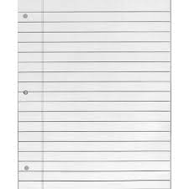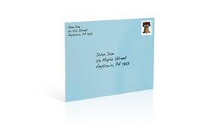

**Mixed Recycling Carts**Empty plastic, metal, and glass containers  
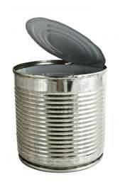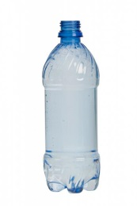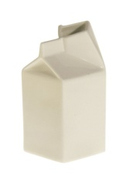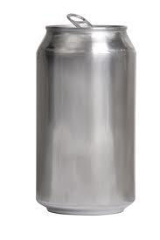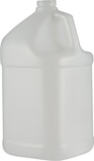

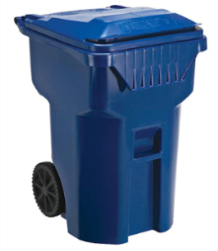

Service Days: **_____________**

# ofCarts:  
 **______________**

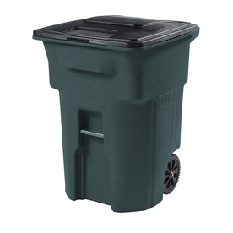

Service Days:  
 **_____________**

# ofCarts:  
 **_____________**

**Organics Carts**Food scraps and soiled paper products  




**Prevent Hauling Issues & Pests** ⚫ Use correct liners ⚫ Keep cart lids completely closed at all times ⚫ Lock dumpster or dumpster enclosure ⚫ Do not allow cars to park in front of dumpster area ⚫ Do not leave bulk trash outside unless you have requested bulk trash services

**Bulk Waste –** Request pick up using SmartDGS.  **Electronic Waste** - Fill out a 525 form. **Hazardous Waste –** Request pick up using SmartDGS. More info at <http://esa.dc.gov/>.