GOVERNMENT OF THE DISTRICT OF COLUMBIA
DEPARTMENT OF GENERAL SERVICES

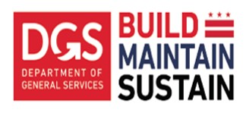

(Date)

Ella Faulkner.
Deputy Director of Capital Construction Services Division
Department of General Services
3924 Minnesota Ave, NE
Washington, DC 20019

Reference: (Project Name)

Subject: Retention reduction for various subcontractors.

Dear Ms. Faulkner:

In a letter dated (date), (vendor name) has requested to reduce the retainage for payment held for various subcontractors to (numeric) % starting with the (month/year) pay period. (Vendor name) based their request to reduce the retainage held on the monthly payment for this particular subcontractor because the work of this subcontractor is substantially completed with (work description) and has executed all applicable releases of claim rights to date.

This request is in accordance with Article (numeric), Section (numeric) of the Agreement between (Vendor name) and the Department of General Services. We confirm that these subcontractors’ work for (work description) is substantially complete as of (date). We therefore recommend the retainage be reduced to (numeric) % starting with the (month/year) billing period.

Should you have any questions or wish to discuss this matter further, please feel free to contact me directly at (phone number).

Sincerely,

(Full Name)
Program Manager ______________________________________
Recommendation Accepted by Ella Faulkner

