Educational Specifications for

Watkins Elementary School Addition and Modernization

440 capacity

December 2014

District of Columbia Public Schools

THE VISION: To Make the Washington, D.C. School System Exemplary

THE MISSION: To Make Dramatic Improvement In the Achievement of All Students Today In Preparation for Their World Tomorrow

CORE BELIEFS:
Children First
Parents Are Our Partners
Victory Is In the Classroom
It Takes A Village to Raise A Child
Leadership and Accountability Are the Keys to Our Success

School Improvement Team Members

Introduction

This document articulates the requirements for a modernized 1st through 5th grade school. It describes the current and planned educational programs and services, the community characteristics that may affect facilities planning, and the opportunities and challenges associated with the design and construction.

Scope

This project is a phase 1 modernization of the existing school, however, the architect will develop concept plans for all three phases of the modernization. The phase 1 work will include modernization of the academic areas, media center and administration functions as follows.
Four classes per grade (1-5)
Resource rooms and office areas (art, music, science, world language)
Media Center/computer lab
Administration and teacher workrooms
Corridors, stairwells, and toilets
The phase 2 and 3 work will include
Dining facility/kitchen
Physical education
Any major building systems and building service areas not replaced/renewed as part of Phase 1 and 2

The site is shared with the DC Department of Recreation (DPR). Site work in Phase 1 will be directed at parking and circulation management.

The building is also shared with DPR with challenging overlap in programming. The modernization and possible future addition may offer opportunities to enhance the facilities that are shared creating more space with better separation. The architect will provide two options that include different levels of contribution from DPR. Additional guidance will be provided during the design process.

Background (from Web site)

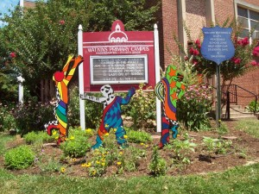
With a commitment to small class sizes along with the amenities of a large school, Watkins is a safe, challenging, and engaging learning environment for first through fifth grade students.

INSPIRING LEARNERS
Watkins develops well-rounded students who work collaboratively and recognize their role as members of a larger community. With a curriculum focused on non-fiction writing, critical thinking skills, and conceptual math, teachers emphasize the application of numeracy and literacy to real-world situations, use multiple methods to teach each skill, and encourage students to explain and discuss their approach to solving problems. Six special subjects – art, music, computer, library, guidance, and physical education – reinforce and enhance the academic curriculum.

READING AND MATH BUDDIES
Capitalizing on our Pre-K through 8th grade learning community, older students partner with younger students as Reading and Math Buddies. These relationships provide younger students with academic support and positive role models while older students gain a sense of responsibility and commitment to their community.

A POSITIVE ENVIRONMENT
Watkins employs Responsive Classroom, a research-based approach to education that encourages cooperation, empathy, responsibility, self- control, and collaborative problem solving. Daily recess is supervised by teachers on a brand-new playground complete with a nature play area and climbing wall. A new turf field, basketball courts, and roller/ice rink provides additional space for play.


FOODPRINTS, GARDENS, AND FOOD LAB
The Watkins campus is home to the largest and most beautiful schoolyard gardening DCPS, with 20 themed gardens that support lessons across the curriculum. First, third and fourth graders participate in the innovative FoodPrints classes in which garden activities such as planting, harvesting, and cooking are used to teach concepts in science, math, social studies, physical education, and writing. Watkins boasts a brand-new Food Lab thanks to the generosity of over 470 individual donors who contributed a total of $60,000 to make the dream of a teaching kitchen a reality.

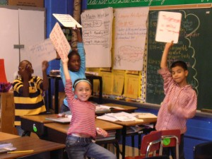
ARTS INTEGRATION IN ACTION
One example of arts integration at Watkins is the Young Playwrights Theater In-School Playwriting Program, which recently received a National Arts and Humanities Youth Program Award from First Lady Michelle Obama. Fourth-grade students explore playwriting, revision, and performance with professional playwrights, actors, directors, and teaching artists. Students learn the importance of language structure, grammar, spelling, and vocabulary choice as a means of clearly communicating their own thoughts to the world around them. During a series of standards-based, in-class workshops, students explore the mechanics of language, drama, and self-expression, culminating in the creation of their own original play.

Enrollment and Classroom Requirements

In 2014 the enrollment was as follows:

 | Current Capacity | Grade 1 | Grade 2 | Grade 3 | Grade 4 | Grade 5 | Total
Watkins ES | 587 | 88 | 105 | 92 | 121 | 93 | 499

This Plan 1 proposes a future capacity of 440 and 4 classes per grade.

Overview of Planning Concepts

Academic Cluster Concept

The Academic Cluster concept best meets the needs of the educational programs, students, and staff. The cluster concept facilitates a variety of instructional strategies and it provides a learning environment which is characterized by flexibility, a sense of community for the students and teachers, and a safe, well-supervised environment. Teachers will have the option and flexibility within a cluster to create and organize learning environments that work for students and their learning styles.

Academic areas are located in the quiet areas of the building that can be isolated during the off-hours. Noisier areas are grouped near the parking and public areas and allow for after-hours access. Diagram Intro A shows a typical design based on the cluster concept.
Diagram Intro A

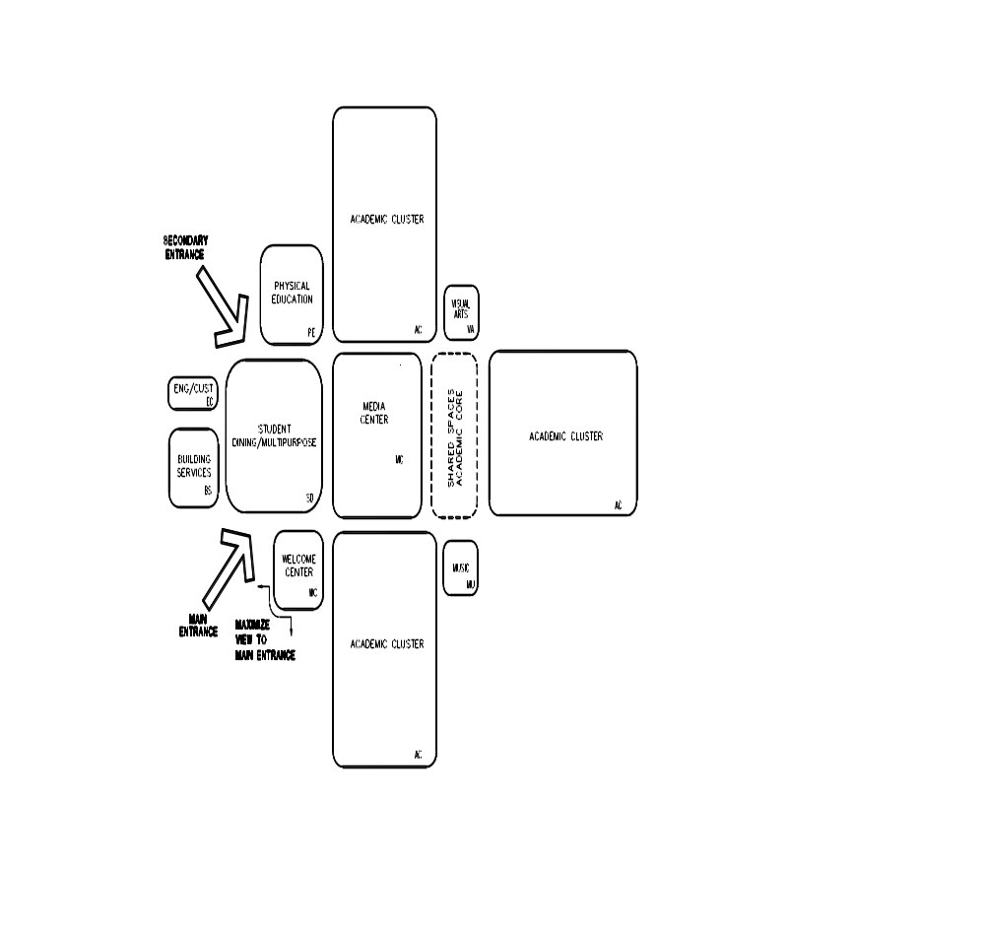

Core Instructional Spaces

The basic organizational cluster for this school should consist of general purpose classrooms, commons or extended learning space for informal instruction, a small group room, and a teacher work center. Each cluster would also contain a resource classroom used by support educators. Student restrooms should be located within the cluster commons.

Special Education

Special education facilities will be integrated throughout the school to support the concepts of inclusion and the specialized requirements for the students. Special attention will be given to accessibility of all facilities and an integrated learning program.

Instructional Methods

Watkins Elementary school is departmentalized. Teachers focus in on 2 subjects, rather than 4. For example, on a team of 4 teachers, two will teach math/science and two will teach literacy/social studies. The math/science and literacy/social studies teachers will "team teach" and students will switch teachers for half of the day. Students come to Watkins from Peabody Early Childhood Campus and then proceed to Stuart-Hobson Middle School. One principal oversees the three campuses with 2 assistant principals at Watkins running the daily operations of the building. There are also two instructional coaches, one who supports math/science and the other literacy/social studies.

Instructional methods vary with grade level, but maintain continuity from early childhood through the primary, intermediate, and middle grades. Predominant elements include:
- Integrated learning, where content areas cross disciplines
- Flexible groupings
- Mentoring of older to younger students
- Extended day learning opportunities
- Parent involvement and volunteer activities

“Welcome Area”/Administration/Student Services

The front entry lobby should be welcoming and inviting for students, staff, and visitors. Extensive display systems should be provided for 2-dimensional and 3-dimensional student work and awards. Finishes should be durable and easy to maintain. The scale of all spaces should be child-friendly. Colors, artificial lighting, and natural daylighting should be managed artfully to create an environment that communicates that school is a very special place.

Visitors should be greeted by a security counter/desk where they will sign-in and show identification. For additional security, it is preferable that the welcome center be able to see visitors coming through the front entrance as well. The primary administrative offices will be located in this centralized area at the main entrance to the school. Additional administrators may be distributed around the school at the school’s request.

Media Center

The library is the heart of the school and it should be a special place for reading, storytelling, and sharing. The current configuration - on both sides of the corridor - is difficult to manage and should be reorganize/relocated to offer a more cohesive identity. It should be spacious with room for two classes at a time. The furniture should be flexible and movable (on casters) so the room could be reconfigures as needed. Bookcases in the center of the room should be low so younger children can access books and so the sight line is clear across the room.

The media center serves a dual role – its traditional role as a gathering place for research and learning and a new role as a technological information base. In its new role, the media center may house a transparent voice/video/data network, which runs throughout the entire building. This network enables the transmission of media services to the desktops of teachers and students without physically entering the media center.

Visual Arts and Performing Arts

The art, music, and multi-purpose classrooms will be shared by all grade levels for general class and small group instruction. The location and access to these rooms should promote orderly transitions.

If possible, the music suite will be located near the performance area with convenient access to the stage.

Physical Education

The new DC Healthy Schools Act calls for 150 minutes of physical education for all children every week. At Watkins this requires 2 teachers. With up to 50 students taking PE at one time, the school needs a physical education space separate from the dining area.

To support the elementary school physical education program, a variety of indoor and outdoor areas are required. Outdoor physical education teaching areas will be located near the indoor gymnasium. Indoor play space will also be used as a performance area. Physical education facilities must be designed with a focus on community use during non-school hours, since there is a high demand for both indoor and outdoor facilities.

The current scope calls for an elementary school physical education spaces (1/2 court). Should DPR partner with this project, it is recommended that the new physical education space be a full size gymnasium and that some support spaces be provided as follows:

 | Total | Comments
Gymnasium  - Storage | 6,500  300 | With dividing wall; Jr High court with some recessed bleachers on one side
Multi-purpose room w/ kitchenette | 1,200
Administration  - Reception and lobby  - Public bathrooms 2@250  - Office  - First Aid center | 300  500  150  100 | w/ staff toilet
 | 9,050

Community Use

It is assumed that the Department of Recreation will continue to use the building for after school and summer programs and that the community will hold meetings and educational functions in the school. Security during these times is important. The architect will note both active and passive security measures.

Cafeteria

The ‘cafetorium’ will be used for student dining, performances, assemblies, and community meetings. It is proposed through creative design that this area will effectively house multiple functions. The serving areas should be efficient and accommodate students of various heights.

The architect should consider designs that would locate the dining and PE spaces adjacent with a movable wall that, when opened, would to allow for a large assemble space.

Furniture & Equipment

Classrooms vary in shape and size; therefore, the furniture should be flexible to accommodate a variety of classroom formats for both individual and group activities. Teachers and students should have storage space for personal belongings, papers, books, supplies, and teaching materials.

To the extent possible, movable furnishings will be used, rather than fixed casework, to provide flexibility for future reconfiguration.

Technology

The facility will contain the latest in technology and be wired for voice, data, and video throughout the building. The program design is intended to bring information to the desk of the student, and computer technology will be distributed in every classroom. It is intended that access to technology will be seamless and pervasive throughout the building.

Every classroom will be wired for teacher audio enhancement. Research into this cutting-edge technology suggests that student learning can improve in classrooms where the teacher’s voice is amplified and the classroom acoustics are designed to support voice clarity.

Handicapped Accessibility

The entire facility will be accessible for students, staff, and visitors. This will be accomplished through judicious use of ramping and elevators with sufficient internal clearances for circulation, convenient bus/van loading and unloading, and nearby handicapped parking spaces. All elements of the Americans with Disabilities Act must be complied with, including wayfinding and signage, appropriate use of textures, and universal accessibility of all indoor and outdoor school facilities.

Site

The site circulation will be organized for safety and efficiency. This will be accomplished through careful separation of vehicular and pedestrian traffic. The architect will evaluate the current morning and afternoon dismissal process and recommend options.

All play areas will be protected from vehicular and pedestrian traffic, so students can be assured of a safe and secure environment on the entire school site.

Environmental Performance Criteria

Scientists who study the "neuroscience of learning" are finding that certain lighting, acoustics, and spatial relationships support or hinder the learning process. The following criteria should be used when creating optimal learning and teaching environments.

Lighting Quality: Improving natural and artificial lighting in classrooms

DESIGN PARAMETERS PARAMETER NOTES

1) Controlled Natural Lighting (Glazing) 10 - 12% of floor S.F. LEED & Green Globe

2) Artificial Light 35-50 Foot-candles IES

Environmental / Air Quality: Addressing temperature control, ventilation, air filtration, carbon dioxide levels, and HVAC background noise to ensure comfortable rooms.

DESIGN PARAMETERS PARAMETER NOTES
1) Winter Temperature 68.5 to 75.5 degrees EPA 2000 & ASHRAE 55-04
Summer Temperature 74 to 80 degrees

2) Humidity 30 to 60% relative humidity EPA 2000 & ASHRAE 55-04

3) Air Changes 6-10 per hour ASHRAE

4) Outdoor Air Ventilation 10CFM per person Plus 0.12 per SF of area

5) Air Filtration MERV 13 LEED
MERV 6 to 8 ASHRAE 52.2-2007 &
62.1-2007
6) Carbon Dioxide Levels Below 700 PPM above ASHRAE 62.1-2007
outdoor air

7) HVAC Background Noise Level RC(N) Mark II level of 37 ASHRAE Handbook
Chapter 47

Acoustics: Limiting reverberation and background noise and improving sound isolation.

DESIGN PARAMETERS PARAMETER NOTES

1) Reverberation .6 per second (ANSI S12.60-2002)

2) Background Noise 45 dBA (LEED)

3) Sound Isolation (Varies) STC 45 between Classrooms

Technology: Providing data connections for online learning resources, AV equipment, closed-circuit televisions, and a sound system with emergency capabilities.

DESIGN PARAMETERS PARAMETER NOTES

1) Data / Computer Drops At Teacher and Student Computers at wireless access points

2) Audio / Video Equipment
Interactive Whiteboard
Document cameras
Sound Reinforcement Amplifier, microphone, speakers

3) Clock Synchronized with Bell system

4) Sound System & Emergency Call-box
Ceiling or Wall Speaker Class change bells, emergency announcements

5) CCTV Camera
Security, WebX conferencing, Distance Learning

Sustainability: Build for energy efficiency

DESIGN PARAMETERS PARAMETER NOTES
1) Building EUI 20% below Baseline ASHRAE 2010

2) Building Envelope Meet or exceed R-value ASHRAE 90.1 2010 standards for building type
3) Water Ultralow flow fixtures ASHRAE 90.1 2010

Safety & Security

DCPS wants to maintain an inviting environment, while simultaneously providing a safe environment for students, staff, and community who use the facility and adjacent support services. The organization of a building will have a major impact on student behavior and safety concerns. Building security can be addressed in an active or a passive manner: active security is based on security systems; passive security is based on program design, building configuration, and community participation. Schools should be based on passive concepts with applied active concepts where necessary.

1. Building Layout
- Avoid blind spots, corners, and cubby holes
- Locate administrative and teacher preparation with good visual contact of major circulation areas (i.e., corridors, cafeteria, bus drop-off, parking)
- Develop spatial relationships that naturally transition from one location to another
- Locate toilets in close proximity to classrooms
- Design toilets to balance the need for privacy with the ability to supervise
- Locate areas likely to have significant community (after school) use close to parking and where these areas can be closed off from the rest of the building

2. Types of Building Materials
- Use durable wall surfaces that are easy to clean so graffiti can be removed
- Incorporate pitched roofs which inhibit roof entry and are aesthetically pleasing
- Operational part of windows on the ground floor should be in the upper portion to prevent access.
- Install non-slip floors and walk-off mats at point of entry

3. Uses of Technology
  - Phones in every instructional and support area
  - Building-wide all-call designed to be heard throughout the school and on the play fields when needed
  - Motion or infra-red detectors, which can also conserve lighting costs
  - Video cameras that are used for instructional purposes could also be used for security purposes during non-school hours
  - Smoke and heat detectors located throughout the building

4. Vehicular and Pedestrian Traffic
- Separate bus drop-off area from other vehicular traffic
- Separate staff and community parking area
- Separate student (pedestrian) traffic flow

5. Landscaping, Play/Practice Fields, Site, and Lighting
- Use native high trees and low bushes (less than three feet high) to deter hiding
- Use aesthetically pleasing fencing around perimeter of the building
- Non-intrusive lighting of all areas (not correctional-type lighting) according to the Light Pollution Credit in LEED-Ss with no lighting to leave property line
- Provide security lighting around building and parking lots with photocell timer, motion sensor and on/off capacity

Energy and Environmental Design

There is a high interest in using the LEED certified school building as a teaching tool to teach environmental stewardship and awareness, while simultaneously providing an engaging environment for students, staff, and community who use the facility.
The organization, understanding and use of a building will have a major impact on student and staff conservation behavior.

The sustainable design and green features of the building can be addressed in an active or a passive manner: active interaction is based on digital displays, educational features and curriculum integrated learning about environmental issues; passive interaction is based on the program design, building configuration, green building features, and energy efficient building automation.

Passive Concepts

1. Building Layout
- Concentrate daylight and views to the outside to areas of frequent human interaction (e.g. classrooms, cafeterias, media center, art rooms, music rooms) with passive solar design
- Avoid skylights and use roof monitors with vertical glazing instead

2. Types of Building Materials
- Use durable wall surfaces that are easy to clean
- Design for cleanability with easy and safe access
- Incorporate light colored pitched roofs to prevent heat gain and leakage
- Install high performance walk-off mats at all points of entry
- Design with noise minimization in mind

3. Uses of Technology
- For instructional and administrative purposes, the new school should have extensive technology systems. These same infrastructures and technology components can be used to enhance the perception of the buildings environmental components.
- Digital display of buildings energy and water use at entrance and in cafeteria
- Website with environmental features of the school
- Use only vacancy sensors for classrooms, cafeteria etc. to turn off (not on) lighting
- Daylight sensors and dimming in larger areas (cafeteria, multi-purpose etc.)

4. Vehicular and Pedestrian Traffic
  - Provide sufficient, covered and secures bicycle storage
  - Provide bicycle lanes to building from all major access directions

5. Landscaping, Play/Practice Fields, Site, and Lighting
  - Use native high trees and low bushes and ground covers and locate to provide shade to the building
  - Non-intrusive lighting of all areas (not correctional-type lighting) according to the Light Pollution Credit in LEED-S with no lighting to leave property line

6. Green Curriculum
- Provide outdoor classroom
- Design interior with sense of buildings orientation to North – East – South - West

Active Concepts

1. Building Layout
- Provide signage to educate users about interior and exterior green building features throughout
- Provide signage for user behavior modification, e.g. DCPS policy for thermostat settings, reminders to turn equipment off when not in use
- Provide visitor map with floor plan for location and explanation of green building features

2. Types of Building Materials
- Provide view window to inside of wall constructions and mechanical room
- Provide materials with environmental massage in selective areas, e.g. 100% recycled post-consumer plastic toilet compartments, wheatboard cabinets, or furniture made of wood harvested from school site, and explain with signage.

3. Uses of Technology
- For instructional and administrative purposes, the new school should have extensive technology systems. These same infrastructures and technology components can be used to enhance the perception of the buildings environmental components.
- Green morning announcement with update on energy and water use
- Student conducted energy audits
- School based resource conservation program with frequent feedback to users

4. Vehicular and Pedestrian Traffic
- Provide preferred parking for DCPS Green Fleet (for carpooling and fuel efficient vehicles)

5. Landscaping, Play/Practice Fields, Site, and Lighting
- Design for no-mow areas
- Design for student garden
- Provide solar or wind powered, off the grid site lighting as demonstration model for select areas

6. Green Curriculum
- LEED credit Schools as a Teaching Tool requires 10 hours of instruction per student, grade and school year on environmental issues related to the school building. The school buildings design should support this requirement wherever possible.

Design Guidelines for Outdoor Classrooms and School Gardens

This section provides guidance on the design of outdoor classrooms (the structure where students gather to learn) and the school garden (the larger area encompassing the outdoor classroom). Outdoor classrooms complement and expand school garden sites by providing a gathering area for teaching, but they are also multi-use spaces that serve as classrooms that support standards-based learning across subject areas.

Expected Site Elements:
- Planting beds
- Organic soil (60% top soil/ 40% compost)
- Mulch (shredded hardwood or straw)
- Hose bib with hose rack (with two spigots- one for hose and one for irrigation, exterior and easily accessible placed within the garden if new construction)
- Plants (a variety of edible and non-edible species)
- Shade tree(s), trellises or awnings.
- Seating (may be moveable)
- Worktables (may be moveable)
- Pathways (around planting beds, through pollinator garden, etc.).
- Tool shed (large storage bench/box that is weatherized and secure no further than 100ft from gardening area. Storage immediately available inside the school may supplement outdoor storage space).
- Signage
- Fencing (height and type depending on local context)
- Access for large vehicles/supplies
- All-weather electrical outlet
- Drip Irrigation (for gardens larger than 200 square feet)

Potential Site Elements:
- Composting area
- Pollinator garden with paths to invite investigation
- Wildlife habitat area with paths to invite investigation
- Drip Irrigation (for gardens smaller than 200 square feet)
- Rain garden
- Outdoor kitchen
- Digging bed (for younger students)
- Hand washing station
- Outdoor science lab
- Arboretum
- Greenhouse/ hoop house
- Interactive learning stations
- Community garden plots
- Wi-Fi access
- Beehive
- Chicken coop
- Pond
- Mounding

Siting: The school garden should be clearly defined and located with the possibility of expanding activities in the future. The space should be inviting and encourage classroom use any time the weather is at all agreeable, including during a warm snap in winter. Capitalize on site features available by deliberately connecting to an existing stream or using a large shade tree for the gathering area or linking pathways to a natural habitat area. Ensure that enthusiasm for the garden does not overwhelm space that students require for active play and athletic activities.

The outdoor classroom should be located within the school garden in a well-used and highly visible part of the school grounds that is easily accessible for students and teachers. Consider environmental factors, including noise, fumes from passing vehicles, sunlight, and slope; it should articulate with existing or planned natural wildlife habitat areas. If there are plans to expand or re-build the school in the foreseeable future, try to ensure the outdoor classroom and school garden is in a place that will remain undisturbed.

Solar aspect/shade: The school garden plots should receive 6-8 hours of direct sunshine a day. However, the outdoor classroom must be shaded either naturally with trees or trellises or with awnings, umbrellas or canopies. Student seating should not face south.

Accessibility: Walkways should be well defined, and accessible to students including those with disabilities. Refer to the current ADA standards for minimum design requirements. Remember to apply these standards as well to other program spaces associated with the outdoor classroom. Garden beds should be no wider than 4 feet for middle school and high school students and 3 feet for elementary school and early childhood students. Consider having at least one raised bed accessible to students in wheelchairs. The school garden and the outdoor classroom will need large enough work areas so that all students can easily pass through. The tool shed/box should including shelving, and storage options for both adult and children tools and located in a central area possibly near the outdoor classroom.

Visibility/Safety: There should be clearly defined perimeters for the outdoor classroom and garden areas; a fence may be preferable, with clear lines of sight throughout avoiding potential hiding spaces. If possible, the outdoor classroom should also be visible from points within the school (windows in nearby classrooms, administrative spaces).

Materials: The outdoor classroom should be built with natural materials. If water is being collected from the roof of the outdoor classroom the roofing material must be non-toxic and non-leaching. Strictly limit use of concrete to high traffic areas; if hardscape is required, permeable paving or local stone (that is too heavy to throw) is encouraged. Note that high-grade engineered wood fiber playground surfacing is certified for wheelchair use. Raised beds should be built of a minimum of 2-inch thick wood or non-toxic manufactured wood, not permanent masonry and filled with organic soil/ compost at a 60/40 ratio. Soil should be filled to 4 inches below top of garden bed and 2 inches of organic mulch (shredded hardwood or straw) is placed on top of the soil. Pressure treated wood, plywood, plastic lumber with wood fibers, tires are strongly discouraged as these products contain toxins that leach into water at dangerous levels. Because teachers need to re-design garden plot locations from time to time as program needs change, garden plots must be re-locatable. Avoid weed cloth as it has little impact on suppressing weeds in the long term and creates maintenance issues.

Outdoor Classroom: The outdoor classroom must be a well-defined shaded space that includes student workstations where teachers can easily engage with each student. An outdoor whiteboard is desirable (flipchart stands stored inside could substitute) and must be situated so that all students can easily read it. Seating can be either fixed or flexible, depending on the site, but should easily accommodate up to 35 students. A teacher demonstration table and student workspaces should be available. If not permanently on site, as with picnic tables, these should be easily portable and on-hand in a storage shed or nearby in the school. The outdoor classroom area may be near a kitchen and/ or science lab.

Plants: Perennial plant material should be chosen based on each specific site condition and with interest in all four seasons. Preference should be given to a variety of native plant species. The visual unity of the site is less important than the educational value of a broad range of different plants that can be used as teaching examples and that are sustainable in terms of biodiversity and susceptibility to extreme weather, insects and disease. Take care to avoid poisonous plants.

Signage: Educational signage must be placed throughout the garden. Signage must be age-appropriate and student-centered. Consider writing signs in multiple languages. Signs should identify elements as well as describe various processes and systems such as:
- Entrance sign with space for posting announcements (highest priority)
- Garden Rules and Procedures
- Native and edible plantings
- Composting systems
- Pollination
- Storm water management
- Soil composition
- Nutrition
- Beneficial Insects
- “Do Not Mow” for in-ground beds near lawns.

Maintenance: The outdoor classroom should be designed for low maintenance with a specific maintenance plan written for each outdoor classroom and garden area. A maintenance agreement must be signed by the principal, and the school garden coordinator. Planting beds, pollinator garden areas and habitat areas must be very clearly differentiated from lawn areas that require mowing in order to avoid having native plants mistaken for weeds and mowed. Ensure that the irrigation system (if applicable) is simple enough so that the school community can maintain it. Hose bib should be given to the school garden coordinator, building engineer, and principal (three keys total).

Approval: Plans, details and specifications should be submitted to the School Garden Specialist at the Office of the State Superintendent of Education for approval.

DCPS Recycles!
All DCPS schools are required to participate in the recycling program provided by DGS. All modernization projects must be designed to be consistent with the standardized supplies and services described at http://dgs.dc.gov/page/healthy-schools, with the expectation that in the near term future all schools will recycle and compost under this program.
Since each school is different, the DGS recycling program should be consulted regarding the following design considerations. In general, every modernization project is expected to provide
- Adequate, accessible space for pick-up of all serviced containers, usually to include (1) 8 cu yd dumpster OR compactor for paper and cardboard; (2-4) 96 gallon toters for glass/plastic/metals, and (3-10) 36 gallon toters for compostable waste; that is accessible to both front-end loaded and rear-end loaded trucks and allows custodian to easily transport toters to be picked up at ground level. The best configuration of containers will depend on the specifics of the hauling contract, the occupancy of the building and space restrictions. Compactors are not usually recommended for buildings with occupancy less than 500. The dimensions of a standard 8 cu yd side loaded dumpster are 71”x 80”x76” (length x width x height).

- Secure space for storing serviced containers and collection bins with easy access for custodian to roll bins to/from pick up location, and distributed as necessary to facilitate flow of materials throughout the building to the pick-up location.

- Cafeteria and kitchen layout and millwork that supports a logical flow of materials including emptying liquids, sorting waste into three categories (landfill, recycling, compost), and tray return, while avoiding congestion; includes space for changeable signage and labels; is consistent with compost and recycling supplies provided by DGS for cafeterias (accommodates 32-gallon Brute-style bins with wheels); allows for easy access for cleaning by custodians (bottom of the sorting station is the floor); and has countertop holes that accommodate easy dumping of waste using both compostable and reusable trays.
The DGS recycling program provides a standardized set of recycling supplies at no cost to each school, the number and type of bins to be determined according to building characteristics supplied by the project team.
Project teams should also consult with the recycling program regarding providing large, highly visible sorting stations with signage in select high traffic common areas (not in hallways, and not built into the wall); as well as regarding the type and placement of wastebaskets.
Proposed Capacity
Room Use
Grade | Number of | Capacity | Total
 | Classrooms | (Program)
1st Grade | 4 | 22 | 88
2nd Grade | 4 | 22 | 88
3rd Grade | 4 | 22 | 88
4th Grade | 4 | 22 | 88
5th Grade | 4 | 22 | 88
Total | 21 |  | 440

Building Space Summary

Space Summary | Phase 1 | Phase 2
 | Total
Core Academic/Special Education Areas | 24,450
Media Center | 3,650
Arts and electives | 5,050
Physical Education | 0 | 5,350
Administration | 3,380
Student Dining & Food Service | As is | 4,500
Maintenance & Custodial Services | As is | 1,220
Mechanical, Electrical, Toilets, Custodial Closets | 17,559
Total Net | 54,389 | 11,070
Construction Factor[.08] | 4,459 | 908
Total Gross | 58,848 | 11,978

Outdoor Area Requirements Summary

Exterior Spaces
Structured Play Area For Primary/Intermediate Grades
Outdoor Paved Play Area
Outdoor Classroom
Green area for garden/environmental programs
Multi-purpose field (shared with DPR)
Faculty, Staff, and Visitor Parking (25-40 spaces)

Core Academic Area Space Requirements
Spaces | Suggested |  |  | Comments
 | Quantity | S.F.* | Total
Grade 1 Classroom | 4 | 900 | 3,600
Grade 2 Classroom | 4 | 900 | 3,600
Grade 3 Classroom | 4 | 900 | 3,600
Grade 4 Classroom | 4 | 900 | 3,600
Grade 5 Classroom | 4 | 900 | 3,600
Grade level commons | 2-3 | varies | 1,800 | Part of cluster circulation
World Language Classroom | 1 | 900 | 900
Resource Classroom (Sped) | 2 | 350 | 700
Resource Classrooms (Acad.) | 2 | 400 | 800 | Classroom with a dividing wall
Offices | 3 | 100 | 300
Inst Coaches | 2 | 150 | 300 | May be one room
Speech Room/OT/PT | 1 | 250 | 250
Special education Suite  - Office  - Conference rm. | 1  1 | 150  200 | 350
Book Storage  - Laptop storage | 1  3 | 400  50 | 550
Workroom/Teacher Dining | 2 | 250 | 500
Total |  |  | 24,450

Tolerances of + or – 5-15% are acceptable as is the combination of spaces within a suite. Adjacencies as specified are desirable, but options may be considered and should be reviewed with the planning team.

GRADES 1-5 CLASSROOM E-ACA-2
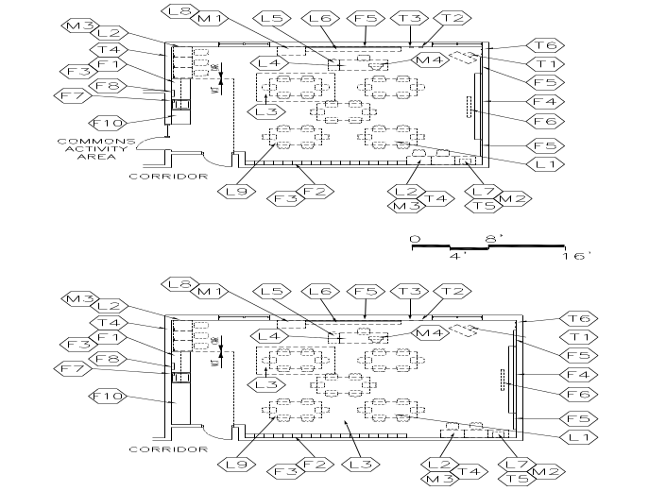  SIZE:  - 900 SF  CAPACITY:  - 22-25 students  - 1 teacher  - Staff members  - Guest speakers/volunteers | GOAL:  - A flexible space to accommodate any of the core academic disciplines  PROGRAM ACTIVITIES:  - Large group instruction  - Small group instruction and group work  - Classroom work/lectures  - Computer instruction  - Team teaching  - Oral presentations  - Group and teamwork activities  - Testing  SPATIAL RELATIONSHIPS:  - Group classrooms for potential teaming  - Consider options for locating cubbies between teamed classrooms  - Locate coat cubbies near door  ENVIRONMENTAL CONSIDERATIONS:  - Uniform lighting  - Windows to provide natural light and egress  - Environmental sound control:  Wall minimum: STC 45  Ceiling minimum: CAC 35  Reverberation Time: .4-.6 seconds  - Electrical outlets for equipment  - Adequate ventilation  - Proportion classroom for effective viewing and listening from all areas of the classroom  - Window treatment to darken room for AV presentations

NOTES:
1. Lose furnishings and features shown represent one of many possible arrangements.
2. Storage closets should be combined with adjacent Teacher Office/Workroom
3. Classroom layouts should be opposite hand allowing sinks to be back to back.
GRADES 1-5 CLASSROOM E-ACA-2
Spec.  Finishes¹: Ref.#  Flooring:  Rubber tile flooring 096519  Base:  Resilient base 096519  Ceiling (9’ high minimum):  Suspended, acoustical 095113  Walls:  Painted concrete masonry units  042000/099123  One tackable wall surface 101100  Loose Furnishings:  L1 6 tables or 24 student desks (see Furniture Standards)  One kidney/horseshoe table  L2 2 computer workstations and 2 chairs – student use (swivel or alternative)  L3 Bound carpet rug large enough to seat 24 students  L4 Teacher workstation with mobile storage and 2 chairs  L5 Four drawer file cabinet or lateral file  L9 27 student chairs  Communications: Div. 27  Single point ‘face plate’ near teachers work station to include:  Voice, data, VGA , audio enhancement, and HDMI 17160  Additional ports:  Printer  Cable/MATV port  3-5 data ports for student use  Electronic white board  Clock/PA  2 wireless  Electronic Safety and Security: Div. 28  Life safety devices per code | Spec.  Features¹: Ref.#  Fixed Equipment:  F1 Casework: 123200  Base/wall cabinets by sink  F2 Casework: Student cubbies (28)  F3 Casework:  Wall shelving over cubbies  F4 Marker board (2 walls) 101100  16 LF primary/8 LF secondary  F5 Tack board flanking marker boards 101100  Plus two (2) parallel rows of continuous tack strips on all available walls (4 LF or longer) at 30” and 48” AFF  F6 Manual projection screen (60”X60”)115213²  F7 Soap dispenser 102800  F8 Towel dispenser 102800  F9 Casework:  Wardrobe (18”X18”) 12320  Tall storage cabinet with poster sized door  Plumbing: Div. 22  Sink with drinking fountain  Plumbing connections  HVAC: Div. 23  Supply/return air system  Independent temperature control  Electrical: Div. 26  Duplex receptacles  3 per primary teaching wall  2 per other walls  TVSS protected quad receptacle  adjacent to each data and  video port  Multilevel switching  Fluorescent lighting  Illumination level: See Table 7600-16  Clock  Central sound system  Miscellaneous: Div. 27  M1 Projection device on cart or interactive board  M3 2 computers for student use (supplement with mobile computing devises)  M4 Computer for teacher use  Audio enhancement equipment
NOTES:
- Finishes/Features: Refer to Chapter 8 for specification references.
- Delete where a digital white board is installed.

RESOURCE CLASSROOM (Special education) E-ACA-4
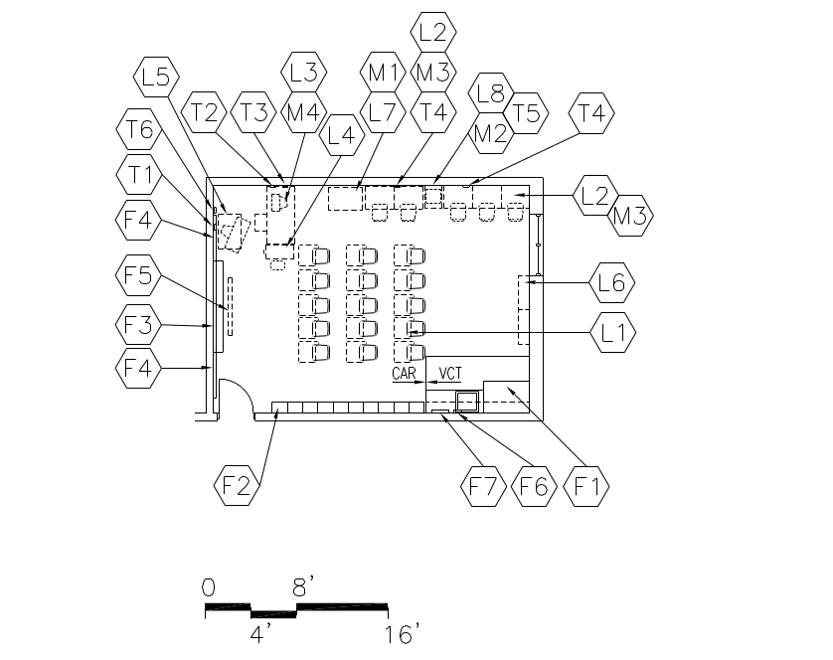  CAPACITY:  - Up to 10 students  - 2 or more staff members  SIZE:  - Varies, see table  ANCILLARY SPACES:  N/A | GOAL:  - To provide a safe and comfortable learning environment for students with unique learning challenges  PROGRAM ACTIVITIES:  - Small group work  - Independent instruction and work  SPATIAL RELATIONSHIPS:  - Located within Academic Core areas  - Near Storage  - Ingress/egress to the building which allows for special transportation pick-ups  ENVIRONMENTAL CONSIDERATIONS:  - Uniform lighting  - Windows to provide natural light and egress  - Environmental sound control:  Wall minimum: STC 45  Ceiling minimum: CAC 35  Reverberation Time: .4-.6 seconds  - Electrical outlets for equipment  - Proportion classroom for effective viewing and listening from all areas of the classroom  - Window treatment to darken room for AV  presentation

NOTES:
- Loose furnishings and features shown represent one of many possible arrangements.
- Orientation of Resource Classroom shall be determined as a result of layout of adjacent classrooms
- Sink shall be located with close proximity to corridor.
RESOURCE CLASSROOM E-ACA-4
Spec.  Finishes¹: Ref.#  Flooring:  Rubber tile 096519  Base:  Resilient base 096519  Ceiling (9’ high minimum):  Suspended, acoustical 095113  Walls:  Painted concrete masonry units or dry wall  042000/099123  Loose Furnishings:  L1 3 student tables with 9 chairs  L2 2 computer workstations and chairs  L3 Teacher workstation and chair  L4 Four-drawer file cabinet or lateral file  L6 Adjustable height bookshelves (20 LF)  Communications: Div. 27  Single point ‘face plate’ near teachers work station to include:  Voice, data, VGA , audio enhancement, and HDMI 17160  Additional ports:  Printer  2-3 data ports for student use  Electronic white board  Clock/PA  1 wireless  Miscellaneous:  M1 Projection device on cart or  Interactive board/table (hung at student height in primary rooms)  M3 2 computers for student use (supplement with mobile computing devises)  M4 Computer for teacher use | Spec.  Features¹: Ref.#  Fixed Equipment:  F3 Marker board (8 LF) 101100  F4 Tack board (8 LF minimum) 101100  F5 Manual projection screen 115213  F8 Casework:  Wardrobe 123200  Tall cabinet (optional)  Fire Suppression: Div. 21  Fire suppression system  Plumbing: Div. 22  none  HVAC: Div. 23  Supply/return air system  Independent temperature  Control  Electrical: Div. 26  Duplex receptacles  3 per primary teaching wall  2 per other walls  TVSS protected quad receptacle  adjacent to each data and  video port  Fluorescent lighting  Illumination level: See Table 7600-16  Multilevel switching 16140  Clock  Central sound system  Electronic Safety and Security: Div. 28  Life safety devices per code

NOTES:
- Finishes/Features: Refer to Chapter 8 for specification references.
RESOURCE CLASSROOM (Other)
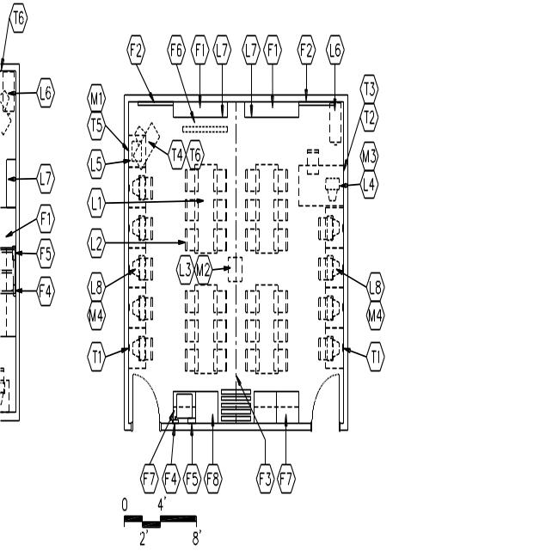  CAPACITY:  - Up to 20 students  - Teacher (s)  - Guest speakers  SIZE:  - 400 SF/each side  ANCILLARY SPACES:  N/A | GOAL:  - To provide a flexible space as a resource area for interdisciplinary activities  PROGRAM ACTIVITIES:  - Large and small group instruction and hands-on activities  - Computerized instruction  - Team teaching  - Oral presentations and plays  SPATIAL RELATIONSHIPS:  - Located centrally  - Near Workroom  - Near Media Center  - Moveable wall between sides  ENVIRONMENTAL CONSIDERATIONS:  - Uniform lighting  - Environmental sound control:  Wall minimum: STC 45  Ceiling minimum: CAC 35  Reverberation Time: .4-.6 seconds  - Electrical outlets for equipment  - Comfortable rooms with pleasant décor  - Proportion classroom for effective viewing and listening from all areas of the classroom  - Windows to provide natural light and egress, desirable; provide treatment to darken if windows are provided

NOTES:

1. Loose furnishings and features shown represent one of many possible arrangements.
RESOURCE CLASSROOM
Spec.  Finishes¹: Ref.#  Flooring:  Resilient tile flooring 096519  Base:  Resilient base 096519  Ceiling: (9’ high minimum)  Suspended, acoustical 095113  Walls:  Painted concrete masonry units or dry wall  042000 / 099123  Loose Furnishings:  L1 4 rectangular tables  L2 24 chairs  L4 Teacher workstation and chair  L5 Printer table  L6 Four-drawer file cabinet  L7 Adjustable height bookshelves (24 LF)  L8 6-10 computer workstations  Communications: Div. 27  T1 10 data ports for student  use (5 each side)  T2 Voice port and phone  T3 Data port near teacher workstation  T4 Video port, monitor, VCR/DVD,  and brackets  T5 Data port for printer  Miscellaneous:  M1 Printer  M2 Projection device on cart Div. 27  M3 Computer for teacher use  M4 6-10 computers for student use | Spec.  Features¹: Ref.#  Fixed Equipment:  F1 Marker boards (8LF each side) 101100  F2 Tack boards (4 LF each side) 101100  F3 Operable partition, manual 102226  F4 Soap dispenser 102800  F5 Towel dispenser 102800  F6 Manual projection screen 115213  F7 Casework: 123200  Base/wall cabinets and shelving  F8 Casework:  Wardrobe 123200  Fire Suppression: Div. 21  Fire suppression system  Plumbing: Div. 22  Plumbing connections  HVAC: Div. 23  Supply/return air system  Independent temperature  control  Electrical: Div. 26  Duplex receptacles  3 per primary teaching wall  2 per other walls  TVSS protected quad receptacle  adjacent to each data and  video port  Multi-level switching  Fluorescent lighting  Illumination level: See Table 7600-16  Central sound system  Electronic Safety and Security: Div. 28  Life safety devices per code

NOTES:

- Finishes/Features: Refer to Chapter 8 for specification references.
COMMONS ACTIVITY AREAS E-ACA-3
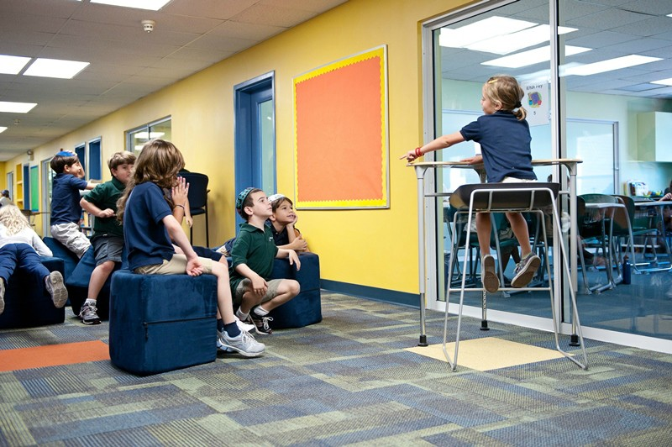  CAPACITY:  - 4-25 students  - 1-2 teachers  SIZE:  - 600-800 SF  ANCILLARY SPACES:  - Grades 1-5 Classroom | GOAL:  - To provide flexible, shared learning support space for various group sizes and activities  PROGRAM ACTIVITIES:  - Small group learning centers  - Story telling  - Team activities  - Individual activities  SPATIAL RELATIONSHIPS:  - Located within classroom clusters  ENVIRONMENTAL CONSIDERATIONS:  - Uniform lighting  - Environmental sound control:  Wall minimum: STC 40  Ceiling minimum: CAC 35  - Coordinate commons finishes and loose furnishings with corridors  - Coordinate plumbing/HVAC/ electrical/technology needs with building’s overall technology plan  - Provide borrowed light for visual supervision from adjacent areas

NOTES:
1. Loose furnishings and features shown represent one of many possible arrangements.
2. Optional window wall(s) at corridor(s) at 3’-4” A.F.F. to accommodate base cabinets and computer carts at side walls.
COMMONS ACTIVITY AREAS
Spec.  Finishes¹: Ref.#  Flooring:  Rubber 096516  Base:  Resilient base 096519  Ceiling:  Suspended, acoustical 095113  Walls:  Painted concrete masonry units or dry wall  042000/099123  One tackable wall surface 101100  Loose Furnishings:  TBD | Spec.  Features¹: Ref.#  Fixed Equipment:  F2 Marker board (8 LF) 101100  F3 Tack board (8 LF) 101100  F4 Manual projection screen 115213  Fire Suppression: Div. 21  Fire suppression system  Plumbing: Div. 22  None  HVAC: Div. 23  Supply/return air system  Electrical: Div. 26  Multilevel switching  Duplex receptacles  TVSS protected quad receptacle  adjacent to each data and  video port  Fluorescent lighting  Illumination level: See Table 7600-16  Clock  Central sound system  Communications: Div. 27  T1 Wireless port  Electronic Safety and Security: Div. 28  Life safety devices per code

NOTES:

Finishes/Features: Refer to Chapter 8 for specification references.
ALL OFFICES M-AC-10
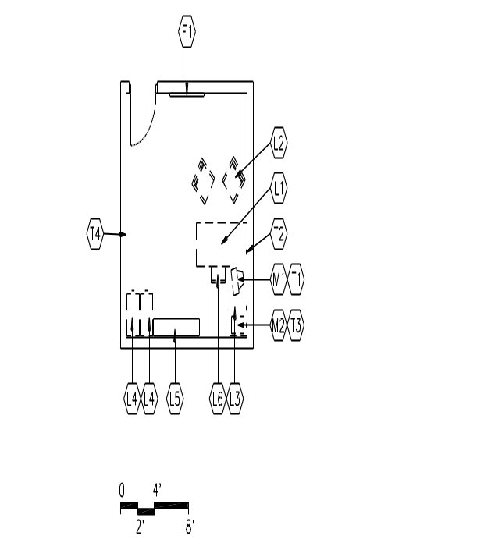  CAPACITY:  - Counselors  - Students and parents  - Staff  - ESL instructors  - Psychologists  - Social workers  SIZE:  - 80-150 SF  GOAL:  - To provide counseling and other student support services that are easily accessible to students, parents, staff, and the community  PROGRAM ACTIVITIES:  - Counseling for parents and students  - Administrative paperwork  - Environment and orientation of new students  - Office space for itinerant staff | GOAL:  - To provide counseling and other student support services that are easily accessible to students, parents, staff, and the community  PROGRAM ACTIVITIES:  - Counseling for parents and students  - Administrative paperwork  - Environment and orientation of new students  - Office space for itinerant staff  SPATIAL RELATIONSHIP:  - Within Academic Core areas  ENVIRONMENTAL CONSIDERATIONS:  - Uniform lighting  - Environmental sound control:  Wall minimum: STC 45  Ceiling minimum: CAC 35  - Windows to provide natural light, desirable  - Auditory privacy  Finishes¹: Ref.#  Flooring:  Rubber tile 096516  Base:  Resilient base 096519  Ceiling:  Suspended, acoustical 095113  Walls:  Painted gypsum wallboard  over metal studs 092116/ 099123  Loose Furnishings:  L1 Desk and chair  L2 Visitor chairs  L3 Small table (optional)  L4 Four-drawer file cabinet  L5 Adjustable height bookshelves (12 LF)
SPEECH ROOM (other small group rooms) E-ACA-6
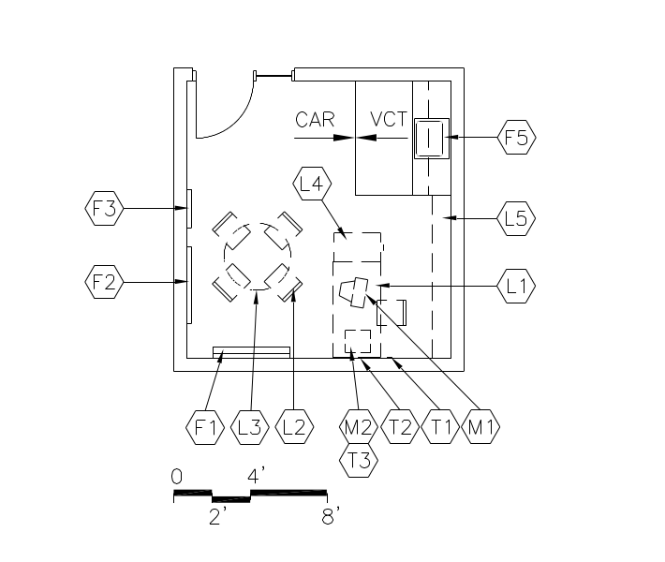  CAPACITY:  - 1-3 students  - 1-2 staff  SIZE:  - 200 SF  GOAL:  - To provide private training for students  PROGRAM ACTIVITIES:  - Group and individual practice  - Student assessment  SPATIAL RELATIONSHIPS:  - Near Academic Core areas  - Near Special Needs Classroom | GOAL:  - To provide private training for students  PROGRAM ACTIVITIES:  - Group and individual practice  - Student assessment  SPATIAL RELATIONSHIPS:  - Near Academic Core areas  - Near Special Needs Classroom  ENVIRONMENTAL CONSIDERATIONS:  - Uniform lighting  - Environmental sound control:  Wall minimum: STC 45  Ceiling minimum: CAC 35  Finishes¹: Ref.#  Flooring: Carpet 096816  Base: Resilient base 096519  Ceiling:  Suspended, acoustical 095113  Walls:  Painted gypsum wallboard  over metal studs 092116/ 099123  Loose Furnishings:  L1 Desk and chair  L2 Visitor chairs  L3 Small table  L4 Four-drawer file cabinet  L5 Adjustable height bookshelves (12 LF)  Wastebasket  Spec.  Features¹: Ref.#  Fixed Equipment:  F1 Marker board (4 LF) 101100  F2 Tack board (4 LF) 101100  F3 24” x 60” Mirror 088000  F4 Casework:  Base/wall cabinet 123200  F5 Soap dispenser 102800  F6 Towel dispenser 102800

WORKROOM/TEACHER COLLABORATION E-ACA-12
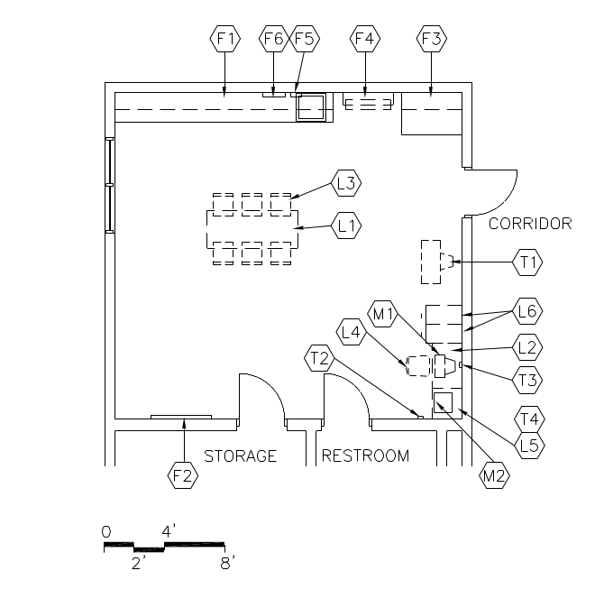  CAPACITY:  - Teachers  - Teachers' assistants  - Volunteers  ANCILLARY SPACES:  - Staff Restroom  - Storage  GOALS:  - To provide a space where adults can meet for committee work  - To provide a space where teachers can perform administrative work  - To provide a space for storage of grade-level materials  PROGRAM ACTIVITIES:  - Team staff meetings  - Lesson planning and grading  - Scheduling appointments  - Record keeping  - Develop and review teacher materials  Miscellaneous:  M2 Networked Printer (all classrooms will print to a workroom location)  Photocopy machine | SPATIAL RELATIONSHIPS:  - Near Academic Core classrooms  - This area should be divided among the different floor levels  - Access to Staff Restroom(s) from within Workroom/Teacher Office  ENVIRONMENTAL CONSIDERATIONS:  - Uniform lighting  - Environmental sound control:  Wall minimum: STC 45  Ceiling minimum: CAC 35  - Adequate ventilation  - Electrical outlets for equipment  - Window to provide natural light, desirable  Finishes¹: Ref.#  Flooring: Rubber tile flooring 096519  Base: Resilient base 096519  Ceiling:  Suspended, acoustical 095113  Walls:  Painted concrete masonry units  042000/099123  Loose Furnishings:  L1 2 Tables  L2 Computer workstation furniture  L3 8 task chairs  L5 Printer table  Communications: Div. 27  T1 Video port, monitor, and brackets  T2 Voice port and phone  T3 Data port near workstation  T4 Data port at printer  Spec.  Features¹: Ref.#  Fixed Equipment:  F1 Casework: 123200  Base cabinets (w/sink)  Wall cabinets/shelving  F2 Tack board (4 LF) 101100  F3 Casework: 123200  Deep storage for poster board  F4 Towel dispenser 102800  F5 Soap dispenser 102800

MEDIA CENTER

Spaces | Qty. | S.F. | Total | Comments
Reading/Learning/Circulation | 1 | 1,800 | 1,800
Computer Project Lab | 1 | 900 | 900 | Laptop lab with movable wall into reading room (flexible seating for 25 – see staff for layout)
Media Production | 1 | 400 | 400
Office/Workroom | 1 | 250 | 250
Storage | 1 | 200 | 200
Telecom Head End Room | 1 | 100 | 100
Total |  |  | 3,650

Comments: Spaces within the Media suite may vary up to 15% and may be combined to facilitate circulation and supervision. The overall square footage may be + or – 15%.
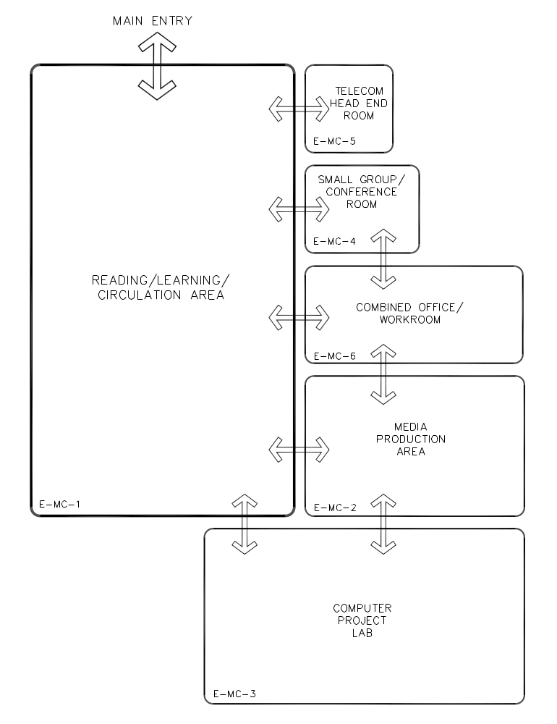

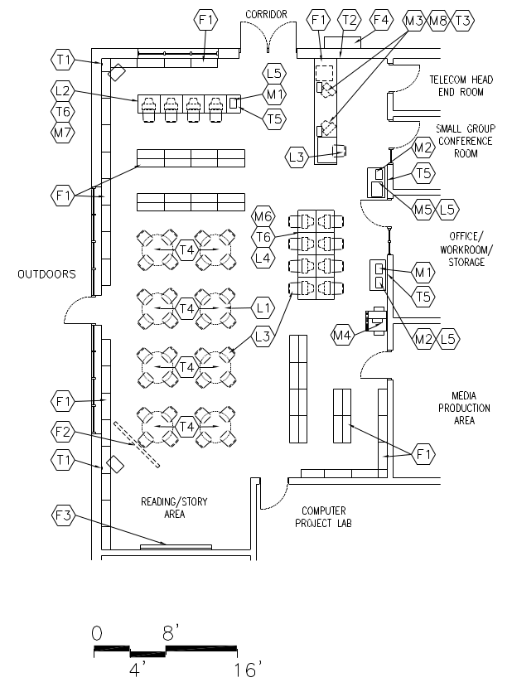
READING / LEARNING / CIRCULATION AREA E-MC-1
CAPACITY:  - 50 students  - 2 teachers  - 1 media specialist  - Community patrons after school hours  GOAL:  - To provide students, staff and community  with access to information and quiet study areas  - To provide a place for on-line testing  PROGRAM ACTIVITIES:  - Independent Reading  - Circulation of materials and resources including online catalogs  - Large group and small group instruction  - Provide meeting areas  - Research  - Dramatic reading and storytelling | SPATIAL RELATIONSHIPS:  - Three activity areas:  - Storytelling area (steps or sunken area if feasible)  - Interactive and small group areas with interactive board  - Relaxed reading area with comfortable seating options  - Information desk with book drop-off located close to entrance and near office/workroom  - Locate standing card catalog station next to information desk  - Good sight lines to all ancillary spaces  - Permanent stacks on the periphery with some short shelving to divide activity areas  - Mobility for all free standing furniture including book shelves  ENVIRONMENTAL CONSIDERATIONS:  - Recessed floor (data and duplex) outlets in floor at tables  - Adequate ventilation  - Lighting appropriate to task with switches to dim separate zones of Media Center  - Environmental sound control:  Wall minimum: STC 45  Ceiling minimum: CAC 35  - Electrical outlets at entrance for future security system  - Electrical outlets at all column locations  - Widows to provide natural light  - Security of school when center is in use after school hours  - Ceiling height in proportion to room dimensions  - Open flow for traffic in reference/professional/periodical areas  - Electrical outlets in toe space of wall shelving  - Window treatment to darken room for AV presentation
NOTES:
1. Loose furnishings and features shown represent one of many possible arrangements.
2. Freestanding book stacks shall be 42” high. Book stacks against the wall may be 60” to 84” high. Coordinate with other equipment and windows.
READING / LEARNING / CIRCULATION AREA E-MC-1
Spec.  Finishes¹: Ref.#  Flooring:  Carpet 096816  Base:  Resilient base 096519  Ceiling:  Suspended, acoustical 095113  Walls:  Painted concrete masonry units  042000 / 099123  Loose Furnishings:  L1 8, four-person tables (different heights)  L2 Automated card catalog stations  L3 42 chairs (different heights)  L4 10 research stations  L5 Printer table  Soft seating for 8  Low book shelving on casters  Miscellaneous:  M1 Black and white printer  M3 Bar code reader  M4 Photocopy machine  M5 Digital scanner  M6 10 computers for student use  M7 2 computers for reference  M8 Computer for staff use | Spec.  Features¹: Ref.#  Fixed Equipment:  F1 Library casework (see furniture standards) for 1,000 linear ft. per 15,000 vol.  F2 Motorized projection screen 115213  F3 Marker board (8 LF) 101100  F4 Display cases 123559  Fire Suppression: Div. 21  Fire suppression system  Plumbing:  N/A  HVAC: Div. 23  Supply/return air system  Independent temperature control  Electrical: Div. 26  Duplex receptacles  TVSS protected quad receptacle  adjacent to each data and  video port  Single-level switching  Fluorescent lighting  Illumination level: See Table 7600-16  Means of egress lighting per code  Central sound system  Floor boxes (electrical/data) throughout  reading room for flexible loose  furnishings layout  Communications: Div. 27  T1 Video port  T2 Voice port and phone  T3 2 data ports at circulation desk  T4 10 data ports for student use  T5 Data ports for printer  T6 Data port for automated data card cat  Cable/MATV port  Electronic Safety and Security: Div. 28  Life safety devices per code
NOTES:

- Finishes/Features: Refer to Chapter 8 for specification references.
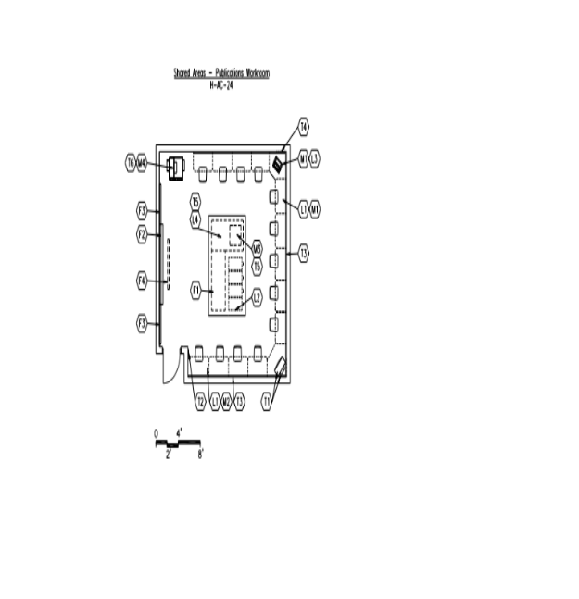MEDIA PRODUCTION
CAPACITY:  - 10 students  - Staff  GOALS:  - To provide flexible space as a resource area for newspaper production and special projects  - To provide a central location for one-of-a-kind production equipment  PROGRAM ACTIVITIES:  - Writing and developing layouts using computer technology  - Printing  - Proofreading  - Copying  - Scanning  - Editing and layout | SPATIAL RELATIONSHIPS:  - Located in Media Center suite  ENVIRONMENTAL CONSIDERATIONS:  - Uniform lighting with an appropriate task level lighting  - Environmental sound control:  Wall minimum: STC 45  Ceiling minimum: CAC 35  - Adequate ventilation  Fixed Equipment:  F1 Casework: Base cabinets with workable surface  F2 Marker board (8 LF on two walls)  F3 Tack board (8 LF)  F4 Manual projection screen  Loose Furnishings:  L1 4-8 computer workstations and swivel or alternative chairs  L2 4, four-drawer file cabinets or lateral file  L3 Printer table  L4 Work Table  Miscellaneous:  M1 Printer (color)  M2 4-8 computers  M3 Scanner  M4 Copier  Communications:  T2 1 voice port and phone  T3 Wireless access  T4 Data port for printer  T5 Data port for scanner  T6 Data port for copier

NOTES:
1. Loose furnishings and features shown represent one of the many possible arrangements.
TELECOM HEAD END ROOM E-MC-5
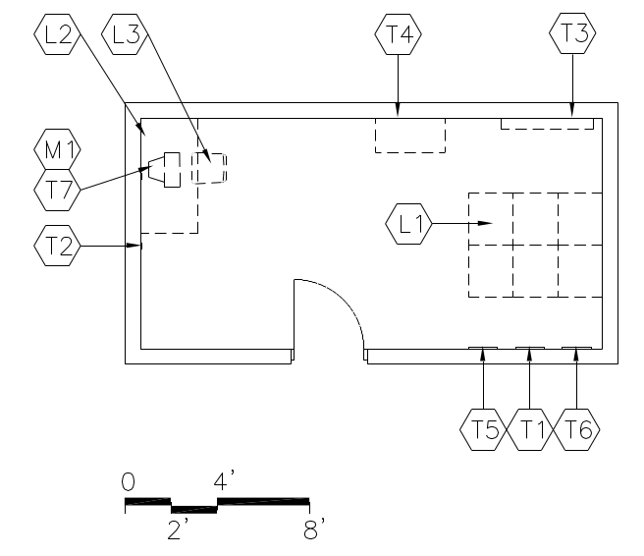  SIZE:  - 200 SF  Location to be determined | GOALS:  - To provide a secure area to serve as the information hub of the school. File servers will serve the building computer network  - To provide satellite up and down links that will send and receive voice, video, and data  - Location of cable TV input and output  - All areas of the school are to be wired to this area  PROGRAM ACTIVITIES:  - Voice, video, data reception, and distribution  - Security system location  - Network management  - Telephone wiring entry and distribution  - Cable and CCTV reception and broadcasting  SPATIAL RELATIONSHIPS:  - May also be located in the Administration Area  - Adjacent to and access to Reading/  Learning/Circulation Area  - Could be accessed from workroom in lieu of Reading/Learning/Circulation Area  - Additional access from corridor  ENVIRONMENTAL CONSIDERATIONS:  - Adequate power supply will be required and auxiliary UPS power for back-up (Quality of power is important.)  - Dedicated electrical circuitry  - Air conditioning dedicated to this space  - Adequate ventilation  - Access to ceiling and walls for modification to systems and wiring  - Security of door
NOTES:
- Loose furnishings and features shown represent one of many possible arrangements.

TELECOM HEAD END ROOM E-MC-5
Spec.  Finishes¹: Ref.#  Flooring:  Resilient tile flooring 096519  Base:  Resilient base 096519  Ceiling:  Suspended, acoustical 095113  Walls:  Painted concrete masonry units  042000 / 099123  Loose Furnishings:  L1 6-8 technology racks  L2 Workstation  L3 Ergonomic task chair | Spec.  Features¹: Ref.#  N/A  Fire Suppression: Div. 21  Fire suppression system  Plumbing:  N/A  HVAC: Div. 23  Supply/return air system  Independent, packaged system  Electrical: Div. 26  Duplex receptacles  Quad receptacles for  electronic systems  Single-level switching  Fluorescent lighting  Illumination level: See Table 7600-16  Central sound system  Communications: Div. 27  T1 Data network system  T2 Voice port and phone  T3 Telephone switchgear  T4 Video network control  T5 Satellite dish connection  T6 Satellite/cable system controls 17430  Access  Electronic Safety and Security: Div. 28  Life safety devices per code  Miscellaneous:  M1 Computer
NOTES:

- Finishes/Features: Refer to Chapter 8 for specification references.

COMBINED OFFICE / WORKROOM E-MC-6
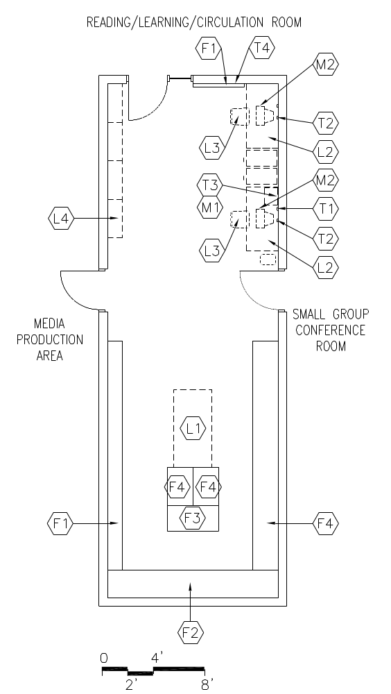  CAPACITY:  - Media specialists  SIZE:  - Varies, see table  ANCILLARY SPACES:  - Reading/Learning/Circulation Area  (E-MC-1) | GOAL:  - To provide a less visible and secure space for processing incoming materials and storage of materials  PROGRAM ACTIVITIES:  - Storage of materials  - Storage of A/V materials and videotapes  - Scanning  - Digitizing  SPATIAL RELATIONSHIPS:  - Adjacent to and access to Reading/Learning/Circulation Area  - Adjacent to and access to Office  - Adjacent to and access to Media Production Area  - Located behind circulation desk and whole class zone  ENVIRONMENTAL CONSIDERATIONS:  - Uniform lighting  - Environmental sound control:  Wall minimum: STC 45  Ceiling minimum: CAC 35  - Auditory privacy
NOTES:
- Loose furnishings and features shown represent one of many possible arrangements.

COMBINED OFFICE / WORKROOM
Spec.  Finishes¹: Ref.#  Flooring:  Resilient tile flooring 096519  Base:  Resilient base 096519  Ceiling:  Suspended, acoustical 095113  Walls:  Painted concrete masonry units  042000 / 099123  Loose Furnishings:  L1 Work table  L2 Computer workstation  L3 Chair  L4 Adjustable height bookshelves  L5 Four – drawer file cabinets | Spec.  Features¹: Ref.#  Fixed Equipment:  F1 Storage shelving 105613  F2 Casework:  Tall cabinet (24” deep) 123200  F3 Poster/map storage 123200  F4 Casework:  Base cabinets with power 123200  Fire Suppression: Div. 21  Fire suppression system  Plumbing:  Plumbing for sink  HVAC: Div. 23  Supply/return air system Div. 15  Electrical: Div. 26  Duplex receptacles  At casework island  TVSS protected quad receptacle  adjacent to each data port  Single-level switching  Fluorescent lighting  Illumination level: See Table 7600-16  Clock  Central sound system  Communications: Div. 27  T1 Voice port and phone  T2 Data port  Electronic Safety and Security: Div. 28  Life safety devices per code  Miscellaneous:  M1 Printer  M2 2 computers
NOTES:
Finishes/Features: Refer to Chapter 8 for specification references.

VISUAL AND PERFORMING ARTS AND ELECTIVE LABS
Spaces | Suggested |  |  | Comments
 | Qty. | S.F. | Total
Visual Arts Lab | 1 | 1000 | 1000
Kiln Room | 1 | 75 | 75
Storage | 1 | 125 | 125
 |  |  | 0
General Music Room | 1 | 1000 | 1000
Instrument storage | 1 | 150 | 150
 |  |  | 0
Science Classroom | 1 | 900 | 900
Food Prints | 1 | 900 | 900
Computer Instructional Lab | 1 | 900 | 900
Total |  |  | 5050

Comments : The overall total for the Instructional area may be + or – 15%.

VISUAL ARTS SPATIAL RELATIONSHIPS

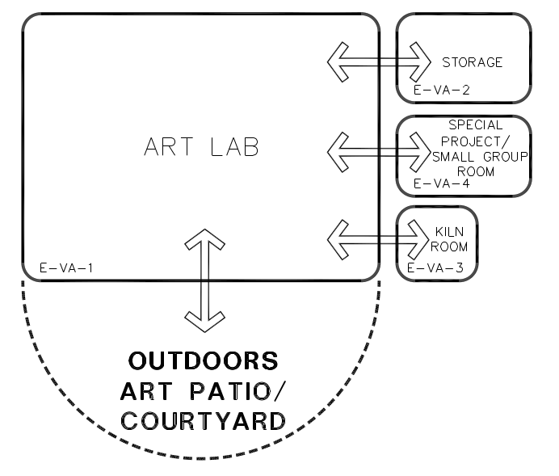

ART LAB E-VA-1
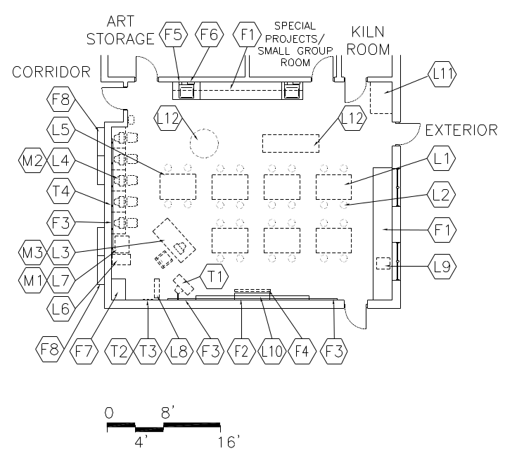  CAPACITY:  - 20-24 students  - 1 teacher  - Student teacher  - Parent volunteers  - Student volunteers  SIZE:  - Varies, see table  ANCILLARY SPACES:  - Kiln Room (E-VA-3)  - Art Storage (E-VA-2)  SPATIAL RELATIONSHIPS:  - Centrally located with convenient access to Core Academic classrooms  - Direct access to art patio – with overhang  - Adjacent and access to Kiln Room | GOALS:  - To provide an area for students to work on a variety of art projects and to have positive experiences, which include developing confidence, commitment, and a sense of accomplishment  - To explore the manipulation of a variety of materials  - To develop technical and expressive skills  - To become aware of and be able to articulate thoughts about art and its reflection of other societies, cultures, and times  - To provide clean, adequate space in which to store art supplies and student projects  PROGRAM ACTIVITIES:  - Drawing, painting, and print making  - Sculpture, model-making, collage, and assembly  - Ceramics-clay (age appropriate)  - Computer graphics and mixed media work  - Guest artist lectures  - Demonstrations  - Viewing prints/slides/movies/art videos  - Research, reading, and writing  - Individual and cooperative group work  - Storage of supplies, projects, and small equipment  ENVIRONMENTAL CONSIDERATIONS:  - Uniform lighting/track and display lighting  - Windows to provide natural light and egress, preferably northern exposure  - Environmental sound control:  Wall minimum: STC 45  Ceiling minimum: CAC 35  - Include outlets on the wall above counter spaces in raceway  - Electrical outlets for equipment  - Provide one ceiling hung, retractable electrical outlet  - Window treatment to darken room for AV presentation as required
NOTES:
- Loose furnishings and features shown represent one of many possible arrangements.
ART LAB E-VA-1
Spec.  Finishes¹: Ref.#  Flooring:  Quartz tile 096618  Base:  Resilient base 096519  Ceiling (12’ high minimum to underside of deck):  Exposed structure, painted 099123  with acoustical treatment 098400  Walls:  Painted concrete masonry units or dry wall  One tackable wall  042000 / 099123  Loose Furnishings:  L1 Art tables for 26 students (discuss with staff)  L2 26 Student stools  L3 Teacher workstation and chair  L4 2 computer (laptops) tables and chairs  L6 1, four-drawer file cabinet  L10 Adjustable height shelves (24 LF) for drying 3D objects  L11 Drying rack (40-80 slats)  Flat storage (10 drawers)  Communications: Div. 27  Single point ‘face plate’ near teachers work station to include:  Voice, data, VGA , audio enhancement, and HDMI 17160  Additional ports:  Printer  3 data ports for student use  Electronic white board  Clock/PA  2 wireless  Miscellaneous:  M1 Interactive white board Div. 27  M2 2-3 computers for student use  M3 Computer for teacher use  Audio enhancement equipment  Document camera | Spec.  Features¹: Ref.#  Fixed Equipment:  F1 Casework:  30” high base/wall cabinets near sinks 123200  Paper storage cabinets  F2 Marker board 101100  16 LF primary  F5 Tack board flanking marker board  Plus two (2) parallel rows of continuous tack strips on all available walls (4 LF or longer) at 30” and 48” AFF  F6 Manual projection screen (60”X60”)115213³  F5 Soap dispenser (at each sink) 102800  F6 Towel dispenser (at each sink) 102800  F7 Casework: Wardrobe 123200  F8 Display cases  Plumbing: Div. 22  Sinks with solids interceptor  2 large, deep sinks 6’ apart  Plumbing connections  HVAC: Div. 23  Supply/return air system  Independent temperature control  Manually controlled general exhaust  Electrical: Div. 26  Duplex receptacles  3 per primary teaching wall  At least 2 per other walls  TVSS protected quad receptacle  adjacent to each data port  Multilevel switching  Fluorescent lighting  Illumination level: See Table 7600-16  Clock  Central sound system  Display/track lighting
NOTES:
- Finishes/Features: Refer to Chapter 8 for specification references.
ART STORAGE E-VA-2
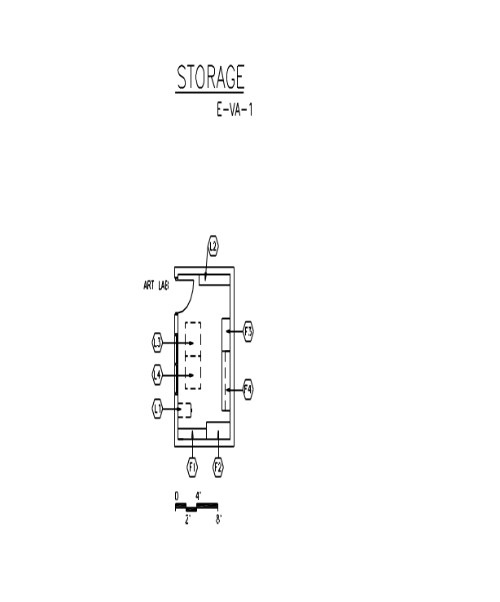  CAPACITY:  - 1 teacher  SIZE:  - 150 SF  ANCILLARY SPACES:  - Art Lab (E-VA-1) | GOAL:  - To provide lockable storage for art supplies, portable equipment, technology, peripherals, and materials  PROGRAM ACTIVITIES:  - Storage of equipment and supplies  SPATIAL RELATIONSHIPS:  - Direct access to Art Lab  - Visual access from Art Lab  ENVIRONMENTAL CONSIDERATIONS:  - Uniform lighting  - Electrical outlets for equipment

KILN ROOM E-VA-3
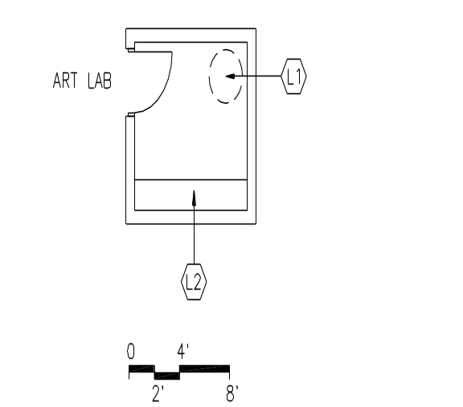  CAPACITY:  - 1-2 persons  SIZE:  - 100 SF  ANCILLARY SPACES:  - Art Lab (E-VA-1) | GOALS:  - To provide an area properly equipped for ceramics  - To provide a space to fire and store completed art work  PROGRAM ACTIVITIES:  - Store 3D sculptural work  - House kiln equipment  SPATIAL RELATIONSHIPS:  - Adjacent and access to Art Lab  ENVIRONMENTAL CONSIDERATIONS:  - Ventilation controlled by a thermostat  - Adequate ventilation with vents to the outside for kiln  - Electrical outlets for equipment  - Lighting appropriate to task  - Consider safety in plumbing room layout

GENERAL MUSIC ROOM E-MU-1
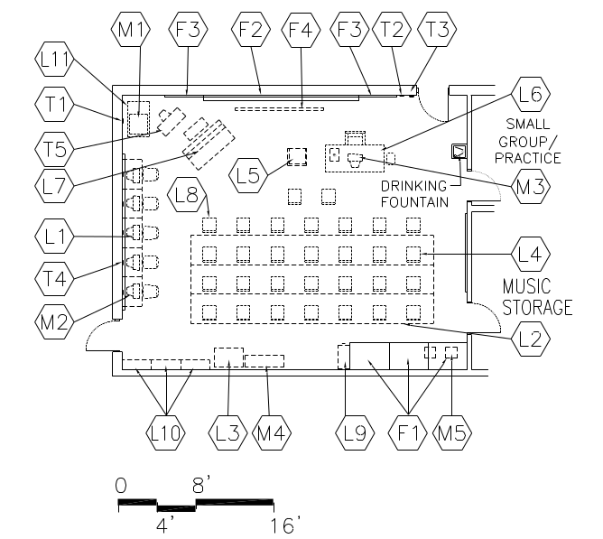  CAPACITY:  - 20-24 music students  - 1 teacher  - Parents/volunteers  ANCILLARY SPACES:  - Music Storage (E-MU-2)  GOAL:  - To provide students with the opportunity develop skills in music through large group, ensemble, and solo experiences  PROGRAM ACTIVITIES:  - Listen, analyze and describe music  - Choral, speech, theatrics  Miscellaneous:  M1 Projection device on cart Div. 27  M2 2 computers for student use  M3 Computer teacher use  M4 MIDI synthesizer  M5 A/V recording/playback equipment  Finishes¹: Ref.#  Flooring: Carpet 096816  Base: Resilient base 096519  Ceiling(10’ high minimum):  Suspended, acoustical 095113  Walls:  Painted concrete masonry units | ENVIRONMENTAL CONSIDERATIONS:  - Uniform lighting/Theatrical lighting  - Environmental sound control:  Wall minimum: STC 50  Ceiling minimum: CAC 35  - Sound insulation in walls (extended above ceiling to underside of deck)  - Acoustical wall treatments  - Electrical outlets for equipment  - Adequate ventilation  - Drinking fountain in or adjacent classroom  Loose Furnishings:  L1 2 computer workstations and chairs  L2 Portable choral risers with rails  L3 Mobile A/V cabinet  L4 27 music posture chairs  L5 Conductor podium, chair and stand  L6 Teacher desk and chair  L7 Upright piano  L9 Four-drawer file cabinet  L10 Adjustable height bookshelves (24LF)  Instrument storage (varied sizes)  L11 Multimedia cart for teacher use  Communications: Div. 27  Single point ‘face plate’ near teachers work station to include:  Voice, data, VGA , audio enhancement, and HDMI 17160  Additional ports:  Printer  3-5 data ports for student use  Electronic white board  Clock/PA  2 wireless  Spec.  Features¹: Ref.#  Fixed Equipment:  F1 Casework: Paper storage cabinets 123200  F2 Marker board (16 LF)  1/2 with music staff bars 101100  F3 Tack board 101100  F4 Manual projection screen 115213  F5 Casework: Wardrobe 123200  F6 Casework: Sink cabinet 123200
GENERAL MUSIC STORAGE E-MU-2
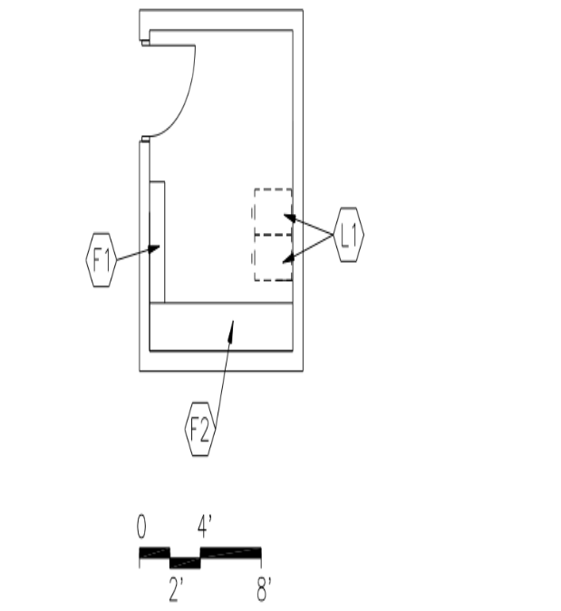  CAPACITY:  - Students  - Teachers  SIZE:  - 150 SF  ANCILLARY SPACES:  - General Music Room (E-MU-1) | GOAL:  - To provide adequate storage for accessories, and instruments  PROGRAM ACTIVITIES:  - Storage and simple repair of accessories and instruments  SPATIAL RELATIONSHIPS:  - Adjacent and access to General Music Room  ENVIRONMENTAL CONSIDERATIONS:  - Uniform lighting  - Electrical outlets

GENERAL MUSIC STORAGE E-MU-2
Spec.  Finishes¹: Ref.#  Flooring:  Resilient tile flooring 096519  Base:  Resilient base 096519  Ceiling:  Suspended, acoustical 095113  Walls:  Painted concrete masonry units  042000 / 099123 | Spec.  Features¹: Ref.#  Fixed Equipment:  F1 Storage shelving:  12" deep 105613  F2 Instrument storage (see furniture standards)  Fire Suppression: Div. 21  Fire suppression system  HVAC: Div. 23  Supply/return air system  Electrical: Div. 26  Duplex receptacles  Single-level switching  Fluorescent lighting  Illumination level: See Table 7600-16  Central sound system

PROJECT LAB / SCIENCE LAB E-ACA-14
CAPACITY:  - 20-24 students  - 1-2 staff  SIZE:  - 900 SF  GOAL:  - To provide a place for students learn about natural and biological science  PROGRAM ACTIVITIES:  - Direct instruction  - Plant and animal centers  - Student projects  - Cooperative learning groups  - Student display  ENVIRONMENTAL CONSIDERATIONS:  - Uniform lighting  - Windows to provide natural light and egress  - Window treatment to darken room for AV presentation  - Proportion classroom for effective viewing and listening from all areas of the classroom  Spec.  Finishes: Ref.#  Flooring:  Quartz tile 096618  Base:  Resilient base 096519  Ceiling (9’ high minimum):  Suspended, acoustical 095113  Walls:  Painted concrete masonry units or dry wall  042000/ 099123 | Spec.  Features¹: Ref.#  Fixed Equipment:  F1 Casework:  Base/wall cabinets and shelving  (attention to height constraints); acid resistant countertops  F3 Casework:  Wall shelving (24 LF- H 30-32”)  F4 Marker board (2 walls)  16 LF primary/8 LF secondary  F5 Tack board flanking marker boards  Plus two (2) parallel rows of continuous tack strips on all available walls (4 LF or longer) at 30” and 48” AFF  F6 Manual projection screen (60”X60”)  F8 Casework: Wardrobe  Plumbing: Div. 22  Plumbing connections  3-4 peripheral sinks, single/deep bowl with solids interceptors  Electrical: Div. 26  Duplex receptacles-  3 per primary teaching wall  At least 2 per other walls  Duplex outlets above countertop  Multilevel switching  Clock  Communications per regular classroom  Loose Furnishings:  L1 12 two-person science tables with acid resistant surfaces  L2 24-30 chairs  L3 2-3 computer workstation furniture  L5 Teacher desk and chair  L8 Four-drawer file cabinet  L9 Adjustable bookshelves (24 LF)
NOTES:
- Casework countertop at sink wall(s) shall be 30” deep with a 6” plumbing chase for services. No plumbing shall be in exterior wall

FOOD PRINTS LAB E-ACA-14
FoodPrints is an educational program that integrates gardening, cooking, and nutrition education into the curriculum at five DC Public Schools. Utilizing organic vegetable gardens, healthy and delicious recipes, and hands-on projects, educators get elementary school students excited about growing, preparing, and enjoying real food. Using fresh produce children learn to create delectable meals from nutritious ingredients.  The current lab was financed and installed through active participation from the PTA. If relocated, the equipment should be relocated or replaced in-kind.  CAPACITY:  - 20-24 students  - 2-4 staff  SIZE:  - 900 SF (including closet)  ANCILLARY SPACES:  Access to gardens | PROGRAM ACTIVITIES:  - Direct instruction  - Student and class projects  - Cooperative learning groups  - Student display  - Cooking demonstrations  SPATIAL RELATIONSHIPS:  - Direct access to the learning garden  - Near outdoor classroom  ENVIRONMENTAL CONSIDERATIONS:  - Uniform lighting  - Windows to provide natural light and egress  - Environmental sound control:  Wall minimum: STC 45  Ceiling minimum: CAC 35  Reverberation Time: .4-.6 seconds  - Window treatment to darken room for AV presentation  - Proportion classroom for effective viewing and listening from all areas of the classroom  - Interior windows

NOTES:
- Casework countertop at sink wall(s) shall be 30” deep with a 6” plumbing chase for services – student height. No plumbing shall be in exterior wall

FOOD PRINTS LAB E-ACA-14
Spec.  Finishes: Ref.#  Flooring:  Quartz tile 096618  Base:  Resilient base 096519  Ceiling (9’ high minimum):  Suspended, acoustical 095113  Walls:  Painted concrete masonry units or dry wall  042000/ 099123  One tackable wall surface 101100  Loose Furnishings:  L1 6 four-person tables  L2 24 chairs  Communications: Div. 27  Per regular classroom | Spec.  Features: Ref.#  Fixed Equipment:  Casework:  Peripheral base cabinets and shelving  (varying heights for all age groups)  Roll-out drawers  Casework:  Lockable food storage  Tackable walls  Demonstration kitchen on island: Dishwasher, oven, microwave, refrigerator/freezer, cooktop  Marker board (2 walls)  16 LF primary/8 LF secondary  Tack board flanking marker boards  Plus two (2) parallel rows of continuous tack strips on all available walls (4 LF or longer) at 30” and 48” AFF  Teacher’s wardrobe  Fire Suppression: Div. 21  Fire suppression system  Plumbing: Div. 22  Sinks with solids interceptor  Demonstration kitchen  2 Student height with access from two sides  Plumbing connections for appliances  HVAC: Div. 23  Supply/return air system  Independent temperature control  Hood vent  Electrical: Div. 26  Duplex receptacles:  3 per primary teaching wall  At least 2 per other walls  Continuous raceway above countertop  Multilevel switching  Clock  Central sound system  Electronic Safety and Security: Div. 28  Life safety devices per code

COMPUTER LAB E-MC-2
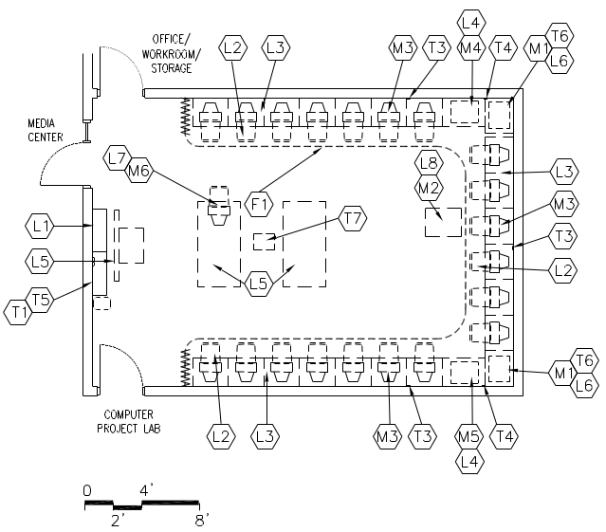  CAPACITY:  - 24-26 students  - 2 teachers  SIZE:  - Varies, see table | GOAL:  - To provide a place for computer instruction  - To provide for on-line testing  ENVIRONMENTAL CONSIDERATIONS:  - Uniform lighting with an appropriate visual comfort level  - Environmental sound control:  Wall minimum: STC 45  Ceiling minimum: CAC 40  Acoustically improved entry door  - Electrical outlets for equipment  - Near media center

NOTES:

- Loose furnishings and features shown represent one of many possible arrangements.
COMPUTER LAB E-MC-2
Spec.  Finishes¹: Ref.#  Flooring:  Carpet 096816  Base:  Resilient base 096519  Ceiling:  Suspended, acoustical 095113  Walls:  Painted concrete masonry units  042000 / 099123  Windows/sidelites:  Security glass 088000  Loose Furnishings:  L1 Adjustable height bookshelf (12 LF)  L2 26 chairs (swivel)  L3 26 computer tables  L4 Printer tables  L5 Work tables (optional)  L6 Tables for scanners and other  equipment  L7 Teacher desk and chair  4 drawer file cabinet  Miscellaneous:  M1 Digital scanners  M3 26 computers for student use  M4 Printer  M6 Computer for teacher use | Spec.  Features¹: Ref.#  Marker board (2 walls)  16 LF primary/8 LF secondary  Tack board flanking marker boards  Plus two (2) parallel rows of continuous tack strips on all available walls (4 LF or longer) at 30” and 48” AFF  Teacher’s wardrobe  Fire Suppression: Div. 21  Fire suppression system  HVAC: Div. 23  Supply/return air system  Independent temperature  control  Electrical: Div. 26  Duplex receptacles  TVSS protected quad receptacle  adjacent to each data port  Multilevel switching  Fluorescent lighting with  parabolic lenses  Central sound system  Communications: Div. 27  T2 Voice port and phone  T3 15 data ports (minimum) for  student use in raceway  T4 Data ports for printer  T6 Data ports for scanners  Wireless ports  Electronic Safety and Security: Div. 28  Life safety devices per code

NOTES:
- Finishes/Features: Refer to Chapter 8 for specification references.

PHYSICAL EDUCATION (Phase 2)
Spaces | Qty. | S.F. | Total | Comments
Assembly/PE Space | 1 | 3,600 | 3,600
Office | 2 | 150 | 300 | PE teacher and DPR
Storage | 3 | 200 | 600
Stage | 1 | 850 | 850
Total |  |  | 5,350

Comments:

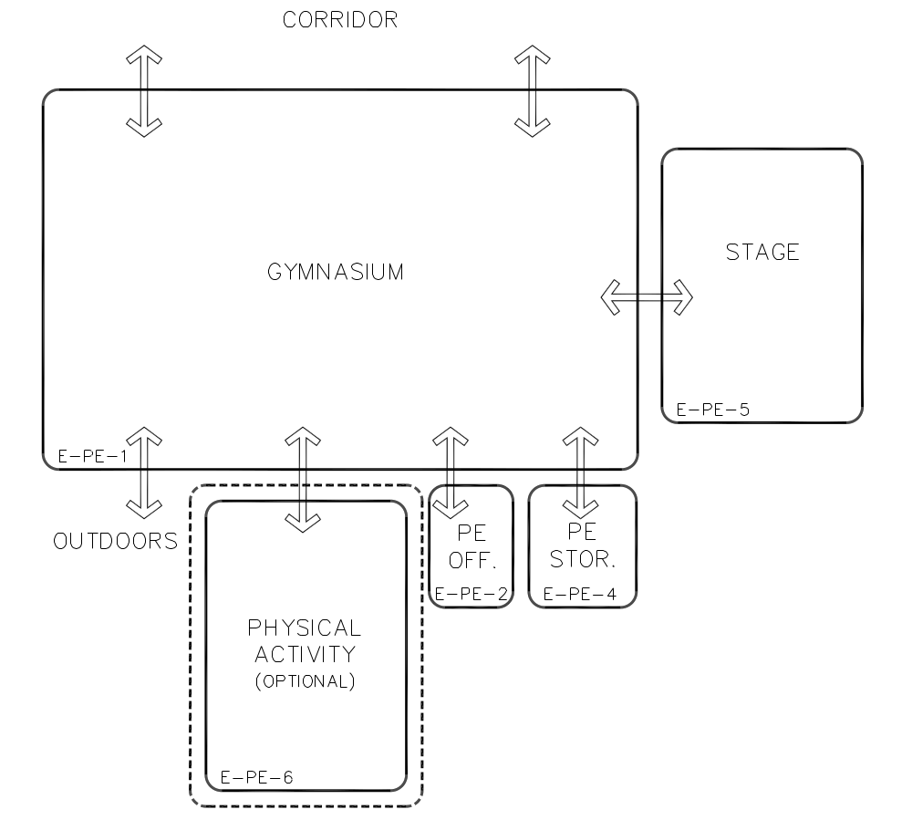

ASSEMBLY/PE SPACE E-PE-1
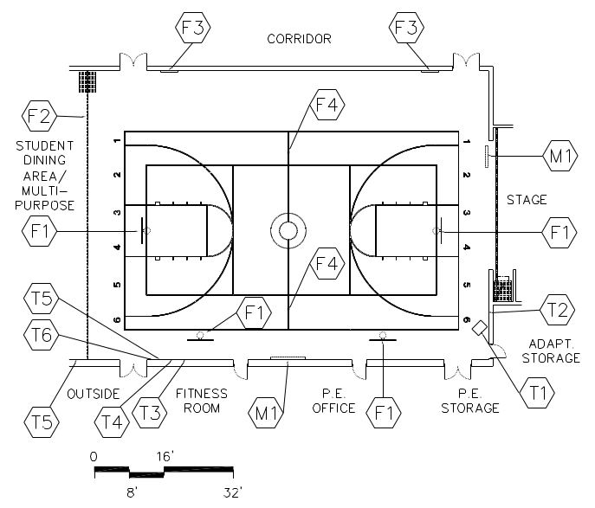  CAPACITY:  - 24-50 students per class  - Teacher  - Parents and community members for meetings  ANCILLARY SPACES:  - P.E. Office (E-PE-2)  - P.E. Storage (E-PE-4)  - Student storage in lobby adjacent to PE area | GOALS:  - To provide space for P.E. classes to meet  - To provide space for students to present performances  PROGRAM ACTIVITIES:  - Athletic skills and leader games  - Adaptive physical education  - Student assemblies and programs  - Lectures/Teaching  - Community use  SPATIAL RELATIONSHIPS:  - Near public restrooms, with easy access  - Access to outdoor physical education play areas  - Near visitor parking  - Located with easy access to rest of school, but must be able to close off area for security during evening activities  - Adjacent and access to P.E. Office  - Adjacent and access to P.E. Storage  ENVIRONMENTAL CONSIDERATIONS:  - Uniform lighting  - Environmental sound control:  Wall minimum: STC 50  - Adequate sound control/acoustics  - Clear height of 20' from floor to nearest  obstruction  - Electrical outlets for equipment  - Drinking fountain in adjacent area  - Structure, lighting, and ducts designed not to trap P.E. balls  - Ceiling heights should be proportional to room volume

NOTES:
1. Loose furnishings and features shown represent one of many possible arrangements.
2. This size space will accommodate 1/2 basketball court
ASSEMBLY/PE SPACE E-PE-1
Spec.  Finishes¹: Ref.#  Flooring:  Wood strip flooring for athletic 096466  applications or  Resilient athletic flooring 096566  Base:  Vented resilient base 096466  Ceiling:  Painted exposed structure 099923  on acoustical deck  Walls:  Painted concrete masonry units  042000 + 099123  Acoustical wall treatment 098400  And/or sound absorbing concrete  masonry units 042000  Communications: Div. 27  T1 Video/cable/MATV port  T2 Voice port and phone  T3 Microphone port  T4 Intercom  T5 Outside microphone ports/portable  System (wireless mics)  T6 Data port  Jacks for sound system  Electronic Safety and Security: Div. 28  Life safety devices per code | Spec.  Features¹: Ref.#  Fixed Equipment:  F1 Basketball backstops, adjustable height (ceiling hung) 116600  F2 Curtain to divide in half 102226  White board in two locations with electrical outlet  Fire Suppression: Div. 21  Fire suppression system  Plumbing:  Drinking fountain in lobby (two heights)  HVAC: Div. 23  Supply/return air system  Independent temperature  control  Electrical: Div. 26  Duplex receptacles  Electrical connections to P.E.  equipment where necessary  Single-level switching  High intensity discharge lighting  Illumination level: See Table 7600-16  Means of egress lighting per code  Clock  Central sound system  Gymnasium sound system  Provide wire guards on light fixtures  and electrical devices

NOTES:

- Finishes/Features: Refer to Chapter 8 for specification references.

P.E./DPR OFFICE E-PE-2
CAPACITY:  - 1-2 teachers  - Student teachers  SIZE:  - 250 SF  GOAL:  - To provide a work area for physical education faculty and staff to conduct administrative duties | PROGRAM ACTIVITIES:  - Ordering  - Scheduling  - Planning  - Maintaining records  - Meetings  SPATIAL RELATIONSHIP:  - Adjacent and access to Gymnasium  - Near restrooms  ENVIRONMENTAL CONSIDERATIONS:  - Uniform lighting  - Environmental sound control:  Wall minimum: STC 45  Ceiling minimum: CAC 35  - Electrical outlets for equipment  - Windows to provide natural light, desirable  - Auditory privacy

NOTES:

- Loose furnishings and features shown represent one of many possible arrangements.
P.E. OFFICE
E-PE-2
Spec.  Finishes¹: Ref.#  Flooring:  Office: Resilient tile flooring 096519  Toilet: Ceramic tile 093013  Base:  Office: Resilient base 096519  Toilet: Ceramic tile base 093013  Ceiling:  Acoustical, suspended 05113  Walls:  Painted concrete masonry units  042000 / 099123  Loose Furnishings:  L1 Amin. workstation  L2 Four-drawer file cabinet  L4 Ergonomic task chair  L5 Adjustable height bookshelves (12 LF) | Spec.  Features¹: Ref.#  Fixed Equipment:  F1 Tack board (4 LF) 101100  F2 Towel dispenser 102800  F3 24” x 60” mirror 102800  F4 Toilet tissue holder 102800  F5 36” and 42” grab bars 102800  F6 Soap dispenser 102800  F7 ADA shower accessories 102800  F8 Coat hook 102800  Fire Suppression: Div. 21  Fire suppression system  Plumbing: Div. 22  Plumbing connections  Wall mounted lavatory  Wall mounted water closet  Shower  Floor drains - in restroom and shower  HVAC: Div. 23  Supply/return air system  Independent temperature  control  Electrical: Div. 26  Duplex receptacles  Single-level switching  TVSS protected quad receptacle  adjacent to data port  Fluorescent lighting 16500  Illumination level: See Table 7600-16  Central sound system  Communications²: Div. 27  T1 Voice port and phone  T2 Data port near teacher workstation  T3 Data port for printer  Electronic Safety and Security: Div. 28  Life safety devices per code

NOTES:
- Finishes/Features: Refer to Chapter 8 for specification references.

P.E. AND CHAIR STORAGE E-PE-4
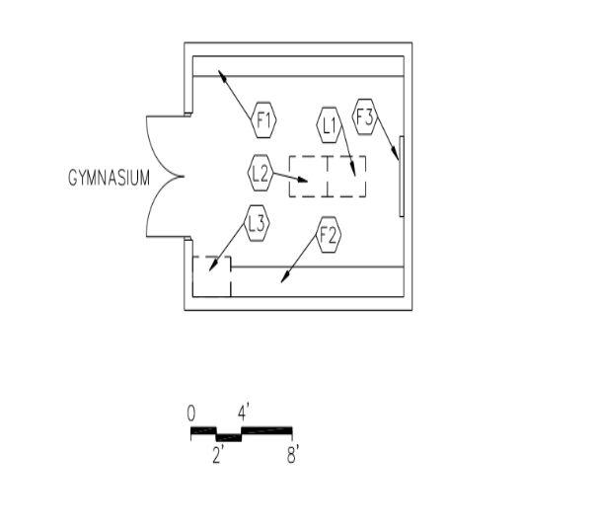  CAPACITY:  - 1-2 teachers  - Student teachers  SIZE:  - Varies, see table | GOAL:  - To provide convenient storage for all physical education equipment  PROGRAM ACTIVITIES:  - Storage for PE  - Storage for DPR equipment  - Storage for chairs  SPATIAL RELATIONSHIPS:  - Adjacent and access to Assembly/PE  ENVIRONMENTAL CONSIDERATIONS:  - Uniform lighting  - Leave space below shelving on one wall for portable bins

NOTES:

- Loose furnishings and features shown represent one of many possible arrangements.
P.E. AND STORAGE
E-PE-4
Spec.  Finishes¹: Ref.#  Flooring:  Resilient tile flooring 096519  Base:  Resilient base 096519  Ceiling:  Exposed structure, painted 099123  Walls:  Painted concrete masonry units  042000 / 099123  Loose Furnishings:  L1 Tumbling mats  L2 Ball bins  L3 Play equipment  Folding chairs and dollies | Spec.  Features¹: Ref.#  Fixed Equipment:  F1 Storage shelving: 105613  12" deep  F2 Storage shelving: 105613  18" deep  F3 Pegboard (4 LF) 101100  Fire Suppression: Div. 21  Fire suppression system  Plumbing:  N/A  HVAC: Div. 23  Supply/return air system  Electrical: Div. 26  Duplex receptacles  Multilevel switching  Fluorescent lighting  Illumination level: See Table 7600-16  Electronic Safety and Security: Div. 28  Life safety devices per code

NOTES:
Finishes/Features: Refer to Chapter 8 for specification references.
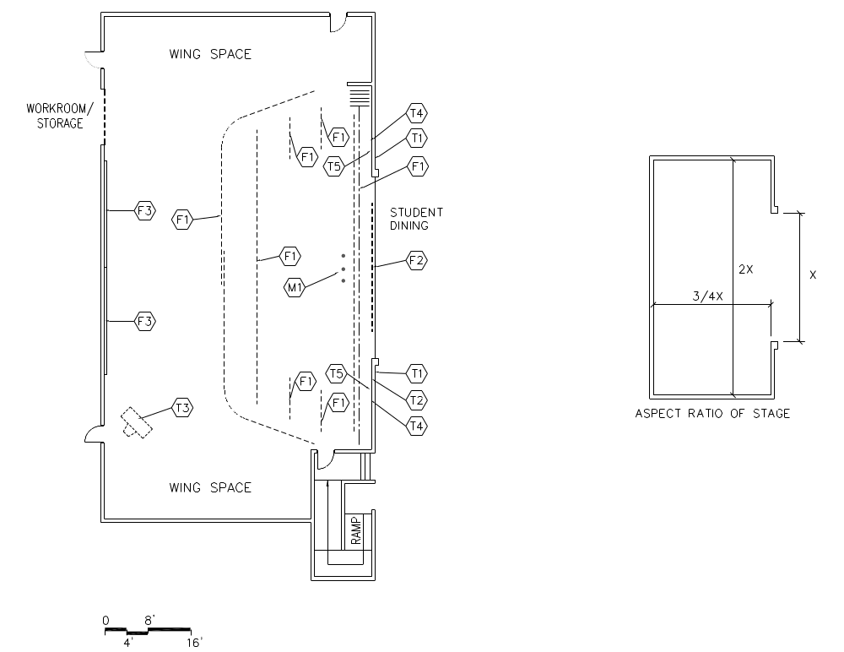
STAGE

CAPACITY:  - Students  - Teachers  - Parents/volunteers  - Members of the community  GOAL:  - To provide a space for student  performances and assemblies | PROGRAM ACTIVITIES:  - Theatrical/musical productions  - Conferences, student assemblies, and award programs  SPATIAL RELATIONSHIPS:  - Near music classrooms  ENVIRONMENTAL CONSIDERATIONS:  - Environmental sound control  Wall minimum: STC 56  Roof minimum: STC 40  - Provide sufficient wings space for productions  - Specialty track lighting for Stage
NOTES:
STAGE
Spec.  Finishes¹: Ref.#  Flooring:  Wood flooring² 096466  Base:  Ventilated resilient base 096466  Ceiling:  Painted exposed structure 099123  Walls:  Painted concrete masonry  units 042000 / 099123 | Spec.  Features: Ref.#  Fixed Equipment:  F1 Theater and stage equipment 116143  F2 Motorized projection screen 115213  Fire Suppression: Div. 21  Fire suppression system  Plumbing:  N/A  HVAC: Div. 23  Supply/return air system  Independent temperature  control  Electrical: Div. 26  Duplex receptacles  12" o.c. on back and wing walls  3 duplex outlets in apron at front  of stage  TVSS protected quad receptacle  adjacent to each data port  Single-level switching  General purpose lighting  Stage dimming system  House lighting  Illumination levels: See table 7600-16  Clock  Auditorium sound system  Provide outlet in apron at front of stage  Communications: Div. 27  T1 2 data ports on stage  T2 Voice port and telephone  T4 Microphone port  T5 Jacks for sound system  T6 Video port, monitor, VCR/DVD,  and bracket  Electronic Safety and Security: Div. 28  Life safety devices per code

NOTES:
- Finishes/Features: Refer to Chapter 8 for specification references.
- Provide hardwood on forestage and extend into stage at width of proscenium by 10'-20' deep.

ADMINISTRATION
Spaces | Suggested |  |  | Comments
 | Qty. | S.F. | Total
Lobby/Gathering area | 1 | 500 | 500
Welcome Center | 1 | 400 | 400 | Welcoming Area, Work area for Administrative Asst.
Security Area w/ locking storage | 1 | 75 | 75
Conference Room | 1 | 200 | 200
Principal and AP, Dean, Business Offices | 5 | 120 | 600 | See staff for locations
Administrative Workroom/mailroom | 1 | 250 | 250
Records Room | 1 | 150 | 150 | Needs to be a secure space.
Toilet | 1 | 50 | 50
Student Services (Counselor) | 1 | 150 | 150
Health Suite |  |  | 0
Office | 1 | 100 | 100
Treatment Area/waiting | 1 | 180 | 180
Cots | 1 | 150 | 150
Storage | 1 | 25 | 25
Toilet | 1 | 50 | 50
Staff Lounge | 1 | 500 | 500 | Includes staff toilet with shower.
Total |  |  | 3380

Comments: The overall total for the administration area may be + or – 15%. Some areas may be combined to facilitate circulation. Some areas (*) may be located outside of the suite to make the best use of the existing building.
WELCOME CENTER E-AD-1
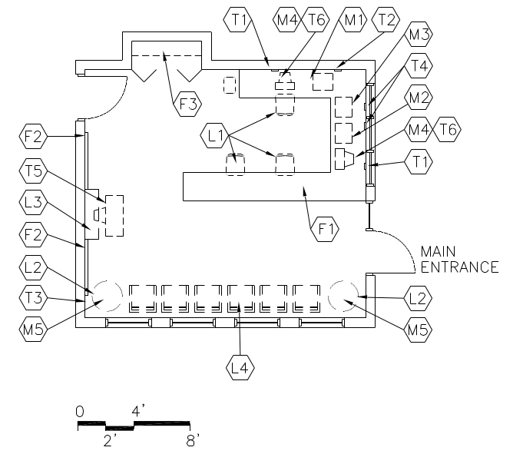  CAPACITY:  - Administrative assistants  - Visitors/parents  - Students  SIZE:  - Varies, see table  ANCILLARY SPACES:  N/A | GOAL:  - To provide a space designed to help students and the public feel welcome and to provide easily accessed information  PROGRAM ACTIVITIES:  - Greeting visitors  - Waiting for students or staff  - Student waiting/pick up area  - 2 Workstations for administrative assistants  SPATIAL RELATIONSHIPS:  - Located inside the main Administrative Area  - Centrally located to Administrative Area  - Near public restrooms  - Maximize view to the exterior and main entry  ENVIRONMENTAL CONSIDERATIONS:  - Uniform lighting, areas of soft lighting  - Environmental sound control:  Wall minimum: STC 45  Ceiling minimum: CAC 35  - Adequate ventilation  - Electrical outlets for equipment  - Administrative area should be mechanically zoned for year round use.  - Windows to provide natural light
NOTES:

1. Loose furnishings and features shown represent one of many possible arrangements.

WELCOME CENTER
Spec.  Finishes¹: Ref.#  Flooring:  Tile carpet 096813  Base:  Resilient base 096519  Ceiling (8’ high minimum):  Suspended, acoustical 095113  Walls:  Painted gypsum wallboard  over metal studs 092116 / 099123  Loose Furnishings:  L1 2 ergonomic task chairs  L4 4-6 guest chairs  Miscellaneous:  M1 Fax  M2 printer  M4 2 computers  M5 Table lamps | Spec.  Features¹: Ref.#  Fixed Equipment:  F1 Finish carpentry  Reception counter 064123  F2 Tack board (8 LF) 101100  F3 Closet shelving 064123  Fire Suppression: Div. 21  Fire suppression system  Plumbing:  N/A  HVAC: Div. 23  Supply/return air system  Independent temperature  control  Electrical: Div. 26  Duplex receptacles  TVSS protected quad receptacle  adjacent to each data port  Single-level switching  Fluorescent lighting  Illumination level: See Table 7600-16  Central sound system  Communications: Div. 27  T1 2 voice port and phone  at workstations  T2 Fax port  T4 data ports for printer  T6 Data port near each workstation  Cable/MATV port  Electronic Safety and Security: Div. 28  Life safety devices per code
NOTES:

- Finishes/Features: Refer to Chapter 8 for specification references.

SECURITY AREA E-AD-2
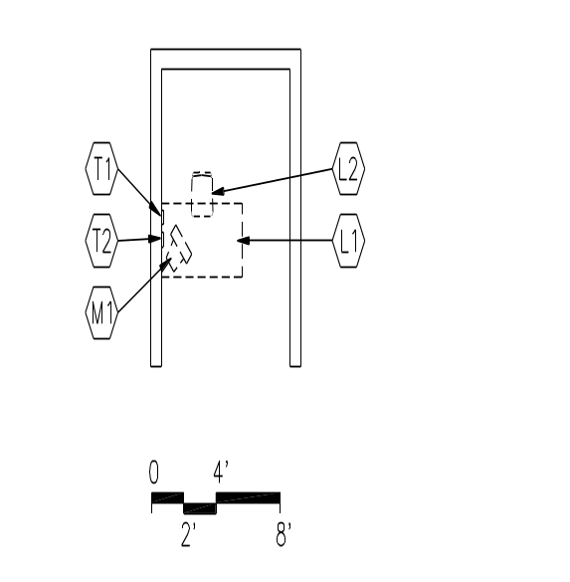  CAPACITY:  - Security officer  SIZE:  - Varies, see table  ANCILLARY SPACES:  N/A | GOAL:  - To serve as a check-in and checkpoint for non-school visitors  PROGRAM ACTIVITIES:  - Check-in/out visitors  - Monitor main entrance to school  - Workstation for security office  SPATIAL RELATIONSHIPS:  - Adjacent to main entry  ENVIRONMENTAL CONSIDERATIONS:  - Uniform lighting  - Environmental sound control:  Wall minimum: STC 45  Ceiling minimum: CAC 35
NOTES:

Loose furnishings and features shown represent one of many possible arrangements.

SECURITY AREA
Spec.  Finishes¹: Ref.#  Flooring:  Resilient tile flooring 096519  Base:  Resilient base 096519  Ceiling (8’ high minimum):  Suspended, acoustical 095113  Walls:  Painted concrete masonry units  042000 / 099123  Loose Furnishings:  L1 Admin workstation  L2 Ergonomic task chair | Spec.  Features¹: Ref.#  Fixed Equipment:  N/A  Fire Suppression: Div. 21  Fire suppression system  Plumbing: Div. 22  Fire protection system  HVAC: Div. 23  Supply/return air system  Independent temperature  control  Electrical: Div. 26  Duplex receptacles  TVSS protected quad receptacle  adjacent to each data and  video port  Multilevel switching  Fluorescent lighting  Illumination level: See Table 7600-16  Clock  Central sound system  Communications: Div. 27  T1 Voice port and phone  T2 Data port  Electronic Safety and Security: Div. 28  Life safety devices per code  Miscellaneous:  M1 Computer
NOTES:
Finishes/Features: Refer to Chapter 8 for specification references
CONFERENCE ROOM E-AD-3
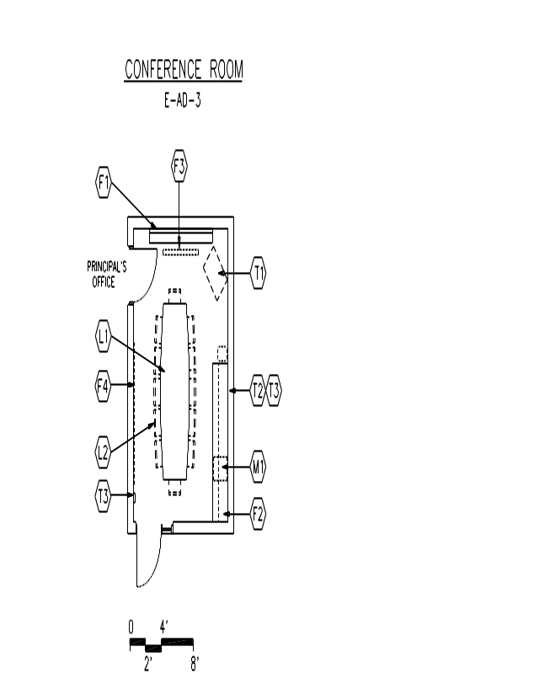  CAPACITY:  - Staff  - Students  - Parents  - Visitors  SIZE:  - 200 SF  ANCILLARY SPACES:  - Principal’s Office (E-AD-4) | GOAL:  - To provide a place for administrative conferences or meetings  PROGRAM ACTIVITIES:  - Conferences with staff, students, parents,  and visitors  SPATIAL RELATIONSHIPS:  - Near Welcome Center  - Centrally located within Administrative Area  - Adjacent and access to Principal’s Office  ENVIRONMENTAL CONSIDERATIONS:  - Uniform lighting, appropriate to task  - Environmental sound control:  Wall minimum: STC 45  Ceiling minimum: CAC 40  - Electrical outlets for equipment  - Windows to provide natural light, desirable  - Auditory privacy
NOTES:

Loose furnishings and features shown represent one of many possible arrangements.
CONFERENCE ROOM E-AD-3
Spec.  Finishes¹: Ref.#  Flooring:  Tile carpet 096813  Base:  Resilient base 096519  Ceiling (8’ high minimum):  Suspended, acoustical 095113  Walls:  Painted gypsum wallboard  over metal studs 092116 / 099123  Loose Furnishings:  L1 Conference table (with table technology installations (VGA jacks, data outlets, power outlets, etc.)  L2 12 chairs | Spec.  Features¹: Ref.#  Fixed Equipment:  F1 Marker board (8 LF) 101100  F2 Casework:  Base/wall cabinets (6 LF) 123200  F3 Manual projection screen 115213  F4 Tack board (8 LF) 101100  Fire Suppression: Div. 21  Fire suppression system  Plumbing:  N/A  HVAC: Div. 23  Supply/return air system  Independent temperature  control  Electrical: Div. 26  Duplex receptacles  TVSS protected quad receptacle  adjacent to each data and  video port  Multilevel switching  Fluorescent lighting  Illumination level: See Table 7600-16  Clock  Central sound system  Communications: Div. 27  T1 Video port, monitor  and bracket  T2 Voice port and phone  Electronic Safety and Security: Div. 28  Life safety devices per code  Miscellaneous:  M1 Under counter refrigerator
NOTES:

- Finishes/Features: Refer to Chapter 8 for specification references.

PRINCIPAL’S OFFICE E-AD-4
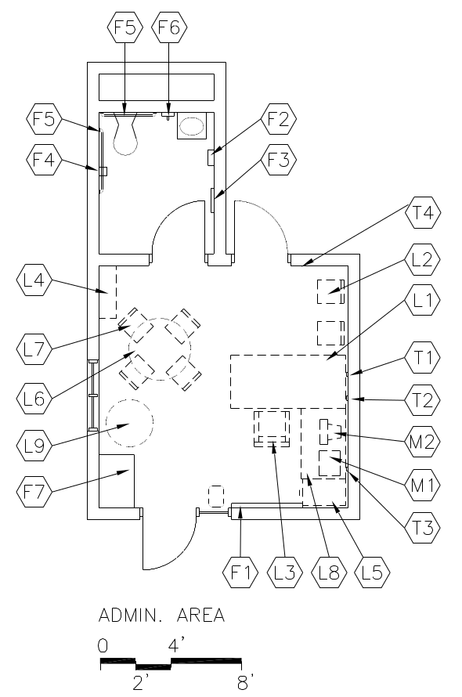  CAPACITY:  - Principal  SIZE:  - 180 SF  ANCILLARY SPACES:  - Conference Room (E-AD-3) | GOAL:  - To provide an office for the principal to give instructional leadership in a personal and organized environment for students, staff, and community  PROGRAM ACTIVITIES:  - Conferences with students, parents, teachers, staff, and visitors  - Curriculum development  - Research and planning  - Telephone communications  - Dealing with personnel issues  - Coordination of school and support services  SPATIAL RELATIONSHIPS:  - Near main entry  - Near administrative assistant  - Adjacent and access to Conference Room  ENVIRONMENTAL CONSIDERATIONS:  - Uniform lighting, appropriate to task  - Environmental sound control:  Wall minimum: STC 45  Ceiling minimum: CAC 35  - Electrical outlets for equipment  - Windows to provide natural light  - One area should be especially child-scaled and friendly for working with individual children  - Auditory privacy  - Back door to secondary corridor, desirable
NOTES:

1. Loose furnishings and features shown represent one of many possible arrangements.

PRINCIPAL’S OFFICE
Spec.  Finishes¹: Ref.#  Flooring:  Tile carpet 096813  Base:  Resilient 096519  Ceiling (8’ high minimum):  Suspended, acoustical 095113  Walls:  Painted gypsum wallboard  over metal studs 092116 / 099123  Loose Furnishings:  L1 Desk  L3 Ergonomic task chair  L4 Adjustable height bookshelves (12 LF)  L5 Four-drawer file cabinet  L6 Conference table  L7 4-6 chairs  Miscellaneous:  M1 Printer  M2 Computer | Spec.  Features¹: Ref.#  Fixed Equipment:  F1 Tack board (4 LF) 101100  F2 Towel dispenser 102800  F3 24” x 60” mirror 102800  F4 Toilet tissue holder 102800  F5 36” and 42” grab bars 102800  F6 Soap dispenser 102800  Wall mounted coat rack/shelf  Fire Suppression: Div. 21  Fire suppression system  Plumbing:  Toilet area  HVAC: Div. 23  Supply/return air system  Independent temperature  control  Electrical: Div. 26  Duplex receptacles  2 outlets per wall minimum  TVSS protected quad receptacle adjacent to each data and  video port  Single-level switching  Fluorescent lighting  Central sound system  Communications: Div. 27  T1 Voice port and phone  T2 Data port near workstation  T3 Data port for printer  Electronic Safety and Security: Div. 28  Life safety devices per code
NOTES:

- Finishes/Features: Refer to Chapter 8 for specification references.

ASSISTANT PRINCIPAL’S /BUSINESS OFFICE E-AD-5
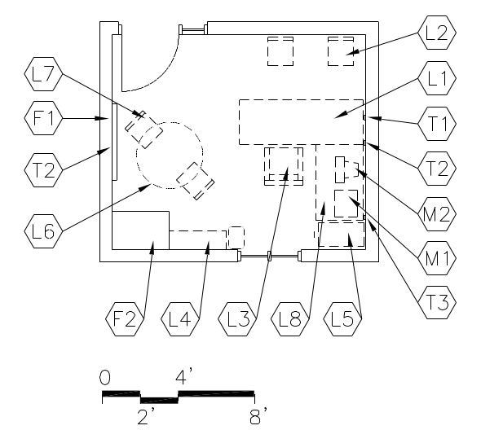  CAPACITY:  - Assistant Principal  SIZE:  - 120 SF  ANCILLARY SPACES:  N/A | GOAL:  - To provide an office for the assistant principal to perform administrative functions  PROGRAM ACTIVITIES:  - Conferences with parents  - Student interaction  - Conferences with individual teachers or small groups  - Telephone communications (private)  - Research and planning  - Coordination of school and support services  SPATIAL RELATIONSHIPS:  - May be located near Academic Core for supervision  - May be located near administration suite  ENVIRONMENTAL CONSIDERATIONS:  - Uniform lighting  - Environmental sound control:  Wall minimum: STC 45  Ceiling minimum: CAC 35  - Electrical outlets for equipment  - Windows to provide natural light  - Auditory privacy
NOTES:

1. Loose furnishings and features shown represent one of many possible arrangements

ASSISTANT PRINCIPAL’S/BUSINESS OFFICE
Spec.  Finishes¹: Ref.#  Flooring:  Tile carpet 096813  Base:  Resilient base 096519  Ceiling (8’ high minimum):  Suspended, acoustical 095113  Walls:  Painted gypsum wallboard  over metal studs 092116 / 099123  Loose Furnishings:  L1 Admin workstation  L2 2 visitor chairs  L3 Ergonomic task chair  L4 Adjustable height bookshelves (12 LF)  L5 Four-drawer file cabinet  L6 Round table | Spec.  Features¹: Ref.#  Fixed Equipment:  F1 Tack board (4 LF) 101100  F2 Casework:  Wardrobe 103200  Fire Suppression: Div. 21  Fire suppression system  Plumbing:  N/A  HVAC: Div. 23  Supply/return air system  Independent temperature  control  Electrical: Div. 26  Duplex receptacles  2-Outlets per wall minimum  TVSS protected quad receptacle  adjacent to data and video port  Single-level switching  Fluorescent lighting  Illumination level: See Table 7600-16  Central sound system 16823  Communications: Div. 27  T1 Voice port and phone  T2 2 data ports  T3 Data port for printer  Electronic Safety and Security: Div. 28  Life safety devices per code  Miscellaneous:  M1 Printer  M2 Computer
NOTES:

Finishes/Features: Refer to Chapter 8 for specification references.

ADMINISTRATIVE WORKROOM E-AD-7
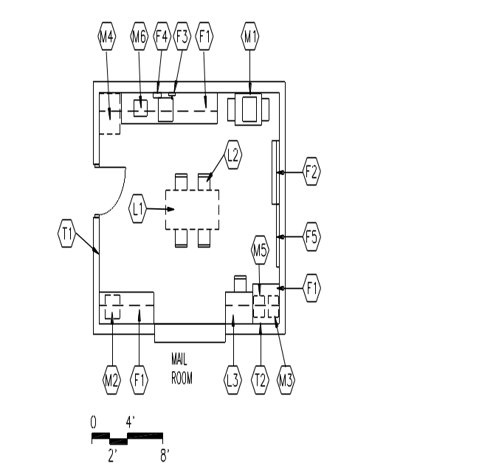  CAPACITY:  - Secretaries and Administrators  - Volunteers  - Staff  SIZE:  - Varies, see table  ANCILLARY SPACES:  - Mail Room (E-AD-8) | GOAL:  - To provide an area for office production activities  PROGRAM ACTIVITIES:  - Copying  - Collating  - Sorting of files  - Preparing communications for mailing  - Binding reports  - Telephone communications  SPATIAL RELATIONSHIPS:  - Near Welcome Center  - Adjacent to Mail Room  ENVIRONMENTAL CONSIDERATIONS:  - Uniform lighting, appropriate to task  - Environmental sound control:  Wall minimum: STC 45  Ceiling minimum: CAC 35  - Adequate ventilation  - Electrical outlets for equipment  - Organize for efficient work flow and sufficient clearance for several people to work at one time
NOTES:

1. Loose furnishings and features shown represent one of many possible arrangements.

ADMINISTRATIVE WORKROOM
Spec.  Finishes¹: Ref.#  Flooring:  Tile carpet 096813  Base:  Resilient base 096519  Ceiling (8’ high minimum):  Suspended, acoustical 095113  Walls:  Painted gypsum wallboard  over metal studs 092116 / 099123  Loose Furnishings:  L1 Work table  L2 4 chairs; task chair  L3 Computer workstation  Wastebasket  Miscellaneous:  M1 Copier  M2 Paper cutter  M3 Laminating machine  M4 Refrigerator with ice maker  M5 Color printer  M6 Microwave | Spec.  Features¹: Ref.#  Fixed Equipment:  F1 Casework: 123200  Base/wall cabinets and shelving  F2 Marker board (4 LF) 101100  F3 Soap dispenser 102800  F4 Towel dispenser 102800  F5 Tack board (4 LF) 101100  Fire Suppression: Div. 21  Fire suppression system  Plumbing: (optional) Div. 22  Plumbing connections  Hook-up for refrigerator ice maker,  sink, single/deep bowl  HVAC: Div. 23  Supply/return air system  Independent temperature  control  Electrical: Div. 26  Duplex receptacles  Raceway above countertop  TVSS protected quad receptacle  adjacent to each data port  Single-level switching  Fluorescent lighting  Illumination level: See Table 7600-16  Dedicated receptacle for copier  Clock  Central sound system  Communications: Div. 27  T1 Voice ports and phones  T2 Data port for printer  Electronic Safety and Security: Div. 28  Life safety devices per code
NOTES:

- Finishes/Features: Refer to Chapter 8 for specification references.

MAILBOX AREA IN WORKROOM E-AD-8
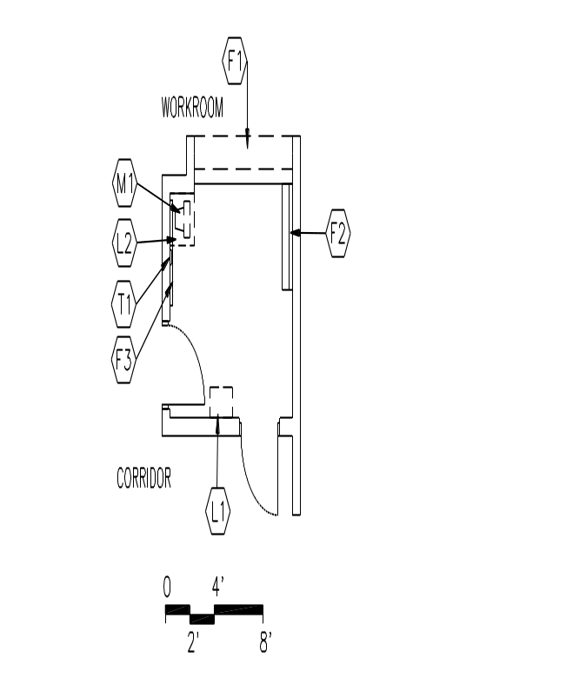  CAPACITY:  - Staff  - Faculty  SIZE:  - Varies, see table  ANCILLARY SPACES:  - Administrative Workroom (E-AD-7) | GOAL:  - To provide an area to disseminate mail to staff members  PROGRAM ACTIVITIES:  - Delivery of general mail  - Sign in/out location  SPATIAL RELATIONSHIPS:  - Adjacent to Administrative Workroom  - Accessible from main corridor  Fixed Equipment:  F1 Casework: 123200  Mail slots  12" wide x 6" high x 15" deep  (45-50 total slots) pass-through  cabinet
NOTES:
1. Loose furnishings and features shown represent one of many possible arrangements. The mail cubicles can be either on the wall or through the wall, verify with each school for their preference.

RECORDS ROOM E-AD-9
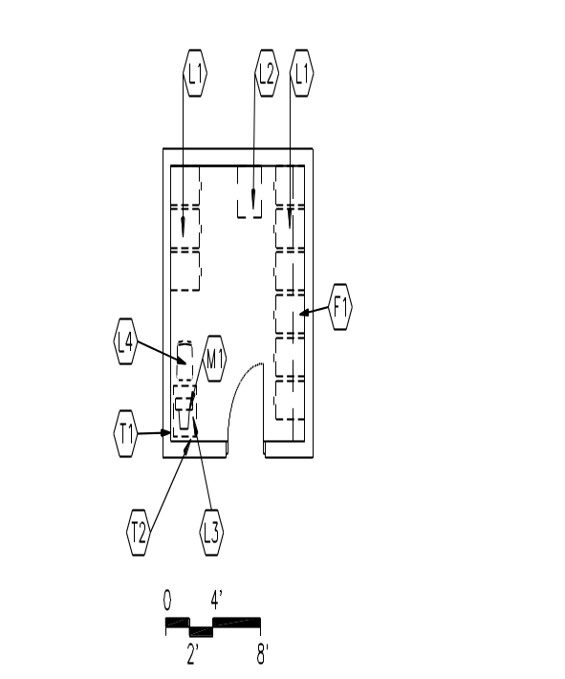  CAPACITY:  - Secretaries  - Staff  SIZE:  - Varies, see table  ANCILLARY SPACES:  N/A | GOAL:  - To provide secure, fireproof, and adequate storage for money, records, and other valuable items  PROGRAM ACTIVITIES:  - Storing of money and other valuable items  - Storage of files and records  - Accessible to administration staff  SPATIAL RELATIONSHIPS:  - Near Data Entry Office  ENVIRONMENTAL CONSIDERATIONS:  - Uniform lighting  - Security of door
NOTES:

- Loose furnishings and features shown represent one of many possible arrangements.

RECORDS ROOM
Spec.  Finishes¹: Ref.#  Flooring:  Tile carpet 096813  Base:  Resilient base 096519  Ceiling (8’ high minimum)  Suspended, acoustical 095113  Walls:  Painted concrete masonry units  042000 / 099123  Loose Furnishings:  L1 8-10, four-drawer file cabinets (fireproof)  L2 Small safe  L3 Small table  L4 Chair | Spec.  Features¹: Ref.#  Fixed Equipment:  F1 Casework:  Wall shelving 123200  Fire Suppression: Div. 21  Fire suppression system  Plumbing:  N/A  HVAC: Div. 23  Exhaust air system  Electrical: Div. 26  Duplex receptacles  TVSS protected quad receptacle  adjacent to each data port  Single-level switching  Fluorescent lighting  Illumination level: See Table 7600-16  Communications: Div. 27  T1 Voice port and phone  T2 Data port
NOTES:

- Finishes/Features: Refer to Chapter 8 for specification references.

STAFF TOILET E-AD-11
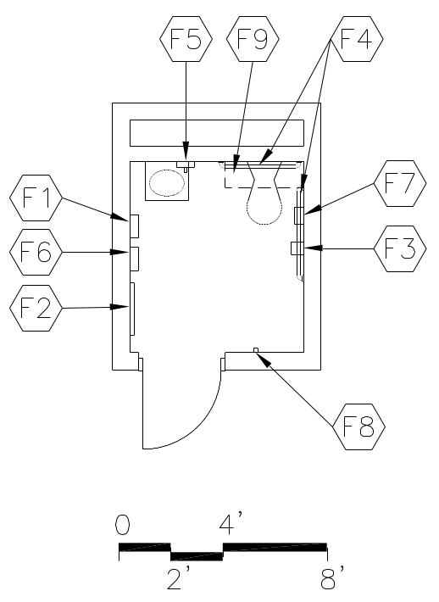  CAPACITY:  - Staff  SIZE:  - 50 SF  ANCILLARY SPACES:  N/A | PROGRAM ACTIVITIES:  - Personal and health needs for administrative staff  - Changing clothing  SPATIAL RELATIONSHIPS:  - Near Welcome Center  ENVIRONMENTAL CONSIDERATIONS:  - Uniform lighting  - Environmental sound control:  Wall minimum: STC 45  Ceiling minimum: CAC 35  - Moisture- and stain- resistant finishes  - Adequate exhaust/ventilation

NOTES:

1. Extend walls above ceiling to deck above for security and acoustical reasons.
2. Provide staff restrooms for both men and women.
3. Each pair of staff restrooms should be distributed throughout the building at appropriate locations.
STAFF TOILET E-AD-11
Spec.  Finishes¹: Ref.#  Flooring:  Ceramic tile 093000  Base:  Ceramic mosaic tile base 093013  Resilient 096519  Ceiling:  Suspended, acoustical 095113  Walls:  Painted concrete masonry units  042000 / 099123 | Spec.  Features¹: Ref.#  Fixed Equipment:  F1 Towel dispenser 102800  F2 24" x 60" mirror 102800  F3 Toilet tissue holder 102800  F4 36" and 42" grab bars 102800  F5 Soap dispenser 102800  F6 Sanitary dispenser 102800  F7 Sanitary disposal 102800  F8 Coat hook 102800  F9 Casework:  Wall cabinet 103200  Fire Suppression: Div. 21  Fire suppression system  Plumbing: Div. 22  Wall-mounted water closet  Wall-mounted lavatory  Plumbing connections  Floor drain  HVAC: Div. 23  Exhaust air system  Supplemental heat as required  Electrical: Div. 26  Duplex receptacles  Single-level switching  Fluorescent lighting  Illumination level: See Table 7600-16  Fire alarm devices per code  Communications:  N/A  Electronic Safety and Security: Div. 28  Life safety devices per code  Miscellaneous:  N/A

NOTES:

- Finishes/Features: Refer to Chapter 8 for specification references.

WAITING/TREATMENT AREA (HEALTH SUITE) E-AD-16
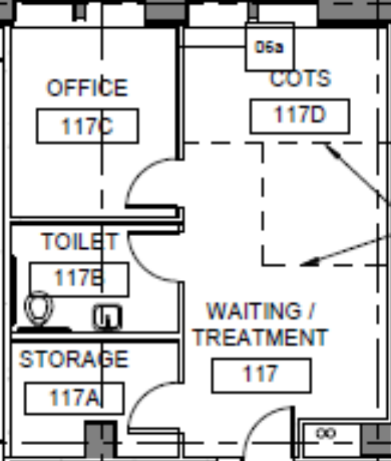  CAPACITY:  - 1 staff member/volunteer/nurse  - Students  SIZE:  - 180 SF  ANCILLARY SPACES:  - Office (E-AD-15)  - Cots  - Storage | GOAL:  - To provide school-based health services  PROGRAM ACTIVITIES:  - First aid  - Consultation with students  - Health screening  - Medical treatments  - Medication administration  - Student resting while awaiting pick-up by parent or guardian  ENVIRONMENTAL CONSIDERATIONS:  - Uniform lighting  - Environmental sound control:  Wall minimum: STC 45  Ceiling minimum: CAC 35  - Stain-resistant floor covering  - Sink with hot and cold water  - Adequate ventilation  - Electrical outlets for equipment  - Locate away from rooms with copiers, interferes with hearing screening  - Auditory and visual privacy  - Visual control to Office/Waiting or Welcome Center

NOTES:

1. Loose furnishings and features shown represent one of many possible arrangements.
WAITING/TREATMENT AREA (HEALTH SUITE) E-AD-16
Spec.  Finishes¹: Ref.#  Flooring:  Resilient tile flooring 096519  Base:  Resilient base 096519  Ceiling (8’ high minimum):  Suspended, acoustical 095113  Walls:  Painted gypsum wallboard  over metal studs 092116 / 099123  Loose Furnishings:  2-3 Chairs  Side table  Mobile exam table  Stool | Spec.  Features¹: Ref.#  Fixed Equipment:  F1 Casework:  Base/wall cabinets 123200  Place for refrigerator  F2 Casework:  Tall storage 123200  F3 Cubicle curtain 102123  F4 Soap dispenser 102800  F5 Towel dispenser 102800  Tackboard  Fire Suppression: Div. 21  Fire suppression system  Plumbing: Div. 22  Plumbing connections  Single sink w/hands-free gooseneck  HVAC: Div. 23  Supply/return air system  Electrical: Div. 26  Duplex receptacles  TVSS protected quad receptacle  adjacent to each data port  Single-level switching  Fluorescent lighting  Illumination level: See Table 7600-16  Clock  Central sound system  Communications: Div. 27  T1 Voice port and phone  T2 Data port  Electronic Safety and Security: Div. 28  Life safety devices per code

OFFICE AREA - Health Suite E-AD-15
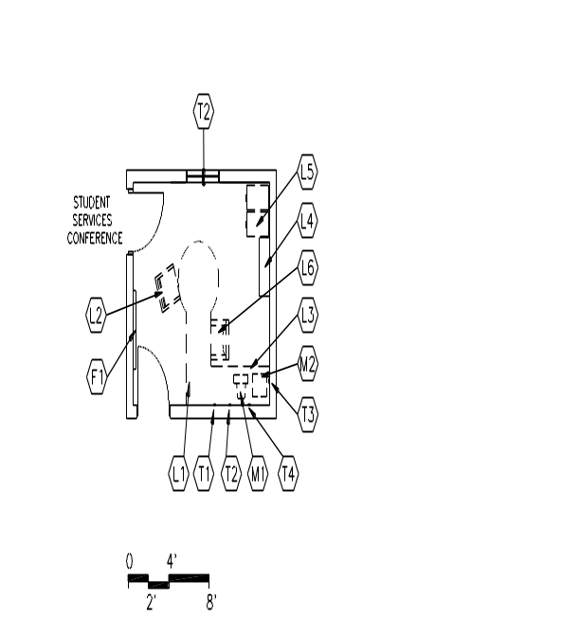  CAPACITY:  - Staff  - Students  - Parents  - Visitors  SIZE:  - 100 SF  ANCILLARY SPACES:  - Treatment Area (E-AD-16)  Storage (E-AD-18) | GOAL:  - Administrative and meeting area for health services  PROGRAM ACTIVITIES:  - Meeting area for students parent or guardian  - Administrative activities by school nurse  - Private conversations  SPATIAL RELATIONSHIPS:  - Adjacent and access to Treatment Area  - Adjacent and access to Storage  ENVIRONMENTAL CONSIDERATIONS:  - Uniform lighting  - Environmental sound control:  Wall minimum: STC 40  Ceiling minimum: CAC 35  - Visual control to Welcome Center or corridor  - Visual and auditory privacy

NOTES:
1. Loose furnishings and features shown represent one of many possible arrangements.
OFFICE AREA - Health Suite E-AD-15
Spec.  Finishes¹: Ref.#  Flooring:  Resilient tile flooring 096519  Base:  Resilient base 096519  Ceiling (8’ high minimum):  Suspended, acoustical 095113  Walls:  Painted gypsum wallboard  over metal studs 092116 / 099123  Loose Furnishings:  L1 Admin workstation  L2 Ergonomic chair  L3 1-2 visitor chairs  File cabinet | Spec.  Features¹: Ref.#  Fixed Equipment:  F1 Tack board (4 LF) 101100  Fire Suppression: Div. 21  Fire suppression system  Plumbing:  N/A  HVAC: Div. 23  Supply/return air system  Electrical: Div. 26  Duplex receptacles  2 outlets per wall, minimum  TVSS protected quad receptacle  adjacent to each data port  Single-level switching  Fluorescent lighting  Illumination level: See Table 7600-16  Clock  Central sound system  Communications: Div. 27  T1 Voice port and phone  2 Data port for printer  T3 Data port near workstation  T4 Cable/MATV  T5 Video port, monitor, VCR/DVD,  and brackets  Electronic Safety and Security: Div. 28  Life safety devices per code

NOTES:
- Finishes/Features: Refer to Chapter 8 for specification references.

COTS Health Suite
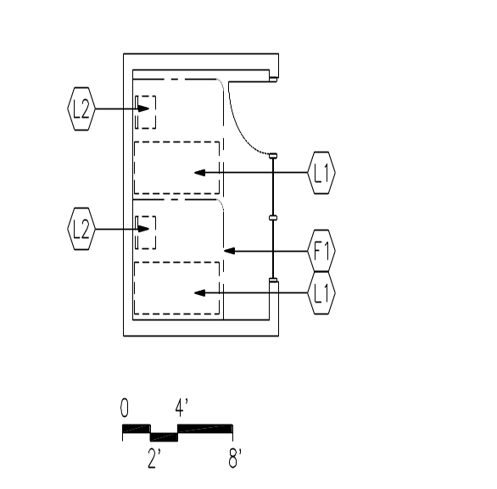  CAPACITY:  - Staff  - Students  SIZE:  - 150 SF  ANCILLARY SPACES:  N/A | GOAL:  - To provide a place for students and staff to lie down when feeling ill  PROGRAM ACTIVITIES:  - A resting place for students and staff when feeling ill  SPATIAL RELATIONSHIPS:  - Located within Health Suite  - Near welcome center  ENVIRONMENTAL CONSIDERATIONS:  - Uniform lighting/dimmable lighting  - Environmental sound control:  Wall minimum: STC 45  Ceiling minimum: CAC 35  - Stain-resistant floor covering  - Adequate ventilation  - Auditory and visual privacy  - Visual control from Office/Waiting or Welcome Center

NOTES:

1. Loose furnishings and features shown represent one of many possible arrangements.
COTS
Spec.  Finishes¹: Ref.#  Flooring:  Resilient tile flooring 096519  Base:  Resilient base 096519  Ceiling (8’ high minimum):  Suspended, acoustical 095113  Walls:  Painted gypsum wallboard  over metal studs 092116 / 099123  Loose Furnishings:  L1 3 cots  L2 2 chairs | Spec.  Features¹: Ref.#  Fixed Equipment:  F1 Cubicle curtains 102123  Fire Suppression: Div. 21  Fire suppression system  Plumbing:  N/A  HVAC: Div. 23  Supply/return air system  Electrical: Div. 26  Duplex receptacles  Single-level switching  Fluorescent lighting with dimmer  Illumination level: See Table 7600-16  Clock  Central sound system  Communications:  N/A  Electronic Safety and Security: Div. 28  Life safety devices per code  Miscellaneous:  N/A

NOTES:

Finishes/Features: Refer to Chapter 8 for specification references.

STORAGE
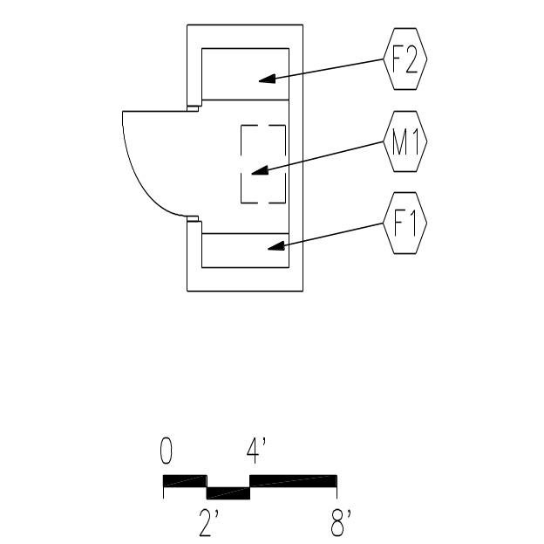  CAPACITY:  - Staff  SIZE:  - 25 SF  ANCILLARY SPACES:  - Office/Waiting Area (E-AD-15) | GOAL:  - To provide storage for medical supplies and equipment  PROGRAM ACTIVITIES:  - Storing chemicals, equipment, and supplies  SPATIAL RELATIONSHIPS:  - Adjacent and access to Office/Waiting  ENVIRONMENTAL CONSIDERATIONS:  - Uniform lighting  - Security of equipment, supplies, and medicines  - Security of door

NOTES:

1. Loose furnishings and features shown represent one of many possible arrangements.
STORAGE
Health Suite
Spec.  Finishes¹: Ref.#  Flooring:  Resilient tile flooring 096519  Base:  Resilient base 096519  Ceiling (8’ high minimum):  Cleanable, suspended, acoustical 095113  Walls:  Painted concrete masonry units  042000 / 099123  Loose Furnishings:  N/A  Note: Refrigerator may be in the office area | Spec.  Features¹: Ref.#  Fixed Equipment:  F1 Storage shelving: 105613  12" deep  F2 Storage shelving: 105613  18" deep  Fire Suppression: Div. 21  Fire suppression system  Plumbing: Div. 22  Fire protection system  Plumbing connections  Hook-up for ice maker  HVAC: Div. 23  Supply/return air system  Electrical: Div. 26  Duplex receptacles  Single-level switching  Fluorescent lighting  Illumination level: See Table 7600-16  Communications:  N/A  Electronic Safety and Security: Div. 28  Life safety devices per code  Miscellaneous:  M1 Refrigerator (lockable) with ice maker

NOTES:

- Finishes/Features: Refer to Chapter 8 for specification references.

TOILET E-AD-19
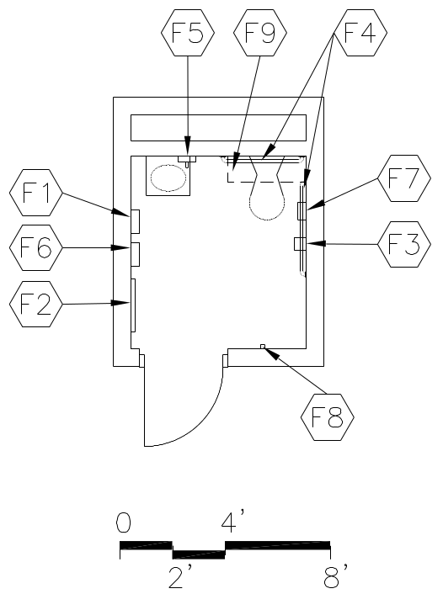  CAPACITY:  - Students  - Staff  SIZE:  - 50 SF  ANCILLARY SPACES:  N/A | PROGRAM ACTIVITIES:  - Personal and health needs for the health suite  - Changing clothing  SPATIAL RELATIONSHIPS:  - Located within Health Suite  ENVIRONMENTAL CONSIDERATIONS:  - Uniform lighting  - Environmental sound control:  Wall minimum: STC 45  Ceiling minimum: CAC 35  - Moisture- and stain-resistant finishes  - Adequate exhaust/ventilation

NOTES:

- Loose furnishings and features shown represent one of many possible arrangements.
TOILET
Spec.  Finishes¹: Ref.#  Flooring:  Ceramic tile 093000  Base:  Ceramic mosaic tile base 093013  Resilient base 096519  Ceiling:  Suspended, acoustical 095113  Walls:  Painted concrete masonry units  042000 / 099123 | Spec.  Features¹: Ref.#  Fixed Equipment:  F1 Towel dispenser 102800  F2 24" x 60" mirror 102800  F3 Toilet tissue holder 102800  F4 36" and 42" grab bars 102800  F5 Soap dispenser 102800  F6 Sanitary dispenser 102800  F7 Sanitary disposal 102800  F8 Coat hook 102800  F9 Casework:  Wall cabinet 103200  Fire Suppression: Div. 21  Fire suppression system  Plumbing: Div. 22  Wall-mounted water closet  Wall-mounted lavatory  Plumbing connections  Floor drain  HVAC: Div. 23  Exhaust air system  Supplemental heat as required  Electrical: Div. 26  Duplex receptacles  Single-level switching  Fluorescent lighting  Illumination level: See Table 7600-16  Central sound system  Communications:  N/A  Electronic Safety and Security: Div. 28  Life safety devices per code  Miscellaneous:  N/A

NOTES:

1. Finishes/Features: Refer to Chapter 8 for specification references.

STAFF LOUNGE E-AD-21
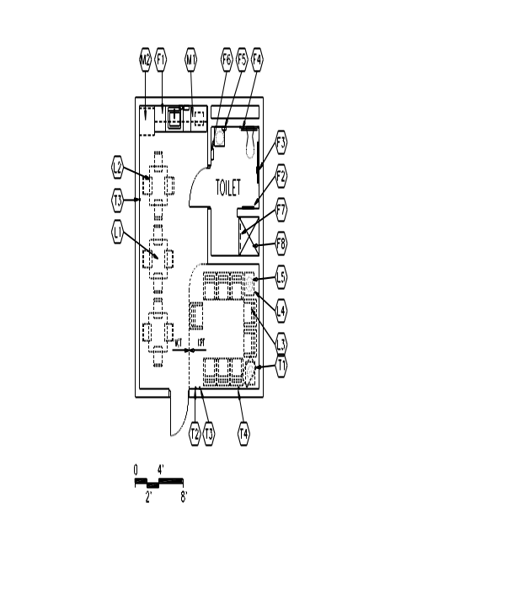  CAPACITY:  - Staff  SIZE:  - Varies, see table  ANCILLARY SPACES:  N/A | GOAL:  - To provide an area for staff dining and for relaxing  PROGRAM ACTIVITIES:  - Staff dining  - Relaxation  SPATIAL RELATIONSHIPS:  - Near Academic Classrooms  - Access to Main Corridor  - May be divided among floors  ENVIRONMENTAL CONSIDERATIONS:  - Uniform lighting, appropriate to task  - Environmental sound control:  Wall minimum: STC 45  Ceiling minimum: CAC 40  - Electrical outlet for equipment  - Windows to provide natural light, desirable

NOTES:

1. Loose furnishings and features shown represent one of many possible arrangements.
STAFF LOUNGE Administrative Support
Spec.  Finishes¹: Ref.#  Flooring:  Tile carpet 096813  Linoleum 096516  Shower: Ceramic mosaic tile 093013  Base:  Resilient base 096519  Shower: Ceramic mosaic tile base 093013  Ceiling (8’ high minimum):  Suspended, acoustical 095113  Shower: Painted portland cement  plaster 092400 / 099123  Walls:  Painted gypsum wallboard  over metal studs 092116 / 099123  Shower: Ceramic tile 093013  Loose Furnishings:  L1 3 square tables  L2 10-15 chairs  L3 3-5 lounge chairs  L4 2 end tables  L5 2 table lamps  Communications: Div. 27  T2 Voice port and phone  T3 2 data ports  Miscellaneous:  M1 Microwaves  M2 Refrigerator with ice maker | Spec.  Features¹: Ref.#  Fixed Equipment:  F1 Casework:  Base/wall cabinets 123200  F2 24" x 60" mirror 102800  F3 Toilet tissue dispenser 102800  F4 36" and 42" grab bars 102800  F5 Soap dispenser 102800  F6 Towel dispenser 102800  F7 Shower curtain with rod 102800  F8 ADA shower accessories 102800  Fire Suppression: Div. 21  Fire suppression system  Plumbing: Div. 22  Plumbing connections  Wall-mounted lavatory  Wall-mounted water closet  Floor drains - in restroom and shower  HVAC: Div. 23  Supply/return air system  Exhaust air system  Independent temperature  control  Electrical: Div. 26  Duplex receptacles  TVSS protected quad receptacle  adjacent to each data and  video port  Multilevel switching  Fluorescent lighting  Illumination level: See Table 7600-16  Clock  Central sound system  Electronic Safety and Security: Div. 28  Life safety devices per code

NOTES:

Finishes/Features: Refer to Chapter 8 for specification references.

Dinning and Food Services
Spaces | Suggested |  |  | Comments
 | Qty. | S.F. | Total
Student Dining Area/Multi-purpose | 1 | 2,250 | 2,250
Chair and Table Storage | 1 | 250 | 250
Serving area | 1 | 300 | 200
Kitchen Suite | 1 | 1800 | 1800
Total |  |  | 4,500

Comments: The overall total for the Dining and Food Services area may be + or – 15%. The existing dining area and kitchen are undersized for the proposed capacity. If these spaces are replaced, the school would like to keep the current dining as a multi-purpose area if feasible. If this area is expanded, the room should be dividable.

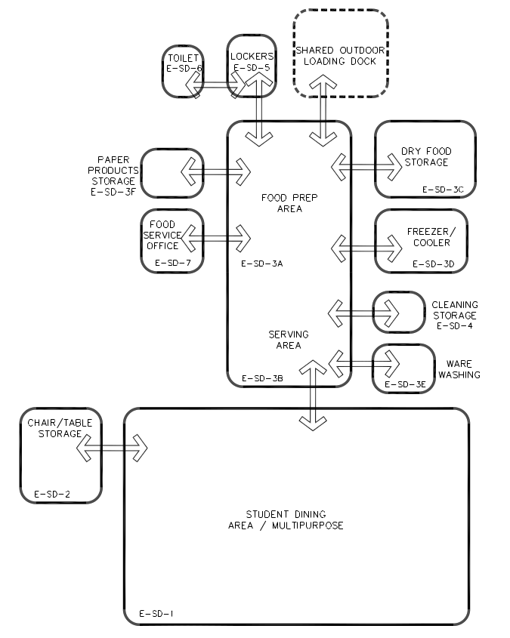
STUDENT DINING AREA / MULTIPURPOSE SD-1
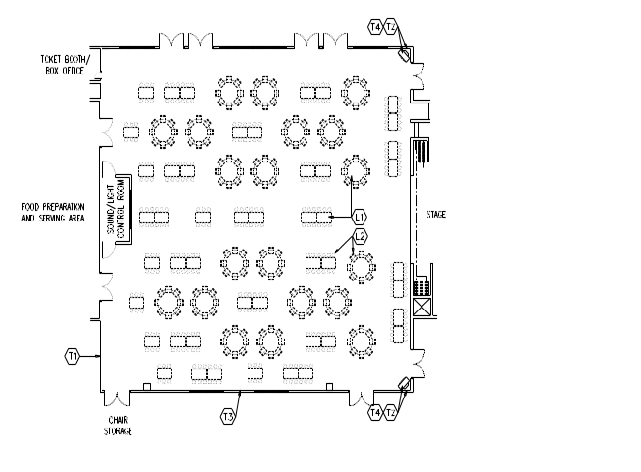  CAPACITY:  - 1/3 of students per lunch period  - 1/3 of staff members per lunch  - Community (after hours)  ANCILLARY SPACES  - Chair/Table Storage (SD-2)  - Food Preparation Area (SD-4) | GOALS:  - To provide a pleasant atmosphere for students to eat meals  - To provide a flexible meeting space for groups if needed  PROGRAM ACTIVITIES:  - Student dining  - School and community programs, meetings, and activities  SPATIAL RELATIONSHIPS:  - Adjacent and access to Food Preparation Area  - Adjacent and access to Chair/Table Storage  - Centrally located to office area, gymnasium, classrooms, and media center  ENVIRONMENTAL CONSIDERATIONS:  - Lighting appropriate to tasks  - Adequate ventilation  - Electrical outlets for equipment along perimeter walls and on columns  - Environmental sound control:  Wall minimum: STC 45  Ceiling minimum: CAC 35  - Higher than normal ceiling height  - Cleanable building surfaces  - Windows to provide ample natural light  - Good sight lines to all areas of the room for supervision  - Window treatment to darken room for AV presentation  - Outlets and data ports for salad bar/POS  Flush to ground with cover  Cold filtered water

NOTES:

1. Loose furnishings and features shown represent one of many possible arrangements.
STUDENT DINING AREA / MULTIPURPOSE SD-1
Spec.  Finishes¹: Ref.#  Flooring:  Fluid-applied athletic flooring 096766  Base:  Resilient base 096519  Ceiling: (15’ high minimum)  Suspended, acoustical 095113  Walls:  Painted concrete masonry units  042000 / 099123  Acoustical wall treatment 098400  Loose Furnishings:  L1 Tables and seating to accommodate 1/3 of school capacity (266 for lunch)  Miscellaneous:  M1 Audio system | Spec.  Features¹: Ref.#  N/A  Fire Suppression: Div. 21  Fire suppression system  Plumbing: Div. 22  Electric water cooler  HVAC: Div. 23  Supply/return air system  Independent temperature  control  Air conditioning  Electrical: Div. 26  Duplex receptacles  Vending Machines  TVSS protected quad receptacles  adjacent to each data and  video port  Multilevel switching  Fluorescent lighting  Illumination level: See Table 7600-16  Clock  Student dining sound system²  Central sound system  Communications: Div. 27  T1 2 cable/MATV ports  T2 4 data ports  T3 Voice port and phone  T4 2 video ports, monitors, VCRs/DVDs,  and brackets  Electronic Safety and Security: Div. 28  Life safety devices per code

NOTES:

1. Finishes/Features: Refer to Chapter 8 for specification references.
CHAIR / TABLE STORAGE SD-2
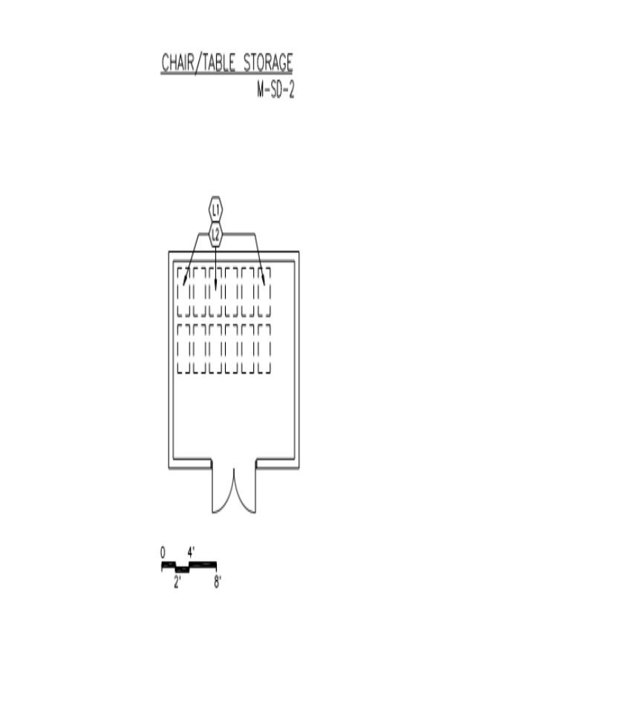  .  CAPACITY:  N/A  SIZE:  - Varies, see table  ANCILLARY SPACES:  - Student Dining Area/Multipurpose  (M-SD-1) | GOAL:  - To provide convenient storage of dining chairs and tables to be used for meetings and performances  PROGRAM ACTIVITY:  - Storage  SPATIAL RELATIONSHIPS:  - Adjacent and access to Student Dining Area/Multipurpose  ENVIRONMENTAL CONSIDERATIONS:  - Uniform lighting  - Cleanable building surfaces  - Accessibility for moving furniture in and out

NOTES:

1. Loose furnishings and features shown represent one of many possible arrangements.
CHAIR / TABLE STORAGE SD-2
Spec.  Finishes¹: Ref.#  Flooring:  Resilient tile flooring 096519  Base:  Resilient base 096519  Ceiling:  Suspended, acoustical 095113  Walls:  Painted concrete masonry units  042000 / 099123  Loose Furnishings:  L1 Chairs  L2 Chair dollies | Spec.  Features¹: Ref.#  Fixed Equipment:  N/A  Fire Suppression: Div. 21  Fire suppression system  Plumbing:  N/A  HVAC: Div. 23  Supply/return air system  Electrical: Div. 26  Duplex receptacles  Single-level switching  Fluorescent lighting  Illumination level: See Table 7600-16  Communications:  N/A  Electronic Safety and Security:  N/A  Miscellaneous:  N/A

NOTES:

- Finishes/Features: Refer to Chapter 8 for specification references.

COOKING KITCHEN
This space consists of the following areas:  A space plate follows for each of these areas.  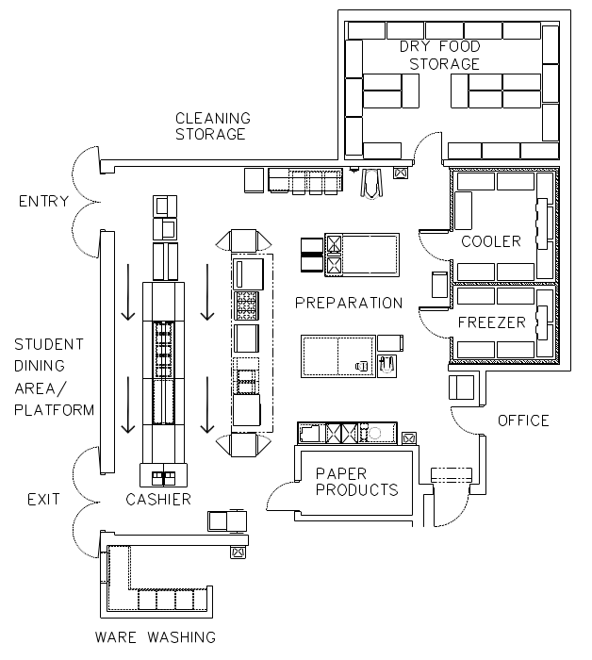  CAPACITY:  - Students  - Staff  - Community  ANCILLARY SPACES:  - Student Dining Area/Multipurpose (E-SD-1) | GOAL:  - To provide an area for the preparation of student and staff meals  PROGRAM ACTIVITIES:  - Prep food  (food delivered from milk, grocery, and produce vendors)  - Serve food  - Storage  - Point of sale (in the dining area associated with the serving area)  SPATIAL RELATIONSHIPS:  - Near loading dock to permit semi-tractor trailers access to docking and storage areas (site specific)  - Adjacent and access to Student Dining Area/Multipurpose  - Near dumpsters  - Cafeteria serving arrangement  ENVIRONMENTAL CONSIDERATIONS:  - Food service department, public health  - Durable flooring  - Proper ventilation of space to remove cooking odors  - Cleanable building surfaces  Hand sinks in each area of service, production, dishwashing, and serving.  Paper towel dispensers need to be uniform with the rest of the school for ordering purposes.  Soap dispensers need to be uniform with schools for ordering purposes.
  Food Preparation Area | 750
  Dry Food Storage | 250
  Freezer & Cooler | 250
  Ware Washing | 100
  Paper Storage | 225
  Lockers | 75
  Toilet | 50
  Food Service Office | 100
   | 1800
NOTES:
- 1. This is an example of a kitchen. Food service equipment will vary from school to school; confirm
requirements with District of Columbia Public Schools Food Service Department.
FOOD preparation AREA
m  CAPACITY:  - Staff  SIZE:  - Varies, see table | GOAL:  - To prepare student meals  PROGRAM ACTIVITIES:  - Prepare food  SPATIAL RELATIONSHIPS:  - Adjacent to Student Dining Area/Multipurpose  - Open to Serving Area  ENVIRONMENTAL CONSIDERATIONS:  - Uniform lighting  - Proper ventilation of space to remove cooking  odors  - Cleanable building surfaces  - Electrical/plumbing/mechanical connections for food service equipment  - Towel dispensers, Soap dispensers,
This is an example of a preparation area. Food service equipment will vary from school to school; confirm requirements with District of Columbia Public Schools Food Service Department.

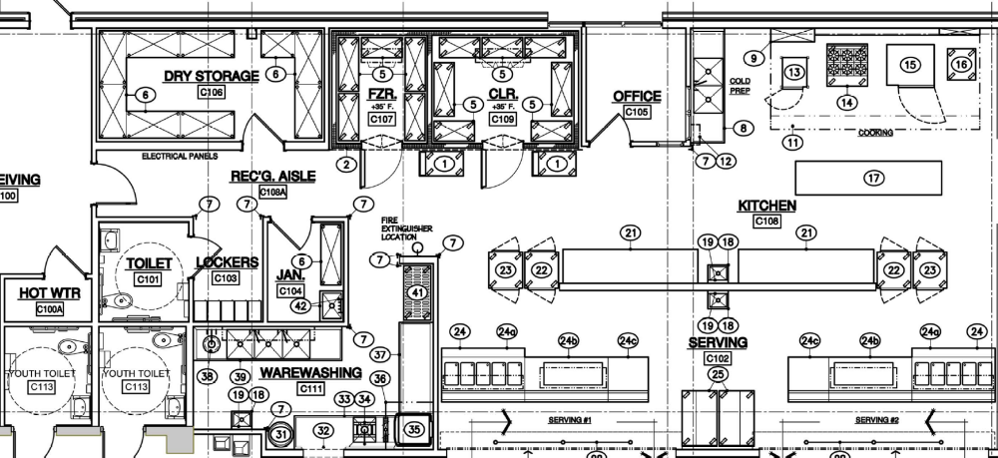
FOOD PREPARATION AREA
Spec.  Finishes¹: Ref.#  Flooring:  Easy clean, non-slip flooring - Single surface poured or rolled flooring  Base:  Resilient base 096519  Ceiling:  Cleanable, suspended, acoustical 095113  Walls:  Epoxy-painted concrete masonry units  Water areas of kitchen, eg. Dish room, pot sink area.  042000 / 099123  Features (Specifications from DCPS):  Equipment:  - Pot washing sinks  - Food Preparation Sinks  - Hand Sinks with adjacent trash bin  - Work Tables  - Warming/Holding/Cabinets  - Refrigeration - Reach-ins  - Storage shelving  - Mop washing sink  - Lockable chemical storage  - Exhaust Hood Systems, including Fire Suppression  - Combi oven  - Convection steamer  - Range, with oven, convection base  - Ware Washing Machine with appropriate accessories (tables, booster heater, disposer, etc.) | Spec.  Ref.#  Fire Suppression: Div. 21  Fire suppression system  Plumbing: Div. 22  Connections to food  service equipment  Plumbing and gas connections  Hand washing lavatory  Floor drains  Food preparation sink with adjacent trash bin  HVAC: Div. 23  Supply/return air system  Independent temperature control  Kitchen canopy exhaust system  Air conditioning  Electrical: Div. 26  Duplex receptacles  Connections to food  service equipment  Single-level switching  Fluorescent lighting  Illumination level: See Table 7600-16  Clock  Central sound system  Communications:  N/A  Electronic Safety and Security: Div. 28  Life safety devices per code  Miscellaneous:  N/A

NOTES:
- Finishes/Features: Refer to Chapter 8 for specification references.

Serving Area E-SD-3B
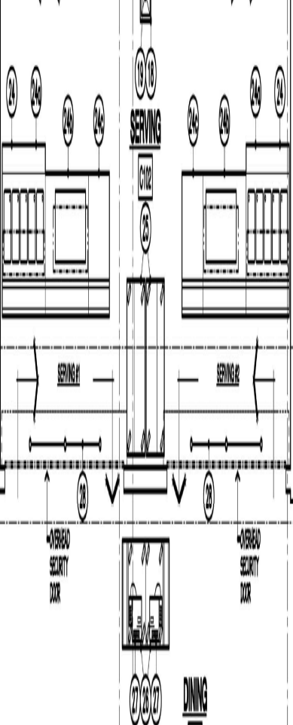  CAPACITY:  - Students  - Staff  - Community  ANCILLARY SPACES:  - Student Dining Area/Multipurpose (E-SD-1)  - Kitchen (E-SD-3) | GOAL:  - To provide serving station for those seeking meals or snacks  PROGRAM ACTIVITIES:  - Serve food  SPATIAL RELATIONSHIPS:  - Within Student Dining Area/Multipurpose or Food Preparation Area  - Beginning of serving line should be near entry door of Students Dining Area/Multipurpose  - Adjacent and access to Student Dining Area/Multipurpose  - Open to Food Preparation Area  ENVIRONMENTAL CONSIDERATIONS:  - Uniform lighting  - Cleanable building services  - Electrical connections for food service equipment

NOTES:
- This is an example of a serving area. Food service equipment will vary from school to school; confirm requirements with District of Columbia Public Schools Food Service Department.
- Loose furnishings and features shown represent one of many possible arrangements.

Serving Area E-SD-3B
Spec.  Finishes¹: Ref.#  Flooring:  Quarry tile 093000  Base:  Quarry tile base 093000  Ceiling:  Cleanable, suspended, acoustical 095113  Walls:  Epoxy-painted concrete masonry units  042000 / 099123  Loose Furnishings:  N/A  Miscellaneous:  Cash registers at end of at point of service  Fire Suppression: Div. 21  Fire suppression system  Plumbing: Div. 22  Connections to food service  equipment  Plumbing and gas connections  Hand washing lavatory  Floor drains | Spec.  Features¹: Ref.#  Fixed Equipment:  Drop-In Individually Controlled Heated Electric Food Wells, Full Service Sneeze Guard with overshelf may use existing milk box or a new airscreen refrigerator for beverages. Size of equipment and number of are determined by space available. A Drop-In Self-Contained Refrigerated Cold Pan will also be included for side items. Counter and sneeze guards are lower than normal for better viewing and service to elementary students.  HVAC: Div. 23  Supply/return air system  Independent temperature  control  Kitchen canopy exhaust system  Air conditioning  Electrical: Div. 26  Single-level switching  Fluorescent lighting  Illumination level: See Table 7600-16  Central sound system  Duplex receptacles along permanent  perimeter walls  Electrical supply to support  equipment specified  Clock  Circuits for portable generator  TVSS protected quad receptacle  adjacent to data and video ports  Communications: Div. 27  T1 1 voice port and phone  T2 2 data ports at cash registers or per salad bar  Electronic Safety and Security: Div. 28  Life safety devices per code

NOTES:

- Finishes/Features: Refer to Chapter 8 for specification references.

DRY Food Storage E-SD-3C
CAPACITY:  N/A  SIZE:  - Varies, see table  ANCILLARY SPACES:  - Warming Kitchen (E-SD-3) | GOAL:  - To provide an area for food storage  PROGRAM ACTIVITIES:  - Storage  SPATIAL RELATIONSHIPS:  - Near Supply Storage/Receiving  - Adjacent and access to  Food Preparation Area  ENVIRONMENTAL CONSIDERATIONS:  - Uniform lighting  - Cleanable building surfaces  - Adequate exhaust/ventilation
NOTES:
- This is an example of a dry food storage area. Food service equipment will vary from school to school; confirm requirements with District of Columbia Public Schools Food Service Department.
DRY Food Storage E-SD-3C
Spec.  Finishes¹: Ref.#  Flooring:  Quarry tile 093000  Base:  Quarry tile base 093000  Resilient base 096519  Ceiling:  Cleanable, suspended, acoustical 095113  Walls:  Epoxy-painted concrete masonry units  042000 / 099123  Loose Furnishings:  N/A | Spec.  Features¹: Ref.#  Fixed Equipment:  F1 Rust-resistant 24" deep shelving  and dunnage racks 114000  Fire Suppression: Div. 21  Fire suppression system  Plumbing:  N/A  HVAC: Div. 23  Supply/return air system  Electrical: Div. 26  Duplex receptacles  Single-level switching  Fluorescent lighting  Illumination level: See Table 7600-16  Fire alarm devices per code  Communications:  N/A  Electronic Safety and Security: Div. 28  Life safety devices per code  Miscellaneous:  N/A

NOTES:
- Finishes/Features: Refer to Chapter 8 for specification references.
Freezer AND Cooler E-SD-3D
SIZE:  - Varies, see table  ANCILLARY SPACES:  - Kitchen (E-SD-3) | GOAL:  - To provide space for manufactured freezer and refrigerator units to store food for short periods of time  PROGRAM ACTIVITIES:  - Storage  - Walk-in type  SPATIAL RELATIONSHIPS:  - Adjacent and access to  Food Preparation Area  - Near the Supply Storage/Receiving  ENVIRONMENTAL CONSIDERATIONS:  - Uniform lighting  - Ventilation for refrigeration machinery equipment  - Cleanable building surfaces  - Floor to be flush with adjacent kitchen floor  - Electrical service for refrigeration equipment  Freezer/coolers need to be connected to the generator.

NOTES:
- 1. This is an example of a freezer and cooler. Food service equipment will vary from school to school; confirm requirements with District of Columbia Public Schools' Food Service Department.
- generally, deliveries occur once a week.
Freezer AND Cooler
E-SD-3D
Spec.  Finishes¹: Ref.#  Flooring:  Poured Resin Floor  Base:  Manufactured insulated panel 114000  Ceiling:  Manufactured insulated panel 114000  Walls:  Manufactured insulated panel 114000  Loose Furnishings:  N/A | Spec.  Features¹: Ref.#  Fixed Equipment:  F1 Rust resistant 24" deep shelving  and dunnage racks 114000  Fire Suppression: Div. 21  Fire suppression system  Plumbing:  N/A  HVAC: Div. 23  Exhaust air system for compressors Div. 15  Electrical: Div. 26  Electrical connections to freezer/cooler  refrigeration equipment  Single-level switching  Incandescent lighting  Illumination level: See Table 7600-16  Communications:  N/A  Electronic Safety and Security:  N/A  Miscellaneous:  N/A
NOTES:
- Finishes/Features: Refer to Chapter 8 for specification references.

Ware Washing E-SD-3E
CAPACITY:  N/A  SIZE:  - Varies, see table  ANCILLARY SPACES:  - Kitchen (E-SD-3) | GOAL:  - To clean food service equipment  PROGRAM ACTIVITY:  - Space and equipment to scrape, wash, dry,  and store food service equipment  SPATIAL RELATIONSHIPS:  - Pass-through into Student Dining Area/Multipurpose  - Adjacent and access to  Food Preparation Area  ENVIRONMENTAL CONSIDERATIONS:  - Uniform lighting  - Proper ventilation of space to remove steam  and condensation  - Cleanable building surfaces
NOTES:
- his is an example of a ware washing area. Food service equipment will vary from school to school; confirm requirements with District of Columbia Public Schools' Food Service Department.
Ware Washing
E-SD-3E
Spec.  Finishes¹: Ref.#  Flooring:  Quarry tile 093000  Base:  Quarry tile base 093000  Resilient base 096519  Ceiling:  Cleanable, suspended, acoustical 095113  Walls:  Epoxy-painted concrete masonry units  042000 / 099123  Loose Furnishings:  N/A | Spec.  Features¹: Ref.#  Fixed Equipment:  F1 Food service equipment 114000  Fire Suppression: Div. 21  Fire suppression system  Plumbing: Div. 22  Lavatory  Connections to food service equipment  Three compartment sink  Floor drain  HVAC: Div. 23  Supply/return air system  Independent temperature  control  Exhaust hood system  Electrical: Div. 26  Duplex receptacles  Connections to food service  equipment  Single-level switching  Fluorescent lighting  Illumination level: See Table 7600-16  Central sound system  Communications:  N/A  Electronic Safety and Security: Div. 28  Life safety devices per code  Miscellaneous:  N/A
NOTES:
- Finishes/Features: Refer to Chapter 8 for specification references.

PAPER PRODUCTS STORAGE E-SD-3F
CAPACITY:  N/A  SIZE:  - Varies, see table  ANCILLARY SPACES:  - Kitchen (E-SD-3) | GOAL:  - To provide storage for paper products used in preparing and serving meals  - To provide storage for food program equipment (BIC, FFVP, and Early Childhood)  PROGRAM ACTIVITIES:  - Lockable space  SPATIAL RELATIONSHIPS:  - Adjacent and access to  Food Preparation Area  ENVIRONMENTAL CONSIDERATIONS:  - Uniform lighting  - Adequate exhaust/ventilation  - Cleanable building surfaces

NOTES:

- Loose furnishings and features shown represent one of many possible arrangements.
PAPER PRODUCTS STORAGE
Spec.  Finishes¹: Ref.#  Flooring:  Resilient tile flooring 096519  Base:  Quarry tile base 093000  Resilient base 096519  Ceiling:  Cleanable, suspended, acoustical 095113  Walls:  Epoxy-painted concrete masonry units  042000 / 099123  Loose Furnishings:  N/A | Spec.  Features¹: Ref.#  Fixed Equipment:  F1 Rust-resistant shelving 114000  Fire Suppression: Div. 21  Fire suppression system  Plumbing:  N/A  HVAC: Div. 23  Exhaust air system  Supply/return air system  Independent temperature  control  Electrical: Div. 26  Duplex receptacles  Single-level switching  Fluorescent lighting  Illumination level: See Table 7600-16  Communications:  N/A  Electronic Safety and Security:  N/A  Miscellaneous:  N/A

NOTES:
- Finishes/Features: Refer to Chapter 8 for specification references.

CLEANING STORAGE E-SD-4
CAPACITY:  - Food service staff  SIZE:  - 50 SF  ANCILLARY SPACES:  - Kitchen (E-SD-3) | GOAL:  - To store chemicals used in cleaning and maintaining kitchen  PROGRAM ACTIVITIES:  - Storing chemicals and equipment  SPATIAL RELATIONSHIPS:  - Adjacent and access to Kitchen  ENVIRONMENTAL CONSIDERATIONS:  - Uniform lighting  - Cleanable building surfaces  - Sensors for spilled chemicals  - Adequate exhaust/ventilation
NOTES:
- This is an example of a cleaning storage area. Food service equipment will vary from school to school; confirm requirements with District of Columbia Public Schools Food Service Department.
- Loose furnishings and features shown represent one of many possible arrangements.

LOCKERS E-SD-5
CAPACITY:  - Food service personnel  SIZE:  - 75 SF  ANCILLARY SPACES:  - Kitchen (E-SD-3)  - Toilet (E-SD-6) | GOAL:  - To provide space for the food service staff to store their personal belongings and to change their clothing  PROGRAM ACTIVITIES:  - Space for the storage of towels, aprons, etc.  - Space to allow food staff personnel to take breaks  SPATIAL RELATIONSHIPS:  - Adjacent and access to Kitchen  - Adjacent and access to Toilet  ENVIRONMENTAL CONSIDERATIONS:  - Uniform lighting  - Environmental sound control:  Wall minimum: STC 40  Ceiling minimum: CAC 35

NOTES:

1. Loose furnishings and features shown represent one of many possible arrangements.
LOCKERS
E-SD- 5
Spec.  Finishes¹: Ref.#  Flooring:  Resilient tile flooring 096519  Base:  Quarry tile base 093000  Resilient base 096519  Ceiling:  Suspended, acoustical 095113  Walls:  Painted concrete masonry units  042000 / 099123  Loose Furnishings:  L1 Chairs  L2 30" x 60" table  Wastebasket | Spec.  Features¹: Ref.#  Fixed Equipment:  F1 Lockers 105113  12" wide x 12" deep x 72" high  F2 Tack board (4 LF) 101100  Fire Suppression: Div. 21  Fire suppression system  Plumbing:  N/A  HVAC: Div. 23  Exhaust air system  Supplemental heat as required  Electrical: Div. 26  Duplex receptacles  Single-level switching  Fluorescent lighting  Illumination level: See Table 7600-16  Clock  Central sound system  Communications:  N/A  Electronic Safety and Security: Div. 28  Life safety devices per code  Miscellaneous:  N/A
NOTES:
1. Finishes/Features: Refer to Chapter 8 for specification references.

TOILET E-SD-6
CAPACITY:  - Food service personnel  SIZE:  - 50 SF  ANCILLARY SPACES:  - Lockers (E-SD-5) | PROGRAM ACTIVITIES:  - Personal and health needs for food service  staff  - Changing clothing  SPATIAL RELATIONSHIPS:  - Adjacent and access to lockers  - Near Kitchen  ENVIRONMENTAL CONSIDERATIONS:  - Uniform lighting  - Environmental sound control:  Wall minimum: STC 40  Ceiling minimum: CAC 35  - Moisture- and stain-resistant finishes  - Adequate exhaust/ventilation

NOTES:

- Loose furnishings and features shown represent one of many possible arrangements.
TOILET
E-SD-6
Spec.  Finishes¹: Ref.#  Flooring:  Ceramic tile 093000  Base:  Quarry tile base 093000  Resilient base 096519  Ceiling:  Suspended, acoustical 095113  Walls:  Painted concrete masonry units  042000 / 099123  Loose Furnishings:  N/A | Spec.  Features¹: Ref.#  Fixed Equipment:  F1 Towel dispenser 102800  F2 24" x 60" mirror 102800  F3 Toilet tissue holder 102800  F4 36" and 42" grab bars 102800  F5 Soap dispenser 102800  F6 Sanitary dispenser 102800  F7 Sanitary disposal (with cover) 102800  F8 Coat hook 102800  Fire Suppression: Div. 21  Fire suppression system  Plumbing: Div. 22  Wall-mounted water closet  Wall-mounted lavatory  Plumbing connections  Floor drain  HVAC: Div. 23  Exhaust air system  Supplemental heat as required  Electrical: Div. 26  Duplex receptacles  Single-level switching  Fluorescent lighting  Illumination level: See Table 7600-16  Central sound system  Communications:  N/A  Electronic Safety and Security: Div. 28  Life safety devices per code  Miscellaneous:  N/A
NOTES:
1. Finishes/Features: Refer to Chapter 8 for specification references.

FOOD SERVICE OFFICE E-SD-7
CAPACITY:  - Food service manager  - Food service staff  SIZE:  - 100 SF  ANCILLARY SPACES:  - Kitchen (E-SD-3) | GOAL:  - To provide an area to keep records and conduct business  PROGRAM ACTIVITIES:  - Scheduling  - Staff evaluations/discipline/meetings  SPATIAL RELATIONSHIPS:  - Adjacent and access to kitchen  ENVIRONMENTAL CONSIDERATIONS:  - Uniform lighting  - Environmental sound control:  Wall minimum: STC 40  Ceiling minimum: CAC 35  - Electrical outlets for equipment  - View of the kitchen

NOTES:

1. Loose furnishings and features shown represent one of many possible arrangements.
FOOD SERVICE OFFICE
E-SD-7
Spec.  Finishes¹: Ref.#  Flooring:  Resilient tile flooring 096519  Base:  Quarry tile base 093000  Resilient base 096519  Ceiling:  Suspended, acoustical 095113  Walls:  Painted concrete masonry units  042000 / 099123  Loose Furnishings:  L1 Desk  L2 Four-drawer file cabinet  L3 Computer workstation  L4 Ergonomic task chair  L5 Adjustable height bookshelves (12 LF)  L6 Printer table  Wastebasket | Spec.  Features¹: Ref.#  Fixed Equipment:  F1 Tack board (4 LF) 101100  Fire Suppression: Div. 21  Fire suppression system  Plumbing:  N/A  HVAC: Div. 23  Supply/return air system  Independent temperature  control  Electrical: Div. 26  Duplex receptacles  TVSS protected quad receptacle  adjacent to data and  video port  Single-level switching  Fluorescent lighting  Illumination level: See Table 7600-16  Clock  Central sound system  Communications: Div. 27  T1 Voice port and phone  T2 Data port near workstation  T3 Data port for printer  Electronic Safety and Security: Div. 28  Life safety devices per code  Miscellaneous:  M1 Computer  M2 Printer  Bulletin board
NOTES:
- Finishes/Features: Refer to Chapter 8 for specification references.

Maintenance & Custodial Space Requirements
Spaces | Suggested |  |  | Comments
 | Qty. | S.F. | Total
Receiving and storage | 1 | 450 | 450
Facilities Manager | 1 | 80 | 80
Custodial Office | 1 | 140 | 140
Toilet/Showers/Lockers | 2 | 125 | 250
Outside storage | 1 | 300 | 300
Total |  |  | 1220

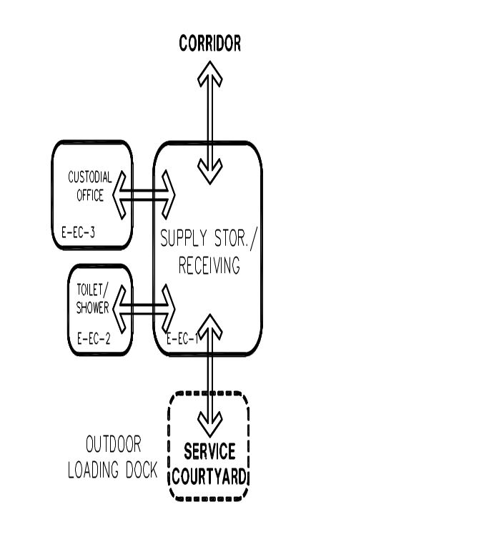
CUSTODIAL OFFICE M-EC-3
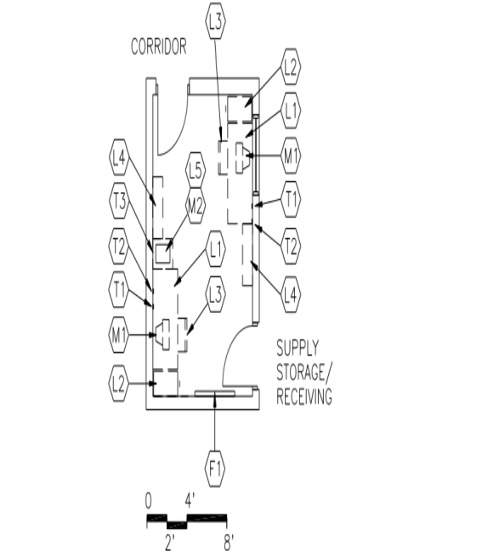  CAPACITY:  - Maintenance and custodial staff  SIZE:  - 150 SF  ANCILLARY SPACES:  - Supply Storage/Receiving (M-EC-2) | GOAL:  - To provide an area for the maintenance manager, staff, and building engineer to provide supervision of the physical plan  PROGRAM ACTIVITIES:  - Conferences with staff and other visitors  - Telephone calls  - Paperwork  SPATIAL RELATIONSHIPS:  - Adjacent and access to Supply Storage/Receiving  - Access to corridor  ENVIRONMENTAL CONSIDERATIONS:  - Uniform lighting  - Electrical outlets for equipment  - Visual control of supply storage/receiving

NOTES:

1. Loose furnishings and features shown represent one of many possible arrangements.
CUSTODIAL OFFICE
M-EC-3
Spec.  Finishes¹: Ref.#  Flooring:  Resilient tile flooring 096519  Base:  Resilient base 096519  Ceiling:  Suspended, acoustical 095113  Walls:  Painted concrete masonry units  042000 / 099123  Loose Furnishings:  L1 desk  L2 four-drawer file cabinet  L3 2 ergonomic task chairs  L4 Adjustable height bookshelves (12 LF)  L5 Printer table | Spec.  Features¹: Ref.#  Fixed Equipment:  F1 Tack board (4 LF) 101100  Fire Suppression: Div. 21  Fire suppression system  Plumbing:  N/A  HVAC: Div. 23  Supply/return air system  Independent temperature  control  Electrical: Div. 26  Duplex receptacles  TVSS protected quad receptacle  adjacent to data port  Single-level switching  Fluorescent lighting 16500 16500  Illumination level: See Table 7600-16  Clock  Central sound system  Communications: Div. 27  T1 2 data ports  T2 2 voice ports and phones  T3 Data port for printer  Electronic Safety and Security: Div. 28  Life safety devices per code

NOTES:

Finishes/Features: Refer to Chapter 8 for specification references.
PLAYGROUNDS

AREA REQUIRED

1. Provide playground areas to allow for difference in age, ability, and varying interests.

2. Follow applicable safety guidelines for different age groups.

Pre-kindergarten to grade 1 play area. See Figure B-1.

a. Plan for play activities that include rocking, swinging, balancing, climbing, and sliding.

b. Include tables and chairs for age group

c. Locate equipment with moving parts, such as swings, at the perimeter of the play area. Use fence or planting beds to prevent children from inadvertently stepping into path of moving equipment.

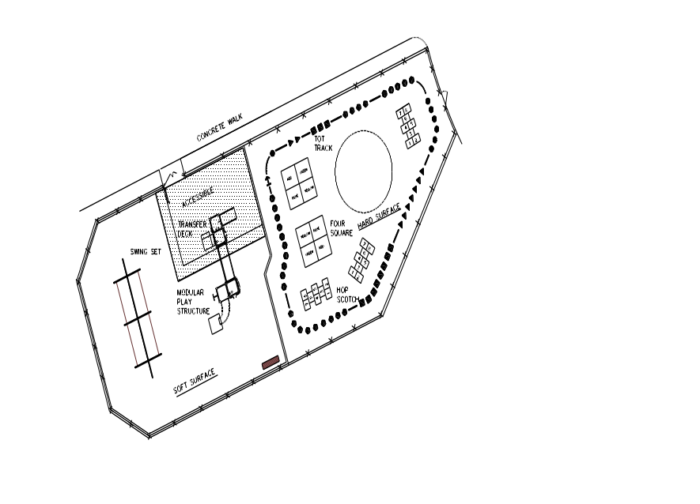
Example of Pre-kindergarten to Grade 1 Play Area
Figure B-1

Primary Play Area (See Figure B-2)

a. Design for grades 1 through 3.

b. Plan for play activities that include rocking, swinging, balancing, climbing, and sliding.

c. Plan for upper-body strengthening devices such as a parallel bar and overhead ladder play equipment.

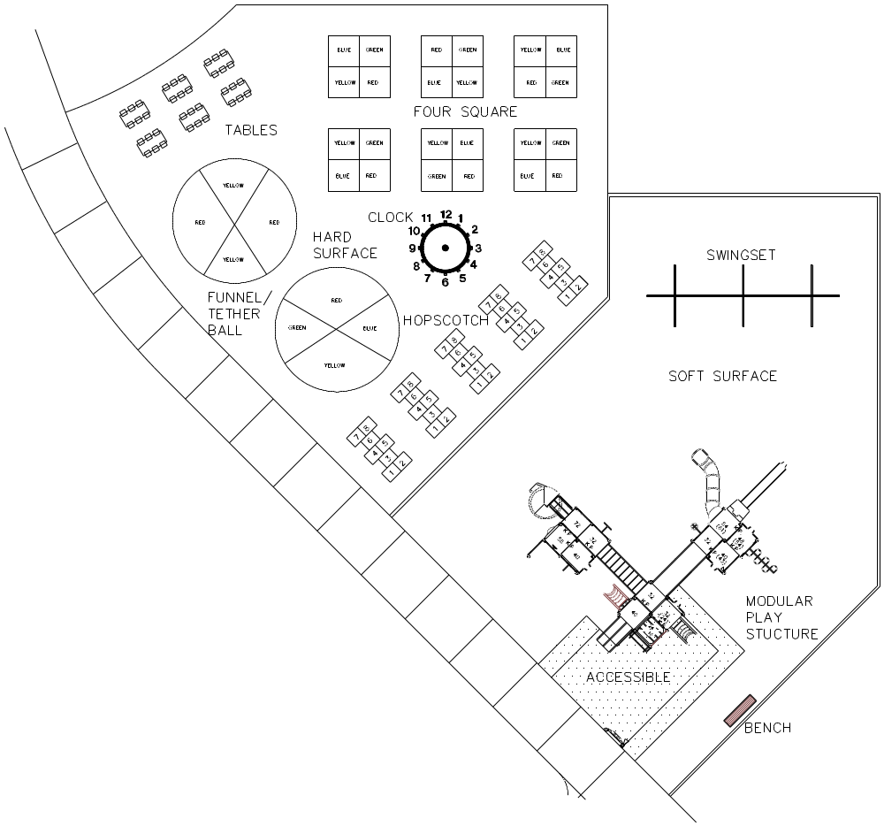

Example of Primary Play Area
Figure B-2

Intermediate Play Area (See Figure B-3)

a. Design for grades 4 and 5.

b. Intermediate play area may be combined with primary play area and a ‘tot track’ designed around both play areas

c. Include an outdoor science classroom that may include a garden.

d. Plan for 1 full basketball court (50 feet by 84 feet) or 2 half courts (50 feet by 42 feet).

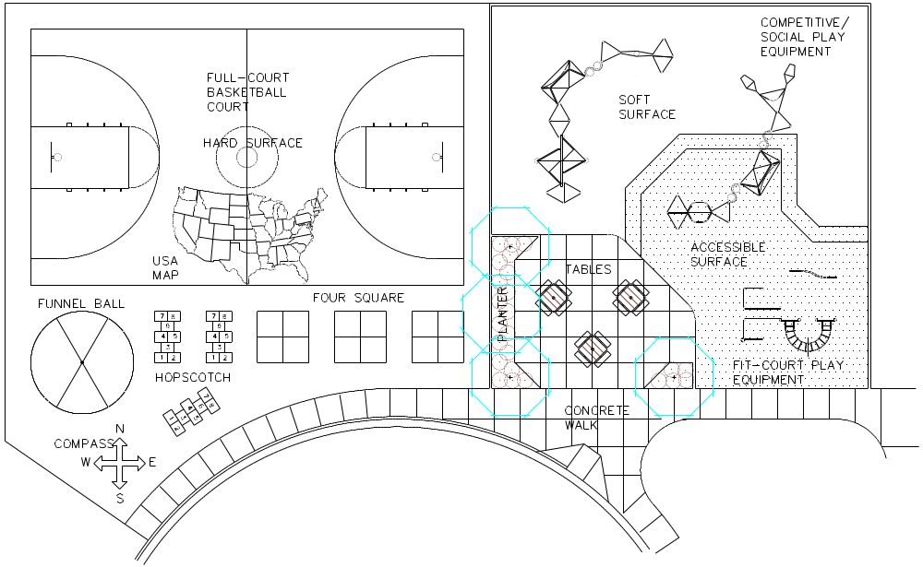

Example of Intermediate Play Area
Figure B-3
SOFT SURFACE PLAY AREA

- Soft surfaces are provided under play equipment and must be handicapped accessible.

- Surfacing is to be a poured polyurethane surface. Avoid using black surfacing.

ACCESSIBILITY STANDARDS
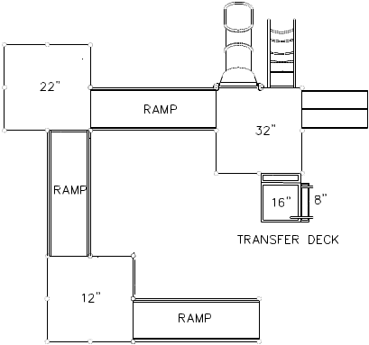
1. Plan for ramps and/or transfer points on composite play structures for access to play components on elevated decks. Meet the Americans with Disabilities Act guidelines for percentage of components that are to be accessible by ramp and by transfer deck. See Figure E-1.

2. Provide table and benches along accessible route.

- Provide upper-body strengthening devices as appropriate for age group and amount of supervision.
Typical Ramp and Transfer Deck
Figure E-1

See Design Guidelines for Site requirements for parking, circulation, etc.

